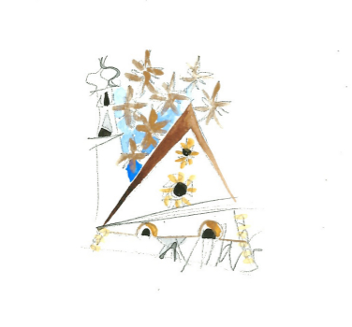 | 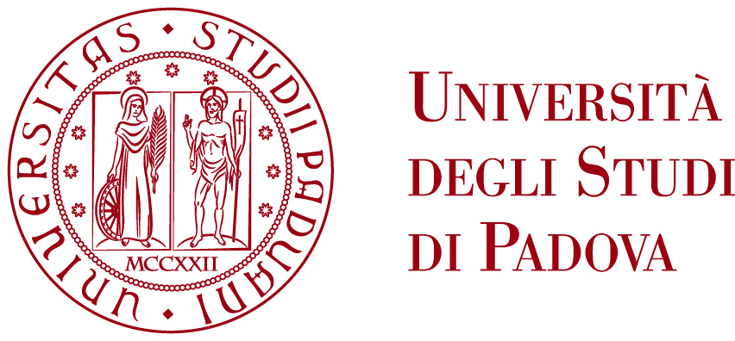 | XVI International Meeting on  “Selected Topics in Nuclear and Atomic Physics”  Fiera di Primiero, October 2 - October 6, 2017

INSTRUCTIONS FOR PAYMENT OF THE CONFERENCE FEE

The payment of 500,00 euro may be made by bank transfer to the following account

Università di Padova - Dipartimento Fisica e Astronomia "G. Galilei" (1)
Account number : 100000046588

Bank: CASSA DI RISPARMIO DEL VENETO
via VIII Febbraio 20 - 35122 PADOVA, Italy

IBAN: IT25J0622512186100000046588
BIC ADDRESS OR SWIFT: IBSPIT2P

IMPORTANT NOTE: please ask your bank to indicate "FIERA 2017 fee" and your name on the transfer.

Università degli Studi di Padova,
Dipartimento di Fisica e Astronomia "G. Galilei"
Via F. Marzolo, 8
I-35131 Padova (PD) Italy
VAT number 00742430283

For the invoice, which will be sent later, please send the following information to paola.zenere@pd.infn.it

- Invoice Header (your full name or your Institute),

- Full Invoice Address (with zip code, town, country),

- Tax Identification number or VAT number (corresponding to the Invoice Header).

