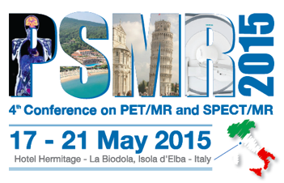Registration Form

Personal Data
- First Name:
- Surname:
- Institution:
- Address:
- City:
- Country:
- Phone:
- Email:
Participation
- Please, specify: Participant / Student / Exhibitor
Hotel Accommodation
- Arrival date:
- Departure date:
- Accommodation type: Hotel Hermitage/Biodola
Additional Information
- Please, enter any additional information:
Accommodation information for participant
- Required accommodation:: single/double room
- Please indicate the name of your roommate. Leave blank if not yet known or if you have no preference:
Accommodation information for participant with family
- Adult companion: 0
- Name of adult companion:
- Children (0-2 yrs): 0
- Name of children (0-2 yrs):
- Children (2-10 yrs): 0
- Name of children (2-10 yrs):
- Please, enter below any special request you might have regarding your accommodation:
Arrival information
- Means of transport: airplane/train/car/other
- If need be to contact you during your trip, please give us your mobile phone number:
Conference bus on Saturday, May 16
- destination La Biodola Hotels
- I will take the meeting bus on Saturday, May 16 from Pisa airport: yes/no
- If 'yes', the flight details (origin, airport of arrival, flight number, arrival time) are:
Conference buses on Sunday, May 17
- destination La Biodola Hotels
- I will take the meeting bus on Sunday, May 17 from:
Rome Fiumicino airport (FCO) at 14:00
Pisa airport (PSA) at 15:30
- Flight details (origin, airport of arrival, flight number, arrival time):
Conference buses on Thursday, May 21
- destination PSA and FCO airports
- I will take the meeting bus on May 21 to:
Rome Fiumicino airport (FCO)
Pisa airport
- Departure details (May 21):
Conference buses on Friday, May 22 (destination PSA airport only)
- I will take the meeting bus on May 22 to Pisa airport: yes/no

