**Deliverable 8.1 FTK workshop at PRIELE - 2014**

Author: Paola Giannetti (FTK collaboration, INFN Pisa)

FTK Workshop at **PRIELE** (D8.1) March 10-11 2014

**Workshop** Goal: Summary of all activities performed on the first year of the project (2013).

**HOW IT HAS BEEN ORGANIZED:**

Participants:

General Assembly members:

Mauro Dell’Orso – UNIPI, Chair connected by skype from Pisa

Kostas Kordas – AUTH, Member present in Alexandroupolis

Alessandro Iovene – CAEN, Member connected by skype from Viareggio

Betty Magnin – CERN, Member connected by skype from CERN

Giovanni Calderini – CNRS, Member connected by skype from Paris

Petros Soukoulias – PRIELE, Member present in Alexandroupolis

Simone Donati – UNIPI, Member present in Alexandroupolis

Additional Executive Board members:

Dimitrios Sampsonidis – AUTH, WP 8 Coordinator, Member present in Alexandroupolis

Paola Garosi – CAEN, WP 2 Coordinator, Member connected by skype from Viareggio

Francesco Crescioli – CNRS, WP 6 Coordinator, Member present in Alexandroupolis

Andreas Sakellariou – PRIELE, WP 1 Coordinator, Member present in Alexandroupolis

Marco Piendibene – UNIPI, WP 5 Coordinator, Member connected by skype from Pisa

Chiara Roda – UNIPI, WP 4 Coordinator, Member connected by skype from Pisa

**Other Participants:**

P. Giannetti – INFN Pisa present in Alexandroupolis

K. Mermikly and Panagiotis Kalaitzis  - Prisma Electronics present in Alexandroupolis

S. Nikolaidis, C.L. Sotiropoulou, Stamatios Gkaitatzis, & Panagiotis Neroutos – AUTH present in Alexandroupolis

C. Gentsos – AUTH connected by skype from Salonicco

S. Citraro, P. Luciano – UNIPI present in Alexandroupolis

D. Magalotti - University of Modena connected by skype from CERN

G. Volpi – UNIPI connected by skype from Lisbon

The scheduled presentations are available at the site

<https://agenda.infn.it/conferenceDisplay.py?confId=7686>

 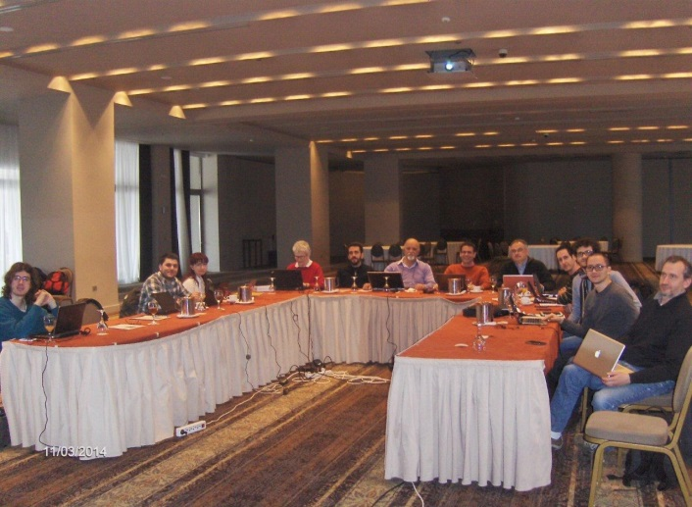

It was a very successful final workshop with a lot of scientific high level presentations. The Prisma organization was excellent, with a very good network connection, and a wonderful conference room as can be observed by the photo above. We had also the Delta Tv the 11th of March, you can see here the video: <http://www.youtube.com/watch?feature=player_embedded&v=lyRPXxa7_bs>

We had also an interesting visit to the Prisma Electronics production line (see photos below):

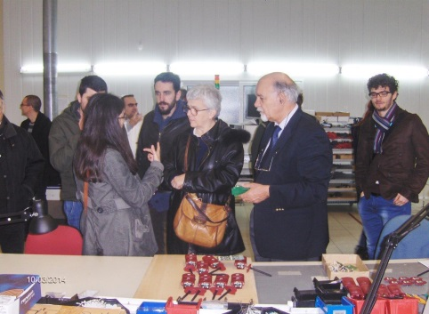 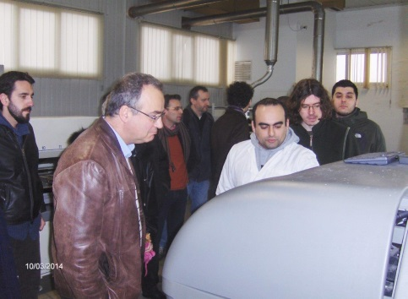 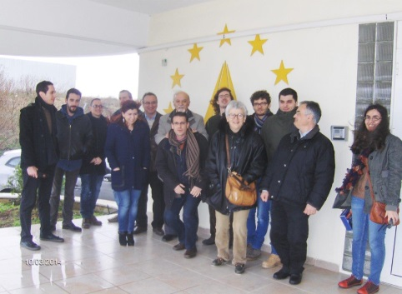

**The FTK workshop agenda: *here is the list of PRESENTATIONS***

***Petros Soukoulias presented the Prisma Electronics company***, the story of the company, the main projects, with a special space to the very successful project LAROS (see slides).

***PRESENTATIONS about the work performed by the FTK researchers (see the slides at web site) followed:***

**WP1 talks**

- “Design and test of the MiniLamb with the Evaluation Board” by P. Lucianno

- “Design and test of the AMBSLP+MiniLamb” by S. Citraro

- “Design and Simulation of SLP1” by C. Gentsos

**WP2 talks**

- “AUX Board and AMBoard Integration at CAEN” by M. Piendibene

- “The CAEN PS - cooling tests @ USA15” by A. Iovene

- “FTK_IM: design and integration in FTK” by L.-C. Sotiropoulou

- “Error Detection and HAndling in FTK” by L.-C. Sotiropoulou

- "lost syncronization" by P. Neroutsos

**WP4 talks**

“Simulation for the AMB-AUX combined tests” by G. Volpi

“Simulation for the FTK_IM test” by S. Gkaitatzis

**WP6 talks**

“Silicon Detector R&D for Phase II” by G. Calderini

**WP7-8 talks**

“The Web site today” by K. Kordas

“Training and MOCAST worshop at AUTH” by L.-C. Sotiropoulou

Social occasions were the lunches, in the conference site with an external catering, and wonderful evening dinners all together. All was offered by Prisma.

It was a great opportunity to reinforce each other knowledge and to discuss results of the first FTK year. We came to the conclusion that this first year was really successful.

Compared to the first year workshop, the information was correctly delivered and received, showing that collaborators have already acquired a good expertise in the project, that is the transfer of knowledge was really successful.

No negative remark for this first year of work.