FTK-IAPP *General Assembly, Executive Board* Meeting and 2nd FTK Workshop

Alexandroupolis with Skype connection, March 10 – 11 2014

**MINUTES**

The following representatives have been invited to the GA:

Mauro Dell’Orso – UNIPI, Chair connected by skype from Pisa

Kostas Kordas – AUTH, Member present in Alexandroupolis

Alessandro Iovene – CAEN, Member connected by skype from Viareggio

Betty Magnin – CERN, Member connected by skype from CERN

Giovanni Calderini – CNRS, Member connected by skype from Paris

Petros Soukoulias – PRIELE, Member present in Alexandroupolis

Simone Donati – UNIPI, Member present in Alexandroupolis

The following representatives have been invited to the EB:

Mauro Dell’Orso – UNIPI, Project Coordinator, Chair connected by skype from Pisa

Kostas Kordas – AUTH, WP 7 Coordinator, Member present in Alexandroupolis

Dimitrios Sampsonidis – AUTH, WP 8 Coordinator, Member present in Alexandroupolis

Paola Garosi – CAEN, WP 2 Coordinator, Member connected by skype from Viareggio

Francesco Crescioli – CNRS, WP 6 Coordinator, Member present in Alexandroupolis

Andreas Sakellariou – PRIELE, WP 1 Coordinator, Member present in Alexandroupolis

Marco Piendibene – UNIPI, WP 5 Coordinator, Member connected by skype from Pisa

Chiara Roda – UNIPI, WP 4 Coordinator, Member connected by skype from Pisa

Betty Magnin – CERN, WP3 Coordinator, Member connected by skype from CERN

**Other Participants:**

P. Giannetti – INFN Pisa present in Alexandroupolis

K. Mermikly and Panagiotis Kalaitzis  - Prisma Electronics present in Alexandroupolis

S. Nikolaidis, C.L. Sotiropoulou, Stamatios Gkaitatzis, & Panagiotis Neroutos – AUTH present in Alexandroupolis

C. Gentsos – AUTH connected by skype from Salonicco

S. Citraro, P. Luciano – UNIPI present in Alexandroupolis

D. Magalotti - University of Modena connected by skype from CERN

G. Volpi – UNIPI connected by skype from Lisbon

The scheduled presentations are available at the site

<https://agenda.infn.it/conferenceDisplay.py?confId=7686>

 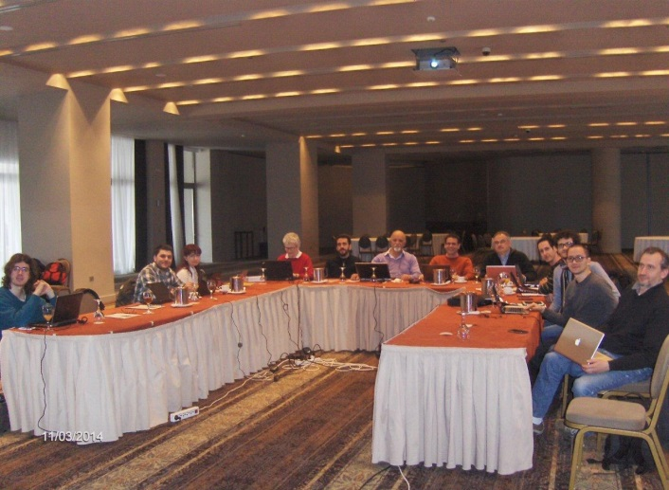

It was a very successful final workshop with a lot of scientific high level presentations. The Prisma organization was excellent, with a very good network connection, and a wonderful conference room as can be observed by the photo above. We had also the Delta Tv the 11th of March, you can see here the video: <http://www.youtube.com/watch?feature=player_embedded&v=lyRPXxa7_bs>

We had also an interesting visit to the Prisma Electronics production line (see photos below):

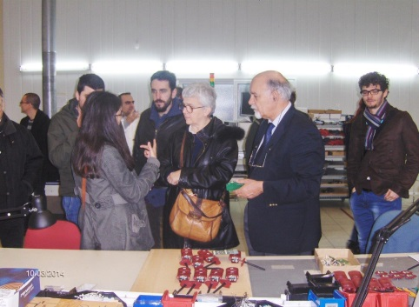 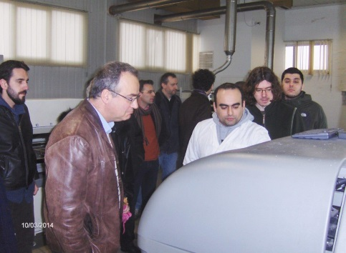 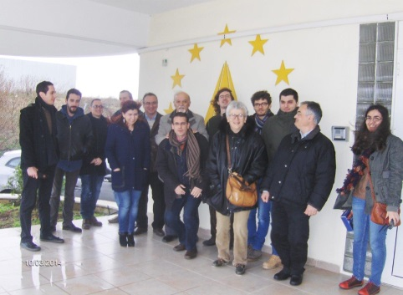

**The 1st Section** was dedicated to the **GA** and **EB** matters.

* ***Petros Soukoulias presented the Prisma Electronics company***, the story of the company, the main projects, with a special space to the very successful project LAROS (see slides).
* ***Presentation by Mauro Dell’orso & Paola Giannetti***.

1. M. Dell’Orso & P. Giannetti handled the GA and EB together, to make important decisions and report about the status and future plans:
2. As a first item we discuss the Outreach schedule, with a full revision of the duties in this year: (1) the IAPP school will be in Pisa, June 4-6, and it is a software school organized by us with the collaboration of Software Carpentry, part of Mozilla Science Lab (see Chiara presentation at the indico agenda). The school will be handled in collaboration with FTK IAPP personnel. Roughly 40 participants are allowed, FTK researchers can apply to this school, instructions are posted here: https://agenda.infn.it/materialDisplay.py?contribId=3&materialId=poster&confId=7686
3. (2) A IAPP Open Day will be associated to the software training, with visits to the FTK lab. (3) The Workshop day was in Salonicco: on Friday March 13 during the **Workshop on Modern Circuits and Systems Technologies** (Mocast workshop) organized by our AUTH colleagues, a full session has been dedicated to the FTK project. You can find slides and videos here: <http://mocast.physics.auth.gr/videos/>. It was a very successful occasion with more than 250 students and professors in the audience. Here you can find the Deliverable describing it https://agenda.infn.it/materialDisplay.py?materialId=1&confId=7686 (4) the training was also organized in Salonicco, with lab sections. You can find the program here <https://agenda.infn.it/getFile.py/access?contribId=19&resId=0&materialId=slides&confId=7686>It was a very successful session, with roughly 10 persons participating from the FTK project. Here you can find the Deliverable describing it https://agenda.infn.it/materialDisplay.py?materialId=0&confId=7686.
4. We discuss about the next training that is expected to be held at CERN. From the proposal the CERN training should be:

**CERN:** “Technology: (a) CERN practical experience for the development of high density electronics boards, (b) kow-how for quality assurance practices in board manufacturing”, with visit to the TE-MPE-EM infrastructures

Betty Magnin declares that their Lab is not in the appropriate conditions to be visited, since there was a plan to move it in new infrastructures at the end of 2013, but it did not happen. CERN asked to have the possibility to delay the visit after the transfer to new infrastructures. Giannetti asked if Prisma or LPNHE could swap their trainings with CERN, and Prisma promised to check about the possibility to do it.

Betty Magnin explains also about the necessity to change the CERN Scientist in charge. We agree about resolving the training issue and than write to the PO to ask the validation of our request and propose the change of responsibility in front of EU for the CERN participant.

During the third year both the FTK Workshop (the 3rd one) and the training is expected to happen at LPNHE, in Paris. It would be nice to couple also the outreach Workshop, where FTK could be presented fully to the French community.

1. We discuss the evolution of the proposal we got in autumn from the INFIERI ITN for our SLP1 research area. Unfortunately the INFIERI international coordinator was against the Thales proposal and as a consequence the INFIERI fellow is not any more available. After that the interest of the Thales company for future collaborations seems drastically decreased. However we are still looking for partners that could participate with us on that area, in particular for an ITN application. We are trying to contact CADENCE.
2. We discuss the status of the recruitment for AUTH. We understand that everybody (GA and EB members) have actually agreed about the procedure proposed by AUTH, based on the scrutiny of the 6 curricula of the received applications. 3 persons have been chosen for an interview.
3. We discuss about the Mid Term Review. The month 20 (September) has been selected by the participants to be proposed to the PO and Pisa has been chosen as the best place for it. We prefer to do it early to free Autumn of all the relative duties, since into Autumn the collaboration will be very busy in the experiment that will be near to start again with data taking. However when I proposed September and Pisa to the PO, I got as answer back, that September is really too early and the review should be at the end of November, if really is a problem for us, we can manage it at the beginning of November. The place should be chosen to be easily reached from Bruxelles, she clearly mentioned Paris as the best place. We should prepare us to the idea of going there. All the researchers active in the project should participate and fill a questioner.
4. We discussed the dates for the next meetings. The next EB is planned for JULY 2014. The next GA-EB meeting will be at the end of September in preparation of the Mid Term Review (one month before we need to submit the report and all the Deliverables.)
5. Paola describes the progress report submission. Together with the report, a set of attachments were added, you can see all the documents on the portal. This is the list of the attachments:
   1. All the Deliverables
   2. Gantt Chart with all approved corrections reported
   3. A file with the explanation of all the changes requested and approved
   4. List of publications and presentations to conferences

This is the FFEDBACK on the 1st report:

============================================================================

Dear Prof Dell'Orso,

Thank you for submitting the first progress report for project FTK.

We appreciate that the project implementation has had no major issues of concern in its first year.

In the next reports (mid-term, periodic, etc.) please include also the following information:

Please discuss more in-depth the **transfer of knowledge** aspect of the project as this is a core element of the Marie Curie fellowship. In the report you also do not seem to mention if **personal career development plans** have been defined for each fellow where their training and research path is defined in relation to their future career development to make the best of their fellowships. You should also include as an attachment to the report a list of the **complementary/soft skills trainings** attended by fellows.

In relation to the table related to International Conferences/Events, please note that the number of researcher days is not linked to the origin of the funding for these researchers, we just would like to know for information **how many the days were covered by the researchers**, ie if 10 external researchers participated for 10 days each then you should indicate 20 in the column. You may correct this in the next reports in which the table will also need to be completed.

Thank you for taking into account the above-mentioned comments in your next reports.

============================================================================

The result is in general positive, but we should prepare documents on the missing issues.

The scientific status is positive. All the milestones have been obtained, a lot of development allowed also many papers and conference contributions. The collaboration appeared active and productive.

1. We discuss the future Milestones. The second year is focalized on WP2 and we have the start of WP3. The WP2 Milestones are all due for September, while the WP3 milestone is for the end of 2014:

Milestone WP Leader Expiration date

M.2.2. Slp2 ok at Caen CAEN M20 SLP2 runs flawlessly at CAEN

M.2.3. Infrastructure ok at CAEN M20 Infrastructure validated

M.2.4 Compare_technologies CAEN M20 Compare and choose technology

M.3.1. Demonstrator ok at Atlas CERN M24 Demonstrator runs flawlessly in Atlas

1. We discuss also the future Deliverables and assign the responsibilities for the work. It looks like our schedule today fits well with this Deliverable’s plan.

Deliverable Exp. Date Responsible

D.4.3. Test Vectors for the SLP2 based FTK R RE M16 Volpi/Magalotti

D.2.3. CAEN power supply ready for integration R RE M18 Piendibene/Iovene

D.2.4. FTK cooling and mechanical tests completed R RE M20 Giannetti/Lanza

D.2.5 SLP2 fully integrated Pub PU M20 paper Tipp

D.3.1. FTK demonstrator commissioned Pub PU M22 paper NSS

D.6.2. Standard characterization R RE M24 Calderini

1. Finally we discuss briefly the web site (<http://ftk-iapp.physics.auth.gr>) development. The part reserved to the collaboration has been improved, collecting all important documents. The public sections instead are still quite empty. Simone Donati from Pisa will work to improve the outreach part (description of the project for the public). Kostas Kordas will care about the description of participants.
2. A brief review of the expenses and the available budgets is carried out. No real problem is detected.

**Papers are collected here:** [**http://www.pi.infn.it/~paola/IAPP/publications/**](http://www.pi.infn.it/~paola/IAPP/publications/)

**Talks and posters here:** [**http://www.pi.infn.it/~paola/IAPP/talks-posters/**](http://www.pi.infn.it/~paola/IAPP/talks-posters/)

**The 2nd Section** was dedicated to the **FTK workshop**

***Following PRESENTATIONS about the work performed by the FTK researchers (see the slides at web site):***

**WP1 talks**

- “Design and test of the MiniLamb with the Evaluation Board” by P. Lucianno

- “Design and test of the AMBSLP+MiniLamb” by S. Citraro

- “Design and Simulation of SLP1” by C. Gentsos

**WP2 talks**

- “AUX Board and AMBoard Integration at CAEN” by M. Piendibene

- “The CAEN PS - cooling tests @ USA15” by A. Iovene

- “FTK_IM: design and integration in FTK” by L.-C. Sotiropoulou

- “Error Detection and HAndling in FTK” by L.-C. Sotiropoulou

- "lost syncronization" by P. Neroutsos

**WP4 talks**

“Simulation for the AMB-AUX combined tests” by G. Volpi

“Simulation for the FTK_IM test” by S. Gkaitatzis

**WP6 talks**

“Silicon Detector R&D for Phase II” by G. Calderini

**WP7-8 talks**

“The Web site today” by K. Kordas

“Training and MOCAST worshop at AUTH” by L.-C. Sotiropoulou