Deleverable 7.2 - Workshop Day 2014 – Thessaloniki
Author: Calliope-Louisa Sotiropoulou (AUTH)

The MOCAST Workshop (Workshop on Modern Circuits and Systems Technologies) is organised yearly at the Aristotle University of Thessaloniki by the Electronics Division of the Physics Department. It is a scientific workshop in the area of ICT and it is an opportunity for scientist from Greece and Europe to gather together and present their research to the public. This year the 3rd MOCAST Workshop was organized on March 14-15. In this Workshop a session was dedicated to the FTK-IAPP project and also the first plenary speech was dedicated to high performance embedded systems for HEP using FTK as a working example (by Dr. Paola Giannetti from INFN, Pisa Section).
A representative from almost all FTK IAPP partners made a presentation in the Fast TracKer (FTK) IAPP Session: Dr. F. Crescioli from CNRS, Mr. D. Magalotti who is a Pisa collaborator, Ms. C.-L. Sotiropoulou from AUTH, Mr. A. Iovene from CAEN and Mr. P. Soukoulias from Prisma Electronics. The program of the session is presented in the table below:
Plenary Talk:
Dr. Paola Giannetti – Director of Research, INFN Pisa Section, Italy
“High Performance Embedded Systems for High Energy Physics Experiments at Hadron Colliders”
Coffee Break
Fast TracKer (FTK) IAPP Session
Dr. Francesco Crescioli – Researcher, LPNHE CNRS, France
“Associative Memories for Hadron Collider experiments: the FTK AMchip experience”
Daniel Magalotti – Researcher, INFN Perugia Section and University of Modena and Reggio Emilia, Italy
“The Associative Memory Board for the Fast TracKer (FTK) processor at ATLAS”
Calliope-Louisa Sotiropoulou – Researcher, Aristotle University of Thessaloniki, Greece
“A High Performance Parallel FPGA Implementation of a 2D-Clustering Algorithm for the ATLAS Fast TracKer (FTK) Processor”
Alessandro Iovene - Project Manager, CAEN SpA, Italy
“CAEN - Electronic Instrumentation for Nuclear Physics: R&D activities and innovative projects”
Petros Soukoulias – Head of the Scientific/Advisory Board and co-Founder, Prisma Electronics, Greece
“Prisma Electronics – Electronics, Production Methods & Practices”

The workshop was very well published in various social media (facebook, twitter, linkedin), webpages about events in the city of Thessaloniki, the AUTH events website etc. Posters were distributed across the campus at least a month before the Workshop (see the poster in Fig. 1).
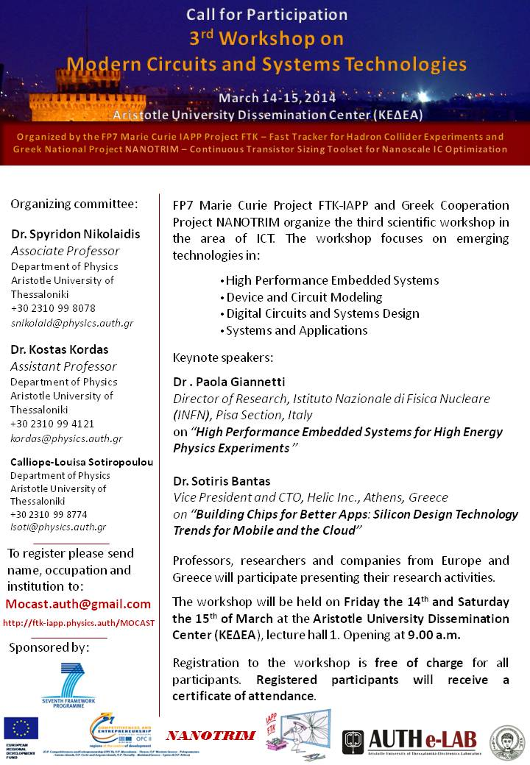
Figure 1: 3rd Mocast Workshop Poster

The Workshop proved to be very successful with 300 registered participants and a full conference hall (with people even standing) during the FTK Session. The participants were undergraduate students, post-graduate students, researchers, professors and professionals from Aristotle University of Thessaloniki (Departments of Physics, Electronics Engineering, Informatics etc.) the Electronics Department of ATEI Thessaloniki and also from companies and universities from all over Greece.
The whole workshop program and abstracts are available on http://mocast.physics.auth.gr/ . Also there is a video from both workshop days available on the workshop website.
All participants received a Certificate of Attendance for their participation in the Workshop.
Figure 2: MOCAST Certificate of Attendance

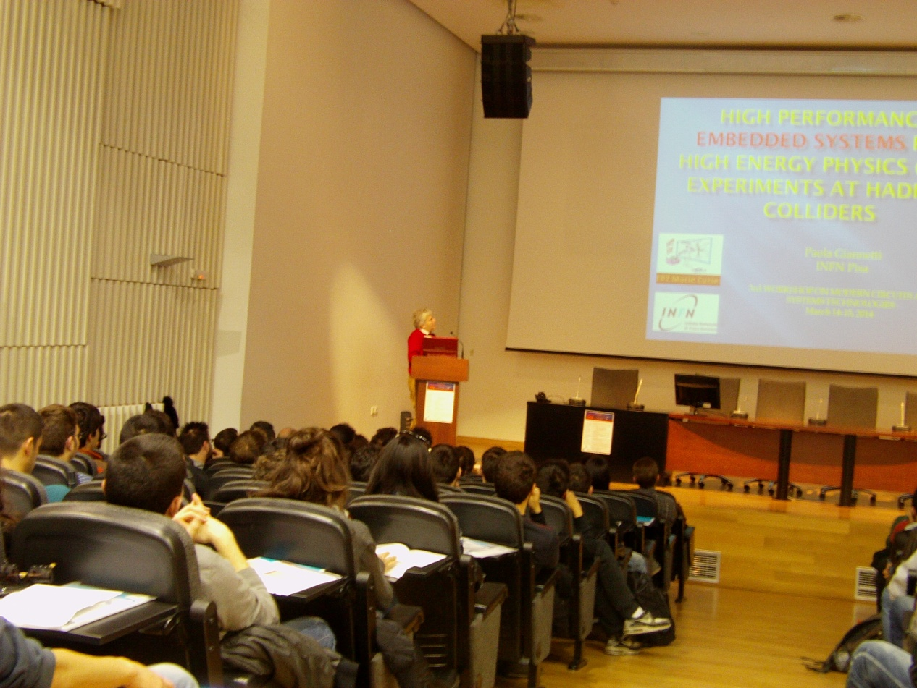
Figure 3: Dr. Gianneti Plenary talk
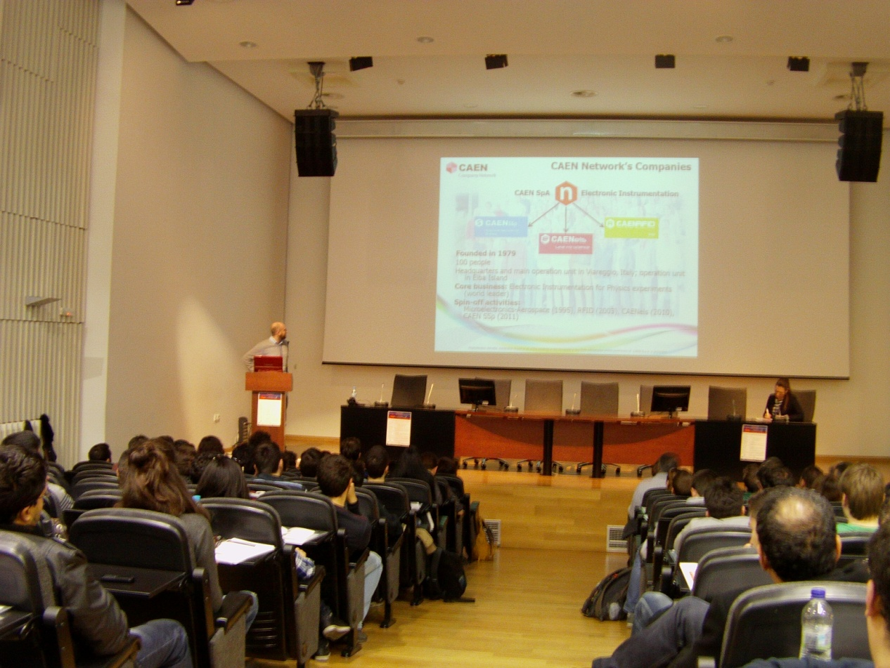
Figure 4: Mr. Iovene talk in the FTK Session

