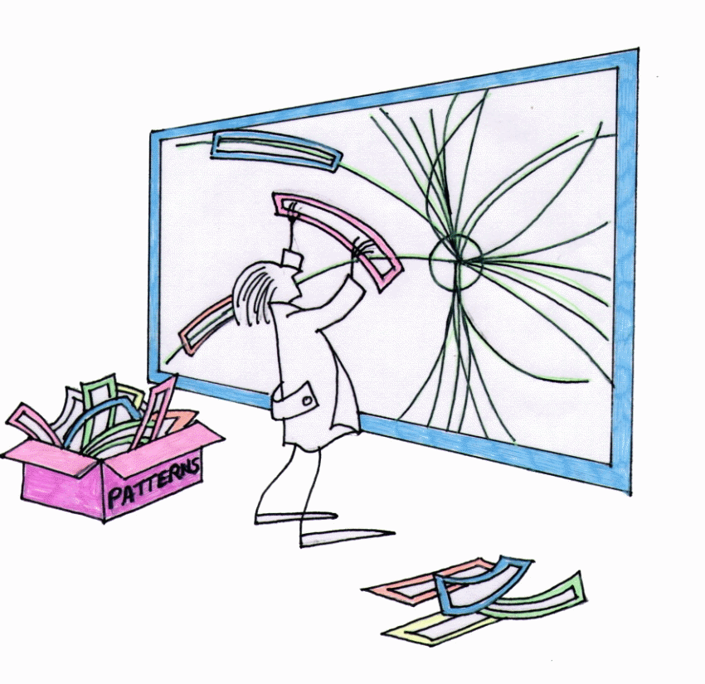 | FTK  Fast TracKer for hadron collider experiments  324318, FP7-PEOPLE-2012-IAPP

Deliverable Dx.y:
Deliverable Full Title

Deliverable Version: | Dx.y, v.1.0
Document Identifier: | ftk - deliverabletemplate.docx
Preparation Date: | Click here to enter a date.
Document Status: | Choose an item.
Author(s): | Click here to enter text.
Dissemination Level: | Choose an item.

Project funded by the European Community in the 7th Framework Programme - People

Deliverable SUMMARY SHEET
Deliverable Details
Type of Document: | Deliverable
Document Reference #: | Dx.y
Title: | Deliverable Full Title
Version Number: | 1.0
Preparation Date: | Click here to enter a date.
Delivery Date: | Click here to enter a date.
Author(s): | Click here to enter text.
Document Identifier: | ftk - deliverabletemplate.docx
Document Status: | Choose an item.
Dissemination Level: | Choose an item.

Project Details
Project Acronym: | FTK
Project Title: | Fast TracKer for hadron collider experiments
Project Number: | 324318
Call Identifier: | FP7-PEOPLE-2012-IAPP
Call Theme: | Industry Academia Partnerships & Pathways (IAPP)
Project Coordinator: | Università di Pisa (UNIPI) – IT
Participating Partners:
Instrument: | CP-FP
Contract Start Date: | Click here to enter a date.
Duration: | Click here to enter text.

Deliverable Dx.y: Short Description
Insert here a short description on the contents of this document.
Keywords: all; relevant; keywords; should; be; inserted; here

Deliverable Dx.y: Revision History
Version: | Date: | Status: | Comments
1.0 | dd/mm/aaaa | Final | Author/Revisor (Participant Short Name)

Copyright notices
© 2013 FTK Consortium Partners. All rights reserved. FTK is an FP7 Project supported by the European Commission under contract #324318. For more information on the project, its partners, and contributors please see FTK WEBSITE. You are permitted to copy and distribute verbatim copies of this document, containing this copyright notice, but modifying this document is not allowed. All contents are reserved by default and may not be disclosed to third parties without the written consent of the FTK partners, except as mandated by the European Commission contract, for reviewing and dissemination purposes. All trademarks and other rights on third party products mentioned in this document are acknowledged and owned by the respective holders. The information contained in this document represents the views of FTK members as of the date they are published. The FTK consortium does not guarantee that any information contained herein is error-free, or up to date, nor makes warranties, express, implied, or statutory, by publishing this document.
Table of Contents
Executive Summary 1
1 Instructions 2
1.1 Starting a new document 2
1.1.1 To start a new document: 2
1.1.2 Updating field values 2
1.2 Styles 3
1.3 Examples 3
1.4 File naming convention 3
2 Section 4
2.1 Subsection 4
2.1.1 Subsubsection 4
2.1.2 Subsubsection 4
2.2 Subsection 4
References 5

List of Figures

List of Tables
Table 1: Document Description Input Table 2
Table 2: Example of a table 3

Abbreviations and Acronyms

Executive Summary

Instructions

Starting a new document
This template is provided to facilitate the creation of documents related to the MODES_SNM Project. The cover pages have been created to ensure consistency throughout all Project reports, deliverables etc. You should not edit the cover page or the headers and footers of this document, as they are automatically generated through linked content elements.

To start a new document:
- Make a copy of this file and name it according to the file naming conventions outlined below:
- On Page i (the second page of this document), update the table:
Document Details
Type of Document: | Specify the type of document (Report, Deliverable, Milestone)
Document Reference #: | A reference number for the document - e.g. D1.1 for a deliverable 1.1
Title: | The title of the document
Version Number: | A version to be updated as the document evolves
Preparation Date: | Date of preparation for the particular version
Delivery Date: | Date that this document was delivered for review, to the Commission Services, to other partners
Author(s): | Authors of the Document
Document Identifier: | This is an automatically updated field and it equals the name of the file
Document Status: | Select from the drop-down list any of the options:  Draft, Final, Under Review, Revision, Other
Dissemination Level: | Select from the drop-down list any of the options:  PU - Public  PP - Restricted to other programme participants (including the Commission Services)  RE - Restricted to a group specified by the consortium (including the Commission Services)  CO - Confidential, only for members of the consortium (including the Commission Services)
Table 1: Document Description Input Table
- Once you have completed this form the cover page, headers, and footers of this document will be automatically updated.
- You might want to update the document revision history on the next page.

Updating field values
Field values are used to automatically update the document identifier, to generate the table of contents, the list of figures and the list of tables. If:
- You change the filename
- You add a new Heading Element
- You add a figure or a table caption
then press Ctrl-A (to select the whole document) and F9 to update the fields.

Styles
You should use the following styles:
Heading 1: For Sections
Heading 2: For Subsections
Heading 3: For Subsubsections

Also the Style for the main text is Normal.

Examples
To add a caption insert the Figure and then select:
References -> Insert Caption -> Select Label “Figure” and then add the caption
If you would like to update the list of figures hit Ctrl-A and then F9 (or right-click on the list of figures field and select “Update Field”.

Follow the same procedure to add a caption to a table.
Example | Table
Table 2: Example of a table

File naming convention
All files should be named according to the following convention:
MODES_SNM_Dx.y_AuthorOrganisation_AuthorInitials_Version.docx

Section

Subsection

Subsubsection

Subsubsection

Subsection

References
Add here your references.

