
PusuIsHED sY IOP PusuIsHING FOR SIssA MEDIAuAs
Received: October 30, 2025
Accepted: November 19, 2025
Published: January 14, 2026

11th International Workshop
on Semiconductor Pixel Detectors for Particles and Imaging Strasbourg, France
18–22 November 2024
TITLE

S. Ravera 𝑎,𝑏 on behalf of the ATLAS collaboration
𝑎 Università Roma Tre, Via della vasca navale,84, Roma, Italy
𝑏 INFN - Sezione di Roma Tre,
Via della vasca navale,84, Roma, Italy
E-mail:

Abstract:

Contents
- Introduction 1
- Pixel modules for ITk innermost layer 1
- Assembly of ITk triplet modules 2
- Quality control of the ITk triplet modules 3
- Bumps delamination studies 4
- Conclusions 5

Introduction

Method

Results
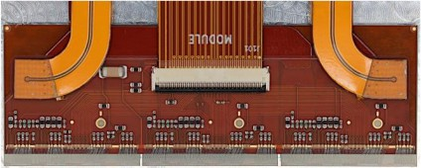
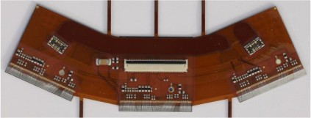
Figure 1. Description of the figure.

Discussion

Conclusions

References
- …

