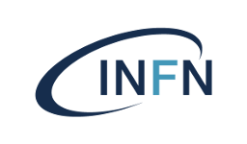
Istituto Nazionale di Fisica Nucleare Laboratori Nazionali di Frascati

Avviso di Seminario Generale

Dr.ssa Laura Miller
TRIUMF

Shedding light on the dark sector with DarkLight

The nature of dark matter remains one of the largest open questions in particle physics. Despite numerous theories and experimental searches, both small-scale and large-scale, it has so far remained unobserved at the particle level.
The DarkLight experiment located at TRIUMF in Vancouver, Canada aims to leverage the ARIEL electron linear accelerator to search for a new dark sector force carrier in the 10-20 MeV range.
Such a force carrier could undergo kinetic mixing with Standard Model photon, and thus could provide possible explanations for experimental anomalies such as the X17.
As the DarkLight experiment has recently been installed and has begun commissioning, this talk will primarily focus on progress up to this point and future plans.

Mercoledi’ 19/11 ore 14:30 Aula Salvini

https://agenda.infn.it/event/49141/

L'invito è esteso a tutto il personale interessato, che è caldamente invitato a partecipare.

