LNF Data Management Plan
Written by | Checked by | Approved by
Antonella Antonelli (Head of the Research Division)  Silvia Pisano  (Coordinator of group 3) | Paola Gianotti (Director)  Patrizia De Simone (Coordinator of group 1)  Giovanni Mazzitelli (Coordinator of group 2)  Gennaro Corcella (Coordinator of group 4)  Cristina Vaccarezza  (Coordinator of group 5)
Subject
Data Management Plan for research activities making use of LNF facilities.

Table of Contents
1 INTRODUCTION 2
2 DEFINITION OF TERMS 2
3 DATA COLLECTION AND STORAGE 3
4 OWNERSHIP OF DATA 3
5 CURATION OF RAW DATA AND ASSOCIATED METADATA 4
6 ACCESS TO RAW DATA AND METADATA 4
7 METADATA CAPTURE AND STORAGE 5
8 PUBLICATION INFORMATION 5
9 PERSONAL DATA 5

INTRODUCTION
The LNF Data Management Plan (DMP) concerns all the research data collected in experiments performed by using the facilities of the LNF.
The aim of the DMP is to plan the life cycle of data. Inspired to the FAIR (Findable, Accessible, Interoperable, Reusable) principles, it offers a long-term perspective by outlining how data will be collected, documented, shared and preserved and describing the process rules, the management workflow, roles and responsibilities of involved parties. The acceptance of this DMP is a necessary condition for the awarding the usage of the LNF facilities.
Some definitions of terms are listed in the second section. The various scenarios for the use of the different facilities operated at LNF are defined in the third section. Methods for storing and ensuring the long term durability of data, and rules to access research data and metadata are described in later sections.

DEFINITION OF TERMS
- Spokesperson: Person responsible for the experiment, identified with the proponent of the activity submitted to the LNF referent person, and for the data management collected during the experiment.
- Data Steward: Person responsible for the management of research data throughout their life cycle, from the collection phase to the storage and sharing ones.
- Experimental account: Directory created by the Information Technology Service containing the data record for an experiment and therefore all the data linked to the experiment.
- Digital Object Identifier (DOI): Unique, long-term identifier allowing the identification of a data record. This identifier will be created by Open Science Working Group as routinely done for the sharing of products on the Open Access Repository (OAR).
- Embargo Period: Period during which the data are available only to the experimental team. Beyond that period the data must be open to the widest audience.
- Experiment contact person: LNF staff member who facilitates the running of the experiment.
- Raw data: All kinds of data collected by experiments carried out by using LNF facilities.
- Metadata: All information necessary to manage and perform the analysis of the raw data, including (but not limited to) the context of the experiment, the experimental team, the experimental conditions, the data format, the logbook, software package, etc.
- Experimental Team: Experimental group which includes the spokesperson and any other person to whom the spokesperson designates the right to access resultant raw data and associated metadata.
- beamtime coordinator: Person in charge of the coordination of the accepted experiments and the preparation of the beamtime schedule maximizing the number of experiments to be performed in the available accelerator beamtime.
- Open Access: Data accessible, upon request, by the community at large, and protected by open license.

DATA COLLECTION AND STORAGE
Frascati National Laboratories (LNF) are engaged in research activites ranging from fundamental physics and detector development to material science and applications. Hence various uses of the facilities are possible and thus require different data management scenarios described below and shown in Fig. 1:
- Data achieved with LNF instrumentation and stored using local resources (Data acquisition system and servers for storage).
- Data achieved with LNF instrumentation which use a data acquisition and storage system that does not belong to LNF. However, data sharing and durability will be guaranteed by LNF by keeping a copy of the data generated which has to be provided by the spokeperson of the experiment.
- Data generated from instruments belonging to a collaboration which uses its data acquisition system and LNF servers for initial storage. This is typically the case of itinerant detectors.
- Data generated from instruments belonging to a collaboration with acquisition and servers outside LNF. The initial data storage does not use resources belonging to LNF. In this case as well, LNF will keep locally a copy of the data (provided by the spokesperson) as a guarantor of the data produced using LNF research infrastructures.
- Data generated during commercial use of LNF research infrastructures belong to the client and will not be stored on local servers unless agreed otherwise.

OWNERSHIP OF DATA
INFN is the owner and the custodian of the raw data (and associated metadata) produced by using research infrastructures installed in its National Laboratories. Often, large collaborations have already a DMP or are ruled by international agreements such as MoUs. In such cases specific agreeements between LNF and the Management Boards of the collaborations have to be established.
The LNF data management policy is shown in Fig. 1 and 2.
All raw data (and associated metadata) collected in experiments performed at LNF faclities (excluding commercial use of LNF research infrastructures) will be open access after an initial embargo period during which access is restricted to the experimental team, represented by the spokesperson.
All raw data (and associated metadata) obtained as a result of proprietary research will be owned exclusively by the client who purchased the beamtime and is not covered by this DMP. Commercial users must agree with the facility management on how they wish their raw data and metadata to be managed before the start of any experiment.

CURATION OF RAW DATA AND ASSOCIATED METADATA
Raw data and metadata will have read-only access for the duration of their lifetime.
Raw data formats must be well documented in the metadata.
All raw data and metadata will be organized in well-defined structures that will depend on the characteristic of the experiments, and which will be made available by LNF. Only data with associated metadata will be archived.
The spokesperson must inform data steward about the requirements in terms of disk space upon the scheduling of the experiment. The spokesperson has the responsibility to provide the data and the metadata (in electronic or pdf format) to the data steward, in compliance with the FAIR principles.
Each experiment and data set will have a unique permanent Digital Object Identifier (DOI). Anybody publishing results based on open access data must quote the same identifier. This DOI will be assigned by the Open Science Working Group as routinely done for the sharing of INFN products on the Open Access Repository (OAR).
The spokesperson must ensure that experiments’ metadata are complete (see the list shown in Table 1), as this will enhance the possibilities for everybody to search for, retrieve and interpret the data in the long term.

ACCESS TO RAW DATA AND METADATA
Access to raw data and the associated metadata obtained from an experiment is restricted to the experimental team for an embargo period of at least five years after the end of the experiment. Any spokesperson that wishes to retain restricted access to data for a period longer than five years will have this possibility to renew this five years period by submitting a written request, specifying the reasons for the proposed prolongation, to the LNF director who will accept or reject the request. In exceptional circumstances, data can be made openly accessible before the end of the embargo period if the spokesperson informs the LNF director about this decision. Thereafter, the data will become accessible upon request to the LNF director.
Data and associated metadata will be accessible through the persistent identifier.
Authorized LNF staff (as, e.g., scientists, computing group members and, in particular, data stewards) have access to any curated data or metadata for facility-related purposes. LNF will undertake that confidentiality of such data is preserved during the embargo period.
The spokesperson has the possibility to transfer parts or the totality of her/his rights during the embargo period to LNF or another registered person of the experimental team.
The spokesperson has the possibility to create and distribute copies of the raw data within the collaboration (without using LNF resources).
Researchers who aim to carry out analyses of raw data and metadata which are openly accessible should, where possible, also contact the original spokesperson to inform her/him and suggest a collaboration if required. Researchers must acknowledge the source of the data and cite its unique persistent identifier as well as any publications linked to the same raw data.

METADATA CAPTURE AND STORAGE
Data and metadata will be stored on a short-term basis (one year maximum) in dedicated LNF servers and preserved for immediate access and data analysis. After that, data and metadata will be transferred and stored to INFN computing infrastractures and preserved for at least fifteen years, unless differently agreed (for instance, in the case of existing DMP or computing models). In the latter case, it is responsibility of the spokesperson to ensure to comply with the FAIR principles.
High level metadata such as Title, Authors, Abstract, will be made public as soon as possible using the dedicated webpage (https://opendata.lnl.infn/). This information will be available through the persistent identifier. A data steward will be in charge to take care of the curation of the data as specified in the present document.

PUBLICATION INFORMATION
Publications related to data collected in experiments performed at LNF must cite the persistent identifier of the data.
Once known, the DOI of the publication must be sent to the Information Technology Service (calcolo@lnf.infn.it), in the person of the data steward, and to the Research Division (divric.segreteria@lists.lnf.infn.it).

PERSONAL DATA
Personal data will be processed, saved and archived by LNF in compliance with the principles set out in art. 6 of the EU Regulation 2016/679.

Table 1: List of metadata
Item | Description | Mandatory field | Comment | Format | Example
Identifier | Digital Object Identifier of the data taking | Y | Assigned by the INFN Open Science WG | DOI format
PAC identifier  (if relevant) | Local experiment number | Y | Assigned by the LNF referent person
Spokesperson | Full name | Y |  | First name and family name
Spokesperson | ORCID | Y | It allows cross referencing (data, publications, etc.) | ORCID Format
Spokesperson | Affiliation | Y |  | Free text
Spokesperson | E-mail address | Y |  | E-mail format
Title | Experiment title | Y | As in the scientific proposal submitted to the responsible of the LNF facility | Free text
Objectives | Experiment objectives | Y | Short description of the objectives | Free text
Publisher | Laboratory where the experiment took data | Y |  |  | INFN – LNL  INFN – LNS  INFN – LNF  INFN – LNGS
Publication Year | Year when the data will be made open upon request to the researcher community | Y | Included the embargo period | YYYY | 2023
Contributors | Scientist or Staff involved in the experiment | N |  | Free text
Experiment contact person | Local contact person | Y |  | Yes or Not
Experiment contact person | Full name | Y if the contact person exists |  | First name and family name
Experiment contact person | ORCID | N |  | ORCID Format
Date | Experiment start date | Y |  | Day Month Year | 21 March 2022
Resource type | Resource type | Y |  |  | Experimental dataset
Topic | Research domain | Y |  | Free text | Fundamental Physics –Applications – Interdisciplinary activities etc
Facility |  | Y |  |  | BTF, FLAME etc
Detectors | Detector's type | N |  |  | Gamma rays – Neutrons – Charged particles – None
Detectors | Experimental set-up used | Y
Target  (if relevant) | Target nature | Y |  |  | Isotope, Organic Compound, Inorganic Compound, None
Target  (if relevant) | Target thickness | Y |  | Thickness in mg/cm² | 0.350 mg/cm²
Target  (if relevant) | Target description | N |  | Free text
Description | All additional information that does not fit in any of the other categories | N |  | Free text

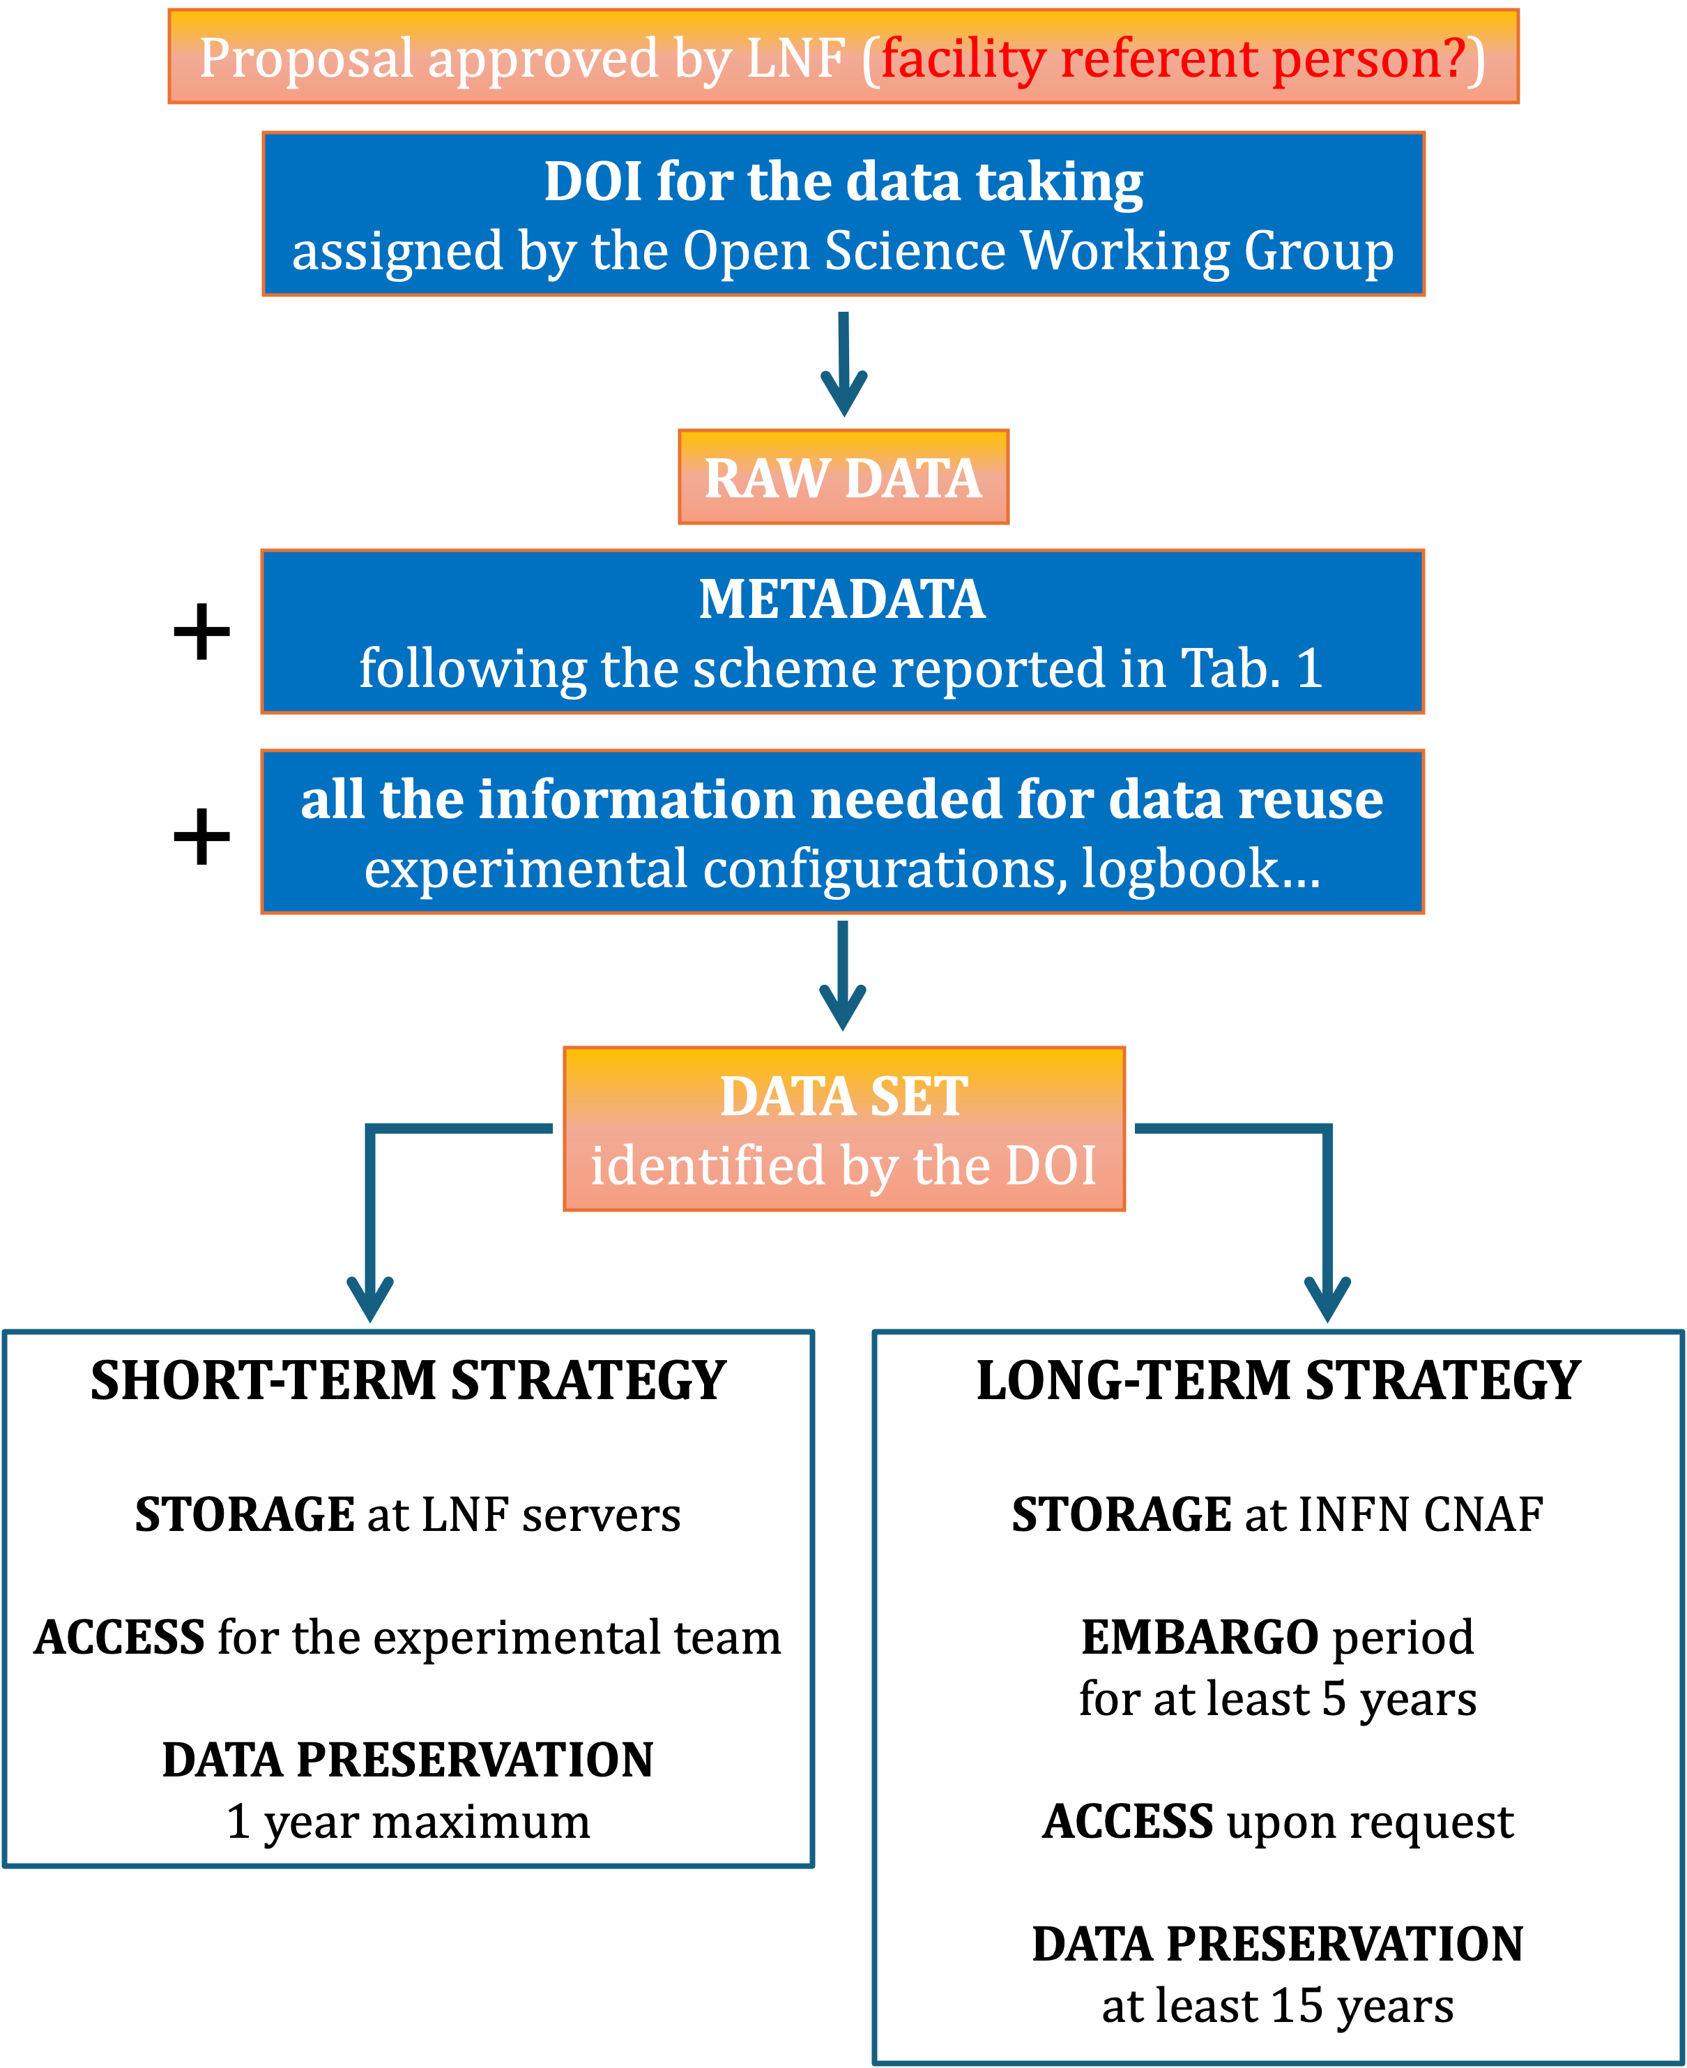

Figure 1: LNF data management policy

