Detecting Crystalline Nuclei with Synchrotron X-ray Sources: Insights from Molecular Dynamics Simulations

Leonardo Lo Presti¹, Margherita Vacchini,¹ Luca Sironi,² Stefano Righi¹ and Giovanni Macetti¹

¹Department of Chemistry, Università degli Studi di Milano, Milano, 20133, Italy
²Department of Chemistry, Durham University, Durham, DH1 3LE, United Kingdom

Presenting author email: leonardo.lopresti@unimi.it

Nucleation is the phenomenon whereby a new crystalline phase emerges from a pre-existing phase, typically a liquid. Studying nucleation is crucial not only for understanding the dynamics of molecular recognition and self-assembly, but also for predicting and potentially controlling the emerging crystalline phase. [1] Unfortunately, to date, no experimental techniques allow direct visualization of crystal nuclei, let alone the even more elusive structures sometimes referred to as pre-nucleation clusters or crystalline embryos.

In this contribution, we employ unbiased classical molecular dynamics simulations with Milano Chemistry Molecular Simulation (MiCMoS) [2] to investigate the possible structure of semi-solid supramolecular aggregates that retain partial crystalline order. To this end, we simulate the dissolution of molecular crystal nanoparticles and monitor how long aggregates that preserve at least some translational order persist. The goal is to determine the minimum spatiotemporal scale at which an aggregate could still yield a recognizable diffraction pattern in carefully designed experiments using hard X-rays, such as those available at large-scale core facilities like DESY or Stanford.

Our numerical simulations show that some Bragg peaks could remain clearly visible as long as the structure is on the order of 3 nm in size and persists for some 100 ps or more (Figure 1), [3] provided that a method is devised to extract this information from the solvent scattering background, and the data collection is fast enough to catch fast evolving clusters with similar dimensions and lifetime. Possible experimental strategies to cope with these problems are discussed.

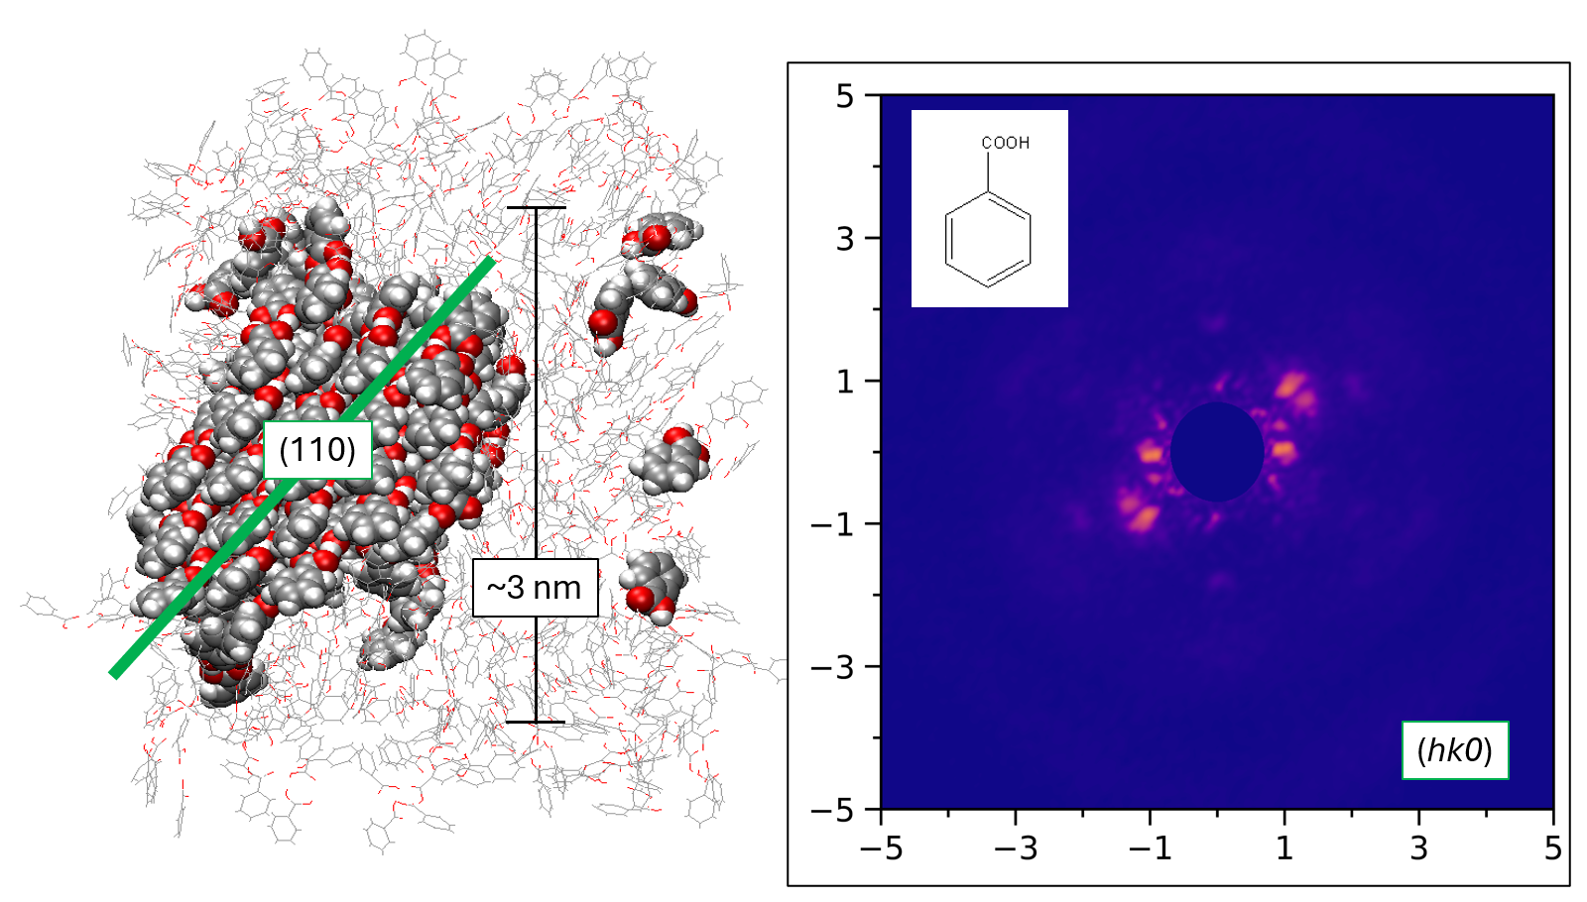

Figure 1. Left: possible structure of supramolecular cluster of benzoic acid along the path towards crystallization. Right: Total scattering from this cluster in the (hk0) reciprocal plane (simulated).

[1] G. Macetti, L. Sironi and L. Lo Presti, in: Comprehensive Computational Chemistry, 2024, Volume 3, p 777-803, Elsevier, Oxford, UK.
[2] A. Gavezzotti, L. Lo Presti, S. Rizzato, CrystEngcomm 2022, 24, 922.
[3] M. Vacchini, L. Sironi, G. Macetti, L. Lo Presti, Cryst. Growth Des., 2025, 25, 8969.

