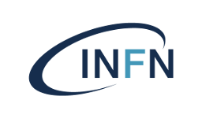**Istituto Nazionale di Fisica Nucleare Laboratori Nazionali di Frascati**

Avviso di Seminario Generale

# Dr. Livio Verra

LNF INFN

**Plasma Wakefield Acceleration – the long and winding road from proof-of-principle experiments to colliders**

The extremely large accelerating fields that can be excited in plasmas are orders of magnitudes larger  than in conventional accelerators, and they could be used to miniaturise the ever-increasing footprint of light sources and high-energy physics facilities.

In this seminar I will review the concepts of plasma wakefield acceleration, present the main experimental results of the field, and discuss the challenges on the path towards applications for high-energy physics.

## Svolgimento Seminario

## Mercoledi’ 11/6 ore 14:30 Aula Salvini

https://agenda.infn.it/event/46369/

L'invito è esteso a tutto il personale interessato, che è caldamente invitato a partecipare.