INSPYRE @LNL – year 2025

DATA ANALYSIS

- Open XRump program. Qualify the type of this program (GUI or command line?) Is it user-friendly? Read the short manual written by some students.

  - ls = list files in the current directory
  - cd (object) = change directory
  - cd .. = return to the previous directory
  - plot (graph) = show the current spectra in a graph
  - replot (graph)= refresh the graph
  - raw plot (graph) = plot raw data before normalizing
  - get (object) = load a file
  - int = integral of a spectrum section
  - reg (from one number to another) = zoom
  - cur = cursor
  - ac = show data's parameters
  - overlay = overlay two or more spectra
  - MANUAL http://www.genplot.com/doc/RUMP/cmds.htm

- Open two different spectra file (.rbs) with command line raw plot. Identify the region above 2.0 MeV. Evaluate the full width half maximum (FWHM) at the pulser peak. Explain in a list what the group do to answer in number of channels.
- Use the elog to highlight the two files related to the known materials in the targets (NaNbO3 on C and Au). Identify the spectra structures and select the channel where the “box”/”curve” starts on the right side. The beam energy is fixed at 1600 keV, the kinematic factor k is calculated theoretically. The scattered particle has the energy E1. A biunivocal relationship is in place: E1 = m* channel + q. Find the equation with xls software. The calibration line is …
- Use the elog to highlight the three files related to the unknown materials in the targets. Identify the spectra structures and select the channel where the “box”/”curve” starts on the right side. ATTENTION: incognito3 is difficult to evaluate! Using the calibration line, find the E1, and the experimental value of kinematic factor k. Picture 1 with DESMOS for fixed scattering angle 160°, and fixed alpha particles beam at energy 1.6 MeV. Picture 2 in literature. Identify the unknown materials with M2, using a simple method.
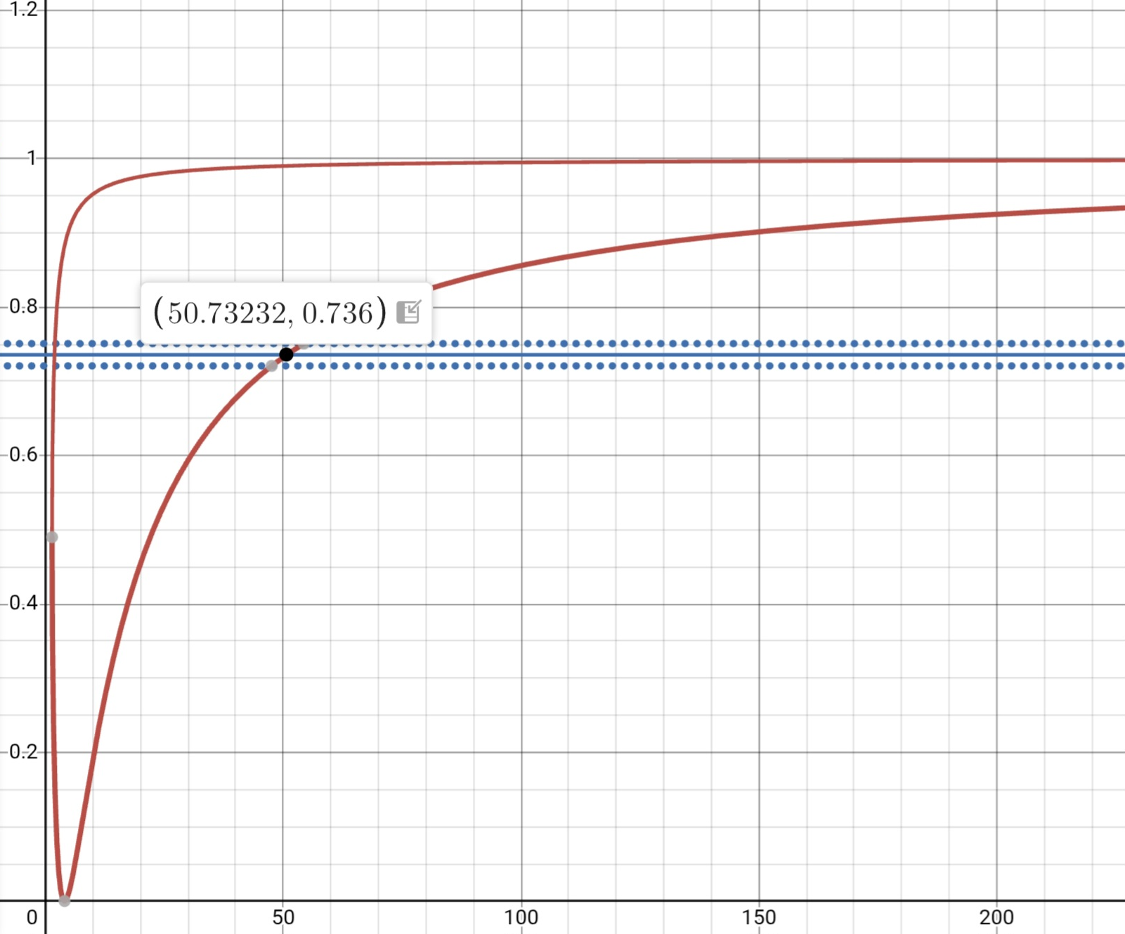
- The resolution in energy for this apparatus is …
- The scattering angle is fixed at 160°; the target is fixed; the beam energy goes from 1100 keV to 2000 keV. Raw plot, integrate the region under the curve on the right side of the spectrum (not the pulser). Compile the column Yield and verify the column Normalized Yield. Check the normalized yield (counts) versus the beam energy. What do you learn?
- Measure the channel on the right side of the “curve”. It is moving from 265 up to 491, is it? Use the calibration line to find E1 and make DeltaE = E1-Ebeam. Check the DeltaE versus beam energy. What do you learn?
- The scattering angle goes from 160° to 110°; the target is fixed (bulk gold); the beam energy is fixed at 1.6 MeV. Raw plot, integrate the region under the box from a fixed channel (like 260) up the channel on the right side of the spectrum (not the pulser). Compile the column Yield and verify the column Normalized Yield. Check the normalized yield (counts) versus the beam energy. What do you learn?
- Discuss your results. How do we use the Rutherford Back Scattering nowadays?

