A Muon Collider at a high center-of-mass energy, in the multi-TeV range, constitutes a viable option to maintain leadership in particle physics investigation with accelerators, and in particular at CERN where the facility footprint could also exploit existing tunnels.

**Physics potential**

A muon collider operating at a center-of-mass energy of 10 TeV or higher could discover new particles with inaccessible masses, including WIMP dark matter candidates. It offers the opportunity to explore deviations from the Standard Model through precise studies of the Higgs boson, enabling direct observation of double-Higgs production and highly accurate measurements of the triple Higgs coupling. It will uniquely pursue the quantum imprint of new phenomena in novel observables by combining precision with energy. Additionally, it provides exceptional access to new physics coupled to muons and delivers beams of neutrinos with unprecedented properties from the muon decay.

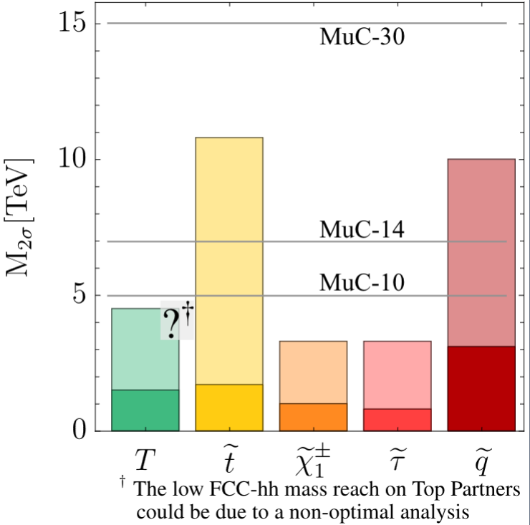

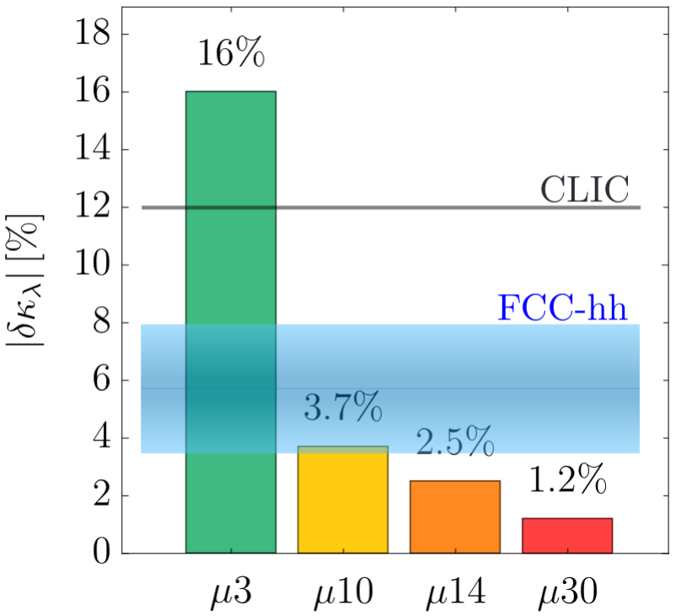

*Left: The HL-LHC (in dark colours) and FCC-hh (in light colours) exclusion mass reach for several beyond the Standard Model particles. The exclusion reach of 10, 14, and 30 TeV muon colliders are reported as horizontal lines. Right: Sensitivity to the Higgs trilinear coupling modifier δκλ of different future collider proposals. A 10 TeV Muon Collider can achieve higher sensitivity than FCC-hh for electroweak susy particles and Higgs trilinear coupling.*

**Long-term perspective**

The Muon Collider is a groundbreaking facility that begins with the development of a few test facilities and a muon cooling demonstrator ultimately aiming to achieve high-energy muon collisions. In the short term, within the next decade, the construction and operation of a “demonstrator” to produce low-emittance and high flux muon beam is foreseen . This effort could proceed in stages, starting with a target and a few cooling cells, along with system integration tests, progressing towards constructing a full-power cooling system.   
If no experimental showstoppers appear, a construction decision for the collider should follow. The accelerator and collider rings can be designed to operate at different initial center-of-mass energies or luminosities, depending on the international context. Furthermore, this facility is not restricted to a center-of-mass energy of 10 TeV; much higher energies may become possible with advancements in accelerator technology.

**Financial and human resources: requirements and effect on other projects**

An evaluation of the cost and human resources is in preparation within IMCC to be provided as ESPPU input.

**Timing**

The technology-driven schedule shown in the figure will be reviewed by IMCC in time for the ESPPU submission, reflecting the phases described in the long-term perspective.

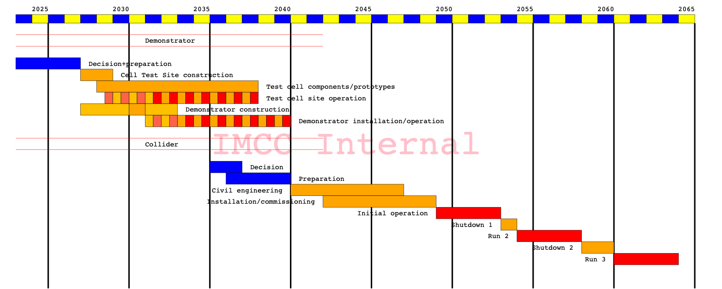

**Careers and training**

The realization of a Muon Collider facility requires extensive studies and R&D across multiple sectors both on accelerators and detectors. Key areas include the target for muon production, the cooling of muon beams, advanced magnets and radio-frequency systems for the accelerator and collider ring, as well as the shielding structures for the detector, to name a few. The Muon Collider facility offers a unique chance to contribute to the design, testing, and integration of a novel accelerator within a relatively short time frame, fostering engagement with pioneering research and development**.**

These activities represent a completely new and challenging field of research, capable of renewing the interest of students and young researchers in accelerator physics and experimental physics at particle accelerators. This initiative provides an invaluable opportunity to develop cutting-edge instruments while gaining hands-on training for the facility's construction.

**Sustainability**

A muon collider is uniquely advantageous.Thanks to the sizable mass of the muon compared to the electron, muon beams can be accelerated to high energy (5 TeV and beyond) in a circular collider with the center-of-mass energy fully available to produce clean events. First, a muon collider has the smallest footprint compared to alternatives with similar physics reach. Second, the luminosity-to-electricity consumption ratio improves as the center-of-mass energy increases, making the muon collider significantly more energy-efficient than other comparable project. Moreover, many components of the machine will operate in pulsed mode, resulting in a low average power consumption. There are several technologies such as HTS for high field magnets development where on-going R&Ds are in synergy with other field of research and transfer to society.