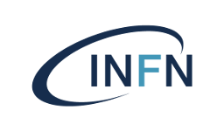**Istituto Nazionale di Fisica Nucleare Laboratori Nazionali di Frascati**

Avviso di Seminario Generale

# Dr. Pavel Fileviez Perez

(Case Western Reserve Univ.)

**On the Origin of Neutrino Masses**

The different theories for neutrino masses are discussed. We show possible connections between the origin of neutrino masses and the properties of dark matter candidates in new theories for physics beyond the Standard Model. We discuss minimal gauge theories for neutrino masses where the neutrinos are predicted to be Dirac or Majorana fermions. We find that the upper bound on the effective number of relativistic species provides a strong constraint in the scenarios with Dirac neutrinos. In the context of theories where the lepton number is a local gauge symmetry spontaneously broken at the low scale, the existence of dark matter is predicted from the condition of anomaly cancellation.  We show that we could test simple gauge theories for neutrino masses at current or  future experiments.

## Mercoledi’ 27/11 ore 14:30 Aula Salvini

https://agenda.infn.it/event/44273/

L'invito è esteso a tutto il personale interessato, che è caldamente invitato a partecipare.