**Continuation of 4 present projects, 4 new ones**

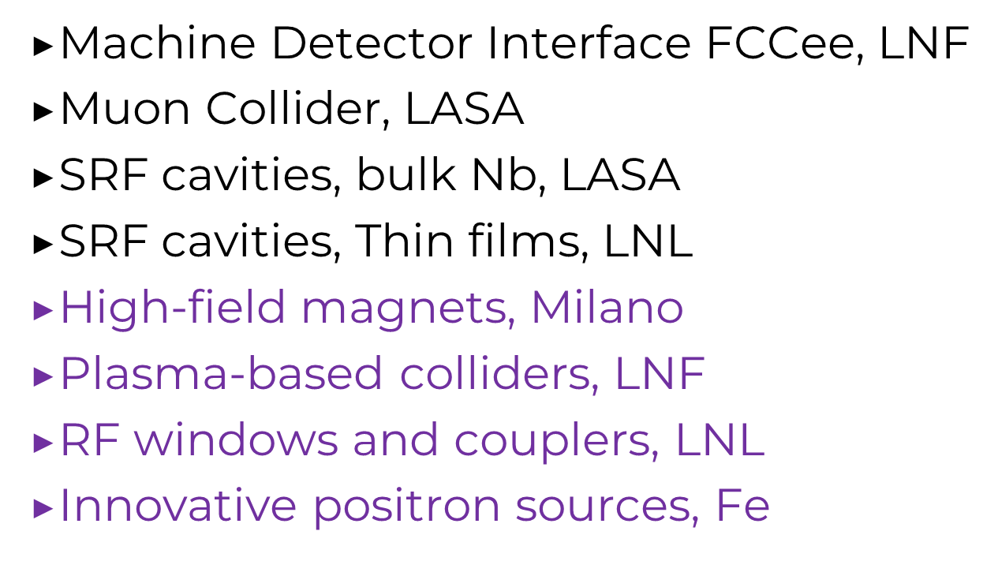

**Other activities in the LNs and LASA (depending on the threshold of our reports): David**

1. **Interaction region for Circular Colliders**

To achieve the required precision on the Physics reach at the e+e- Future Circular Collider (FCC-ee), it is of utter importance the control of the material budget of the beam pipes and the vertex detectors which are intimately nested in the interaction region (IR) of the machine.

The unprecedented luminosity of the FCC-ee, reached also through a very high beam current, together with the small vacuum chamber diameter, induces a considerable power dissipation in the chambers, up to about 500 mW/cm2, which needs to be removed with cooling systems that are as light as possible in term of material budget.

Controlling the material budget requires the development of vacuum chambers of less than 0.5 % of a radiation length, comprising mechanical stability with embedded cooling, representing a considerable challenge compared to the state of the art. Currently INFN is developing a full-scale mockup of the FCC-ee IR led by LNF with the co-participation of Pisa and Perugia.

INFN is strongly interested to further develop this R&D activity by improving the following aspects:

* technical feasibility of IR thin vacuum chambers design and construction
* integrated solutions for vacuum chambers cooling;
* thermal and beam coupling impedance calculations;
* fully integrated lightweight vertex detectors and services;
* validation of assembly with full-scale IR mock-up.

This program is fully embedded within the ECFA DRD8 activity together with other international institutes.

1. **Plasma R&D activities for future colliders**

Plasma accelerators are capable to accelerate extremely short bunches with electric fields of more than 10 GV/m. These properties make plasma accelerators a promising accelerator technology for a more compact, less expensive and more sustainable high-energy linear collider or injectors for circular colliders.

Several large, international projects - at different levels of development - explore some accelerator schemes and address issues relevant for application to particle physics: EuPRAXIA at INFN-LNF, AWAKE at CERN, HALHF in Europe, FACET II in the US.

An intense R&D program is needed towards the demonstration of a plasma-based LC design that, has already anticipated, can be developed in the framework of the EuPRAXIA facility.

INFN is strongly interested to develop these activities and the proposed methodology to design and build advanced plasma components is based on:

* development of theory and simulations for multistage acceleration and muon acceleration;
* realization of high repetition rate capillary prototypes to operate at kHz regime;
* beam manipulation for high efficiency acceleration to reach high *transformer ratio*;
* positron production and acceleration;
* scalable laser driver technology.
* Demonstration of staging

1. **Positron Sources for Future Colliders**

Future colliders require high-intensity, low-emittance positron sources to achieve the luminosity and precision levels necessary for future experiments. Severe heat load and a high density of energy deposited in the target represent a crucial constraint for the achievable intensity in conventional systems. One possibility to overcome such limitations is to exploit the intense channelling radiation in oriented crystals to achieve a high rate of e+e- pairs in a thinner target, thereby strongly decreasing the energy deposited and the peak deposition density (PEDD) in the target, while also permitting to decrease the electron beam current.

The development of positron sources based on oriented crystals represents a significant technological advancement, with substantial impacts on both particle physics and collider design.

INFN is strongly interested in developing these activities. They are focused on:

* study of hybrid sources that combine the use of oriented crystal radiator with an amorphous converter;
* prototyping using granular and/or rotating converter targets to distribute the thermal load;
* study of single crystal sources for circular collider, allowing to insert the crystal target directly into the magnetic matching used to capture the highly divergent positron beam;
* development of advanced simulations integrated into the Geant4 toolkit and RF-track;
* irradiation test to assess the target’s durability and the resilience of its crystalline structure.

1. **Radiofrequency studies in High Magnetic Field for Muon cooling channel towards a Demonstrator Facility**

A multi-TeV Muon Collider requires dedicated R&D to demonstrate the feasibility of the production channel of muon beams of small emittance and high flux.

The first relevant step along this path is indeed to design a full muon cooling channel demonstrator. A muon cooling channel consists essentially of absorbers, focusing magnets and RF cavities.

In this scheme the performance of the RF cavities is critical, since in the presence of a strong magnetic field, they become much more susceptible to the breakdown phenomena.

Limits have never been explored experimentally at the field levels required in the muon cooling cells (>30 MV/m). The lack of experimental data and, as a consequence, the difficulties to develop and verify theoretical models of the involved phenomena need to be addressed on a short timescale.

In the frame above discussed, there are different lines of R&D activities of INFN interest:

* test of RF cavities at different frequencies with electric field larger than 30 MV/m embedded in strong (> 7 T) magnetic field to develop BDR models;
* design and fabricate single and multi cells structures and fabricate SC HTS large bore solenoids (>400 mm).

The use of HTS magnets (20K) is mandatory for reason of performance and sustainability .

At present, a first stage for a muon cooling demonstrator line is being considered at CERN and present on-going preparation studies are crucial to define parameters and to establish the plan to exploit such facility.

1. **Bulk Nb superconducting resonators for future colliders.**

Most types of being investigated colliders rely on improved superconducting resonators for efficient particle acceleration (high gain, high quality factor). The activity proposed by the LASA team builds up on the current one and aims to specialize the so far acquired know-how in SRF cavities (fabrication and treatment processes) to those structures operating at the reference frequency of the future HEP machine. Moreover, it is proposed to study those SRF structures, also operating in CW mode, allowing recovery of the beam energy to highly improve acceleration energy efficiency of beams with high average currents (needed for ERL and future linear collider projects such as ReLiC). The main overall goals are:

* to improve the currently achieved performance by improving the quality factor and therefore reducing cryogenic consumption with a view to energy saving (sustainability)
* to transfer this development towards industry production, an expertise for which LASA is at the forefront at present.

In this framework, the realisation of a horizontal cavity test cryomodule is proposed, filling the gap in the European landscape between large-scale horizontal cryostats (CEA, ESS, DESY) and simple vertical immersion cryostats.

The possibilities opened by this infrastructure are multiple and strategic:

* to optimise integration of the and the helium tank
* to study cavity behaviour in its final configuration (horizontal, as in an accelerator), also equipped with a power coupler.
* develop and qualify all RF ancillaries (frequency tuner, piezoelectric actuators, magnetic shield, etc.) for which LASA already has a consolidated experience.

1. **Superconducting resonators with energy saving.**

Although the 2K SRF technology based on bulk Nb cavities remains the state of the art for high energy physics accelerators, the need to make new accelerators more sustainable has led the SRF community to focus its efforts on the search for a technology with higher Tc superconductors, to raise the working T to 4.2-4.5 K. This will allow to achieve a factor 3 reduction in cryogenic costs. Currently, PVD is the most promising technology to deposit Cu-based cavities with Nb3Sn Cu is also a cheaper material than Nb and this will reduce the primary cost item for cavity fabrication. INFN-LNL is a leader in the development of this technology, and the first prototype of a working 1.3 GHz cavity is foreseen in 2025. With the proposed continuation of this activity, it is expected:

* to industrialise the process and make it ready for mass production within the next 5 years; with a positive outcome, the team aims at scaling this technology to whatever frequency will be required by the next HE colliders, including the 400 MHz case for FCC;
* to setup the needed technology for finishing the Cu surface substrate, on which the SRF performance of superconducting films strongly depends; further development of the Plasma Electrolytic Polishing (PEP) is proposed, which promises 10 times quicker treatments, lower roughness than is achieved by so far developed methods and better sustainability, as it is using aqueous saline solutions, instead of concentrated acids.

1. **High Field Magnets in Italy (HFM-I)**

The High Field Magnet project (HFM-I) is the Italian component in the wider European HFM R&D project on high-field magnets for next generation collider. The proposed program has been already discussed and agreed with the HFM management of CERN and a formal agreement is under preparation (approval expected by CERN FC in December 2024). The Italian groups in Genova and Milan-LASA sections are involved in the Falcon-D 12 T dipole project (based on Nb3Sn technology) spanning the period 2019-2026 and half-funded by CERN.

The aim is to develop high-field SC magnets (12-20 T), the fundamental technology for FCC-hh, already recommended in highest priority by the 2020 ESPP update. It is equally significative for a HE-LHC (as possible back-up of FCC-hh). This technology has strong synergy with the magnets for the Muon Collider. In the background, it is also useful for the Chinese SppC project, if this machine were approved. The high-temperature superconductor (HTS) part of the programme is also synergistic with the studies for the FCCee accelerator and for the related detector (IDEA).

Specific goal of HFM-I is, for Nb3Sn, to demonstrate by 2030 that this technology, at 14 T (nominal value for FCC-hh), is ready for the pre-industrialization phase. The foreseen developments are:

* + to design and build a Nb3Sn dipole of the “Cosine theta” type in full scale in section, although of a reduced length, able to operate at 4.2K (instead of 1.9K) with significant energy saving;
  + to build the first Two-In-One FCC dipole for FCC (i.e. hosting two beams, as in the LHC), based on the Nb3Sn coils of the Falcon D project.

On the HTS technology, the HFM-I goal is to develop an accelerator-type magnet in HTS within early 2028, to verify whether HTS can achieve higher fields and operate at 20 K, yielding a ~ factor 10 energy saving factor and in particular:

* to investigate industrial scalability and cost reduction.
* to design and build a feasibility demonstrator, in 1:2 scale in section and about 1 m in length, aiming at 10 T, and 20 K operational temperature.

1. **R&D on RF windows and couplers**

All RF cavities (normal or superconducting) are fed by RF power couplers. To transmit 100’s kW into SRF cavities reliably (with only W’s left in the cold mass) through thin ceramic windows is a delicate R&D topic for future colliders: couplers are the interface between the RF distribution network (in air) and the rf cavities (in ultra-high vacuum). Moreover, in the SRF case the couplers are also at the transition between room temperature and cryogenic temperature. For FCC, in particular, 400 MHz-1 MW-CW and 800 MHz, 250 kW CW SW couplers are foreseen, which is twice the present state of the art on power couplers. INFN has strong competencies in several fields which are crucial for the development of high-power couplers. At LNL, it can leverage on a set of high-power RF amplifiers which enable high-power tests in realistic conditions.

The proposed R&D lines are:

* RF design and studies of the sensitivity of the coupler geometries to MultiPacting (MP), to be conducted in an optimization loop between RF ad particle tracking loop.
* a qualification process for the Ti(N) coating of different shapes of alumina windows (discs, coaxial, cylinders);
* setup of a sputtering facility to perform high quality coating on larger size alumina;
* to develop the brazing process ceramic-to-metal, a key asset for the coupler production and nowadays one of the most time-demanding steps on the procurement chain;
* to perform the coupler high power RF test, to give the final demonstration of the RF coupler compliancy.