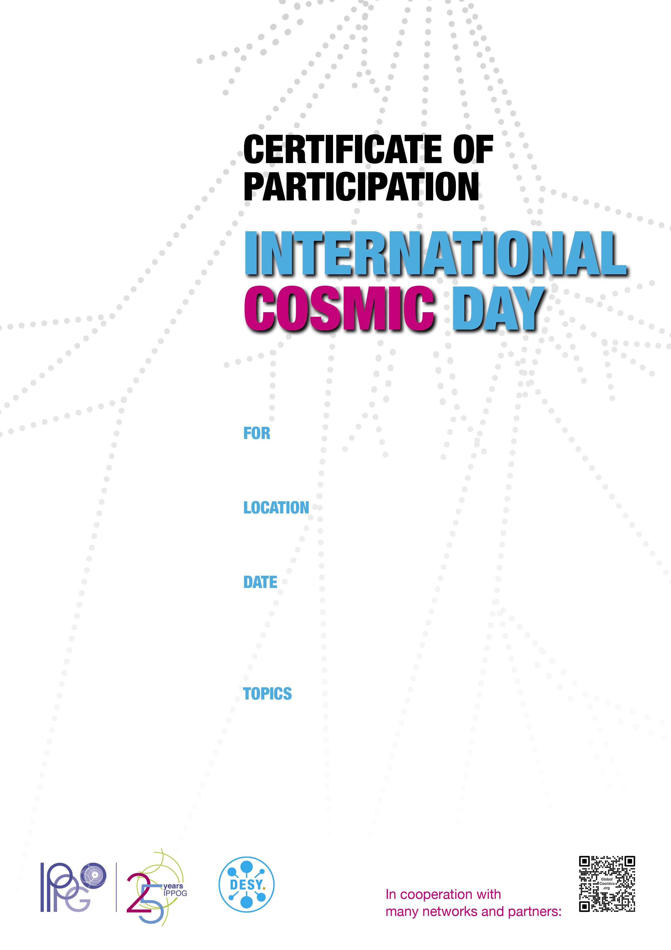

Measurement of Cosmic Rays

Data Analysis

Presentation of Results

November 26 | 2024