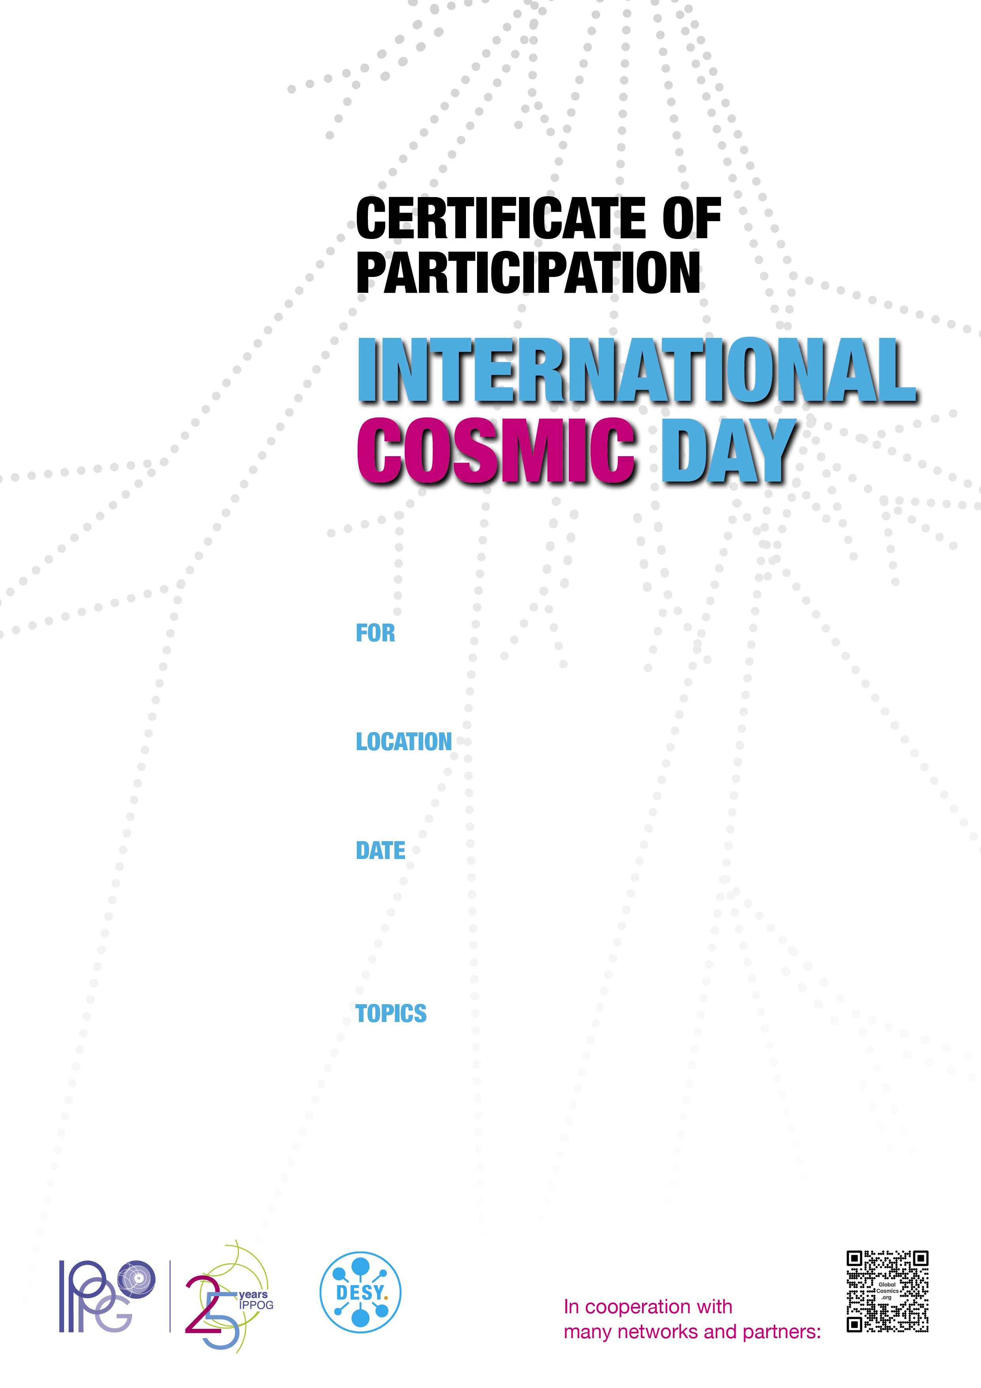

Institute for Fundamental Physics of the Universe, Miramare, Trieste

November 26 | 2024

Measurement of Cosmic Rays

Data Analysis

Presentation of Results