SuperB integration questionnaire

Date: 111111

Sub detector name: Calorimeter

Calorimeter (EMC) consists of three detector components: Forward (FEMC), Barrel (BBEMC), and Backward (BEMC).

Author: Valerio Bocci, Claudia Cecchi, Gerald Eigen, Kevin Flood, Corrado Gargiulo, Frank Porter, Cristostomo Sciacca

**Electronics:**

Number of electronic channel:

Barrel – 5760x2 = 11,520

Forward – 4500x2 = 9,000

Backward – 1152 assuming one piece, will be more if split into halves

Power dissipated per channels:

**Barrel – Babar preamps: 2 x 50 mW/xtal (source: Babar NIM, §9.2.5)**

**Babar ADBs: 3 kW per end-flange (ibid.)**

**Backward – 1152 preamps times 50 mW/preamp (60 W total) on outer radius of calorimeter near the readout MPPC’s. Power to calibration boards to be checked. SPIROC board power to be checked.**

Volume occupied by the electronics (drawings of electronic modules):

Backward – No realistic drawings exist, see sketch below. SPIROC electronics (ADCs and TDCs) conceptual design is to mount on back of BEMC. Alternatively could be moved further away, would need to be tested. Each SPIROC chip has 36 channels, and each board carries one SPIROC chip. There are thus 32 boards if the calorimeter is not split. There is uncertainty still about whether the serial readout from the SPIROCs will be fast enough, or we need to use more channels. This will be tested. Not clear how SPIROC boards will be mounted/enclosed yet, may need modification; current boards are not crated, connections all sides.

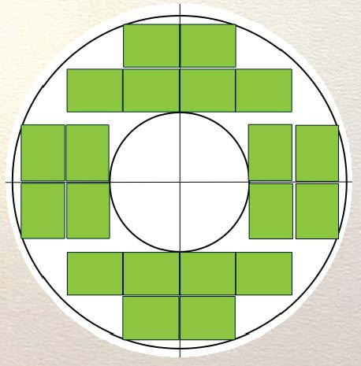 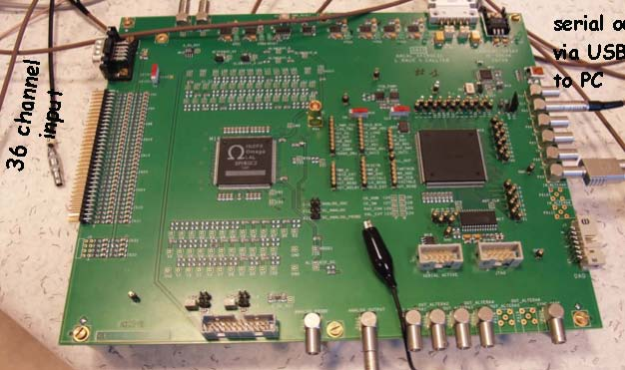

Calibration and monitoring boards (CMB, 2x8 = 16) to be placed on outer radius of BEMC. See sketches below – thick green lines are CMBs. Board size not known (existing ones too large 50 cm x 10-15 cm). Maybe will have more than 16 smaller ones.

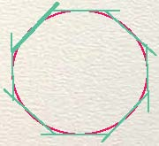 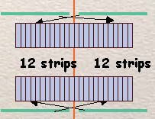

Max tolerable distances between the detectors to the electronic modules:

Backward – See above, to be tested, current assumption is 50 cm maximum cable length, probably could be longer.

Access frequency on the external electronic per year:

**Barrel – “our electronics guys were in that area constantly” (source: former EMC systems manager)**

Backward – SPIROC electronics inside endplate, anticipate no/rare access other than when endplate opened for other reasons.

Frequency access on the detector per year:

Barrel – Preamps/PIN diodes: No access except in case of serious incidents requiring major repairs.

**Barrel – Several non-critical accesses required per year to replace failed ADBs (1 ADB = 12 xtals) in early Babar days, typically done in conjunction when other systems required access; access frequency substantially decreased after ADB design mods were made (ibid.)**

Backward – MPPC readout and preamps will be designed anticipating less than once/year access (we hope never).

Modularity of the electronic unit (housing racks):

Backward - Need rack space for power supplies. Need supplies for SPIROC, CMB, preamps.

**Cables:**

Number and size of power cable:

Backward – Design incomplete with regard to daisy-chaining preamp power. Calibration boards TBD; at most 1 per Calibration board or 16 total. SPIROC boards TBD at most 1/SPIROC or 32 total.

Number and size of Read-out cables or fibers:

Backward – Readout 1152 X 1.5 mm diameter cables from detector to SPIROC chip boards

**Barrel – (1 electronics cable + 1 light pulser fiber) / preamp (source: Babar NIM, Fig. 62).**

**1 flat ribbon cable (~2 cm width) / preamp (source: Babar NIM, Fig. 62)**

Number and size of slow control cables:

Backward – Thermocouple cables (12); SPIROC control (3x32=96); CMB (16)

Minimum bending radius.

Backward – Readout are coax ribbon, pretty stiff, spec unknown.

Shielding requirements (thermal and electrical)

Backward – Electrical not designed; will need to incorporate shielding in design. Thermal shielding – SiPM bias will be corrected for T changes, no thermal shielding requirement foreseen.

Information drawings on the cable distribution on the detector geometry:

Barrel:

Forward:

Backward: No drawings exist.

**Cooling system.**

Requirement of cooling system:

Barrel: **preamp heat removed by conduction to module strong back which are directly cooled using fluorinert; digitizing electronics housed in 80 mini-crates, each in contact with the end-flange support structure, cooled by chilled water flow through channels milled into the end-flanges close to the inner and outer radii (source: Babar NIM, §9.2.5)**

Forward:

Backward: No requirement for an active cooling system anticipated.

Power, flow, temperature and type of fluid:

Allowed detector temperature variations:

Size of the chiller:

Cooling pipes distribution at sub detector ends (drawings):

**Describe other requirements that have an impact of the space available like auxiliary equipment, minimum space for accessibility, etc**

Forward/Barrel - In addition to the requirements above, the barrel and forward calorimeter will have a radioactive source calibration system that will have significant requirements for space and assembly. The design is along the lines of the existing system for BaBar. A schematic of the system is shown below:

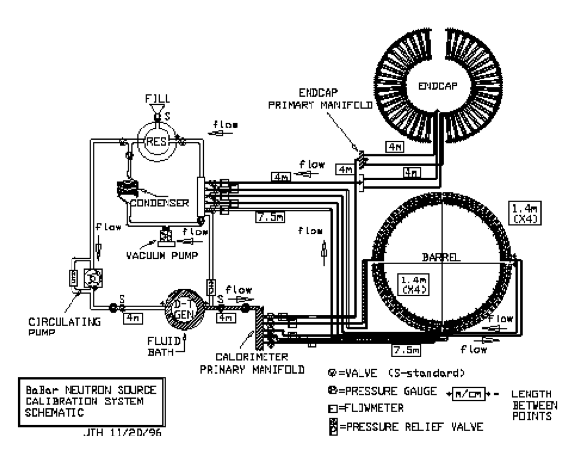

A comment on this figure is that the vacuum pump/condenser system to evacuate the lines through the detector was never implemented. We should discuss whether this feature is needed in SuperB.

When operating, high fluorine (eg, flourinert) coolant is pumped through deuterium-tritium (DT) generator at approximately 3.5 l/s. Plumbing takes fluid to manifolds on the detector. Interface to barrel crystal loops is via flexible stainless transitions. See pictures:



The DT generator should be as close to the detector as possible, with plumbing to detector as straight as possible to minimize transit distance following irradiation of the fluid. In BaBar, the maximum distance was 11.5 m (needs to be checked). The return lines may be longer.

The DT generator resides in a bunker for radiation protection. This should be designed in concert with the appropriate health physics specialists. Nominally, the requirement is for 1 m (needs to be checked) equivalent concrete neutron absorber surrounding the DT generator. In addition, the DT generator is cabled to a remotely-located (that is, outside the radiation wall) HV source, of order 100 kV.



Backward – The backward calorimeter baseline design is such that it captures the beam pipe.

**Describe other requirements that have an impact of the space available like space for the commissioning operations and assembly.**

Backward – Anticipate building in a location other than collider hall. This location could be another institution or on the laboratory site. Will need to be tested with sources and/or cosmic rays on site before installation into detector.