Grant Agreement No: 101004761

AIDAinnova

Advancement and Innovation for Detectors at Accelerators

Horizon 2020 Research Infrastructures project AIDAINNOVA

deliverable report

**Report on prototypes construction, performance and assessment of industrialisation**

Deliverable: D8.2

|  |  |
| --- | --- |
| Document identifier: | AIDAinnova-Del-D8-2v1.0(1) |
| Due date of deliverable: | End of Month 35 (02/ 2024) |
| Justification for delay: | [if delays occurred] |
| Report release date: | dd/mm/yyyy |
| Work package: | WP8: Calorimetry and Particle Identification detectors |
| Lead beneficiary: | CERN |
| Document status: | Draft [Final when fully approved] |

Abstract:

New materials for high precision timing and/or for use in future calorimeters have been tested in the various laboratories and prototypes have been built and tested under high energy particle beams. This document summarises the results obtained with the prototypes and provides some input for the selection of the best materials, taking into account both performance and production capability.

AIDAinnova Consortium, yyyy

For more information on AIDAinnova, its partners and contributors please see <http://aidainnova.web.cern.ch/>

The Advancement and Innovation for Detectors at Accelerators (AIDAinnova) project has received funding from the European Union’s Horizon 2020 Research and Innovation programme under Grant Agreement no. 101004761. AIDAinnova began in April 2021 and will run for 4 years.

Delivery Slip

|  |  |  |  |
| --- | --- | --- | --- |
|  | Name | Partner | Date |
| Authored by | R. Cala‘, L. Martinazzoli, E. Auffray  Xx, M. Nikl  Xx, G. Tamulaitis,  Xx C. Cecchi,  Xx, M. Moulson  Xx N. Pastrone,  Xx, S. Brovelli  Xx, S. Sykorova | CERN  IP_ASCR  Vilnius  INFN Perugia,  INFN Frascatti  INFN Torino  GlasstoPower  Crytur | 20/12/23 |
| Edited by | E. Auffray | [Short name] | dd/mm/yy |
| Reviewed by | E. Auffray [Task coordinator]  R. Pöschl [WP coordinator]  K. Krüger [WP coordinator]  R. Ferrari [WP coordinator  I. Surname [Scientific coordinator] | CERN  CNRS/IJCLab  DESY  INFN/Padova | dd/mm/yy |
| Approved by | I. Surname [Scientific coordinator]  Steering Committee |  | dd/mm/yy |

TABLE OF CONTENTS

1. Introduction 4

2. Main RESUlts on materials 1 5

2.1. Institute 1 5

2.2. Institute 2 5

3. Main results on Prototypes 5

3.1. INFN Frascati and Glass To Power **Error! Bookmark not defined.**

3.1.1. Heading level 3 **Error! Bookmark not defined.**

4. Production 10

4.1. Material 1 10

4.2. Material 2 10

4.3. Material 3 10

5. FUTURE PLANS / Conclusion / relation to other AIDA-2020 work 11

6. References 12

Annex: Glossary 14

Executive summary

*[This text (in italics for emphasis) needs to summarise the entire deliverable document in a clear, succinct form.*

*It could have short paragraphs, each paragraph summarising the content of one section in the document, so that the main points are covered.*

*Please note that this deliverable report will be publicly available on the AIDAinnova website and will also be sent to the European Commission]*

# Introduction

Activities of AIDAinnova WP8 focus on the development of calorimeters and particle identification detectors for future experiment in high energy physics (HEP). Light based detectors are potential technology studied in the task 8.3. Future detectors in HEP required radiation hard scintillating materials with ultrafast timing response. Several materials were tested various laboratories with the set-ups described in Milestone MS32 [1] and prototypes have been built and tested under high energy particle beams. The description of the different tested prototypes is presented in the following sections as well as well as the possible production capability of the studied materials.

# Main RESUlts on materials

## Institute 1

[Text]

Fig. 1 Image captions.

## Institute 2

[Text]

* **Bulleted list:** text
* **Bulleted list:** text
* **Bulleted list:** text
* **Bulleted list:** text

# Main results on Prototypes

**3.1 INFN FRASCATI AND GLASS TO POWER**

Due to the high quantum yield and relative ease of manufacture of semiconductor nanocrystals (“quantum dots”), there is much interest in their possible application for the development of high-performance scintillators and scintillating components (wavelength shifters, scintillating films) for use in high-energy physics instrumentation. Nanocomposite scintillators can be obtained by casting nanocrystals into a transparent polymer matrix, to obtain materials functionally similar to conventional plastic scintillators. Since inorganic nanocrystals can potentially have O(100 ps) light decay times and O(1 MGy) radiation resistance, nanocomposite scintillators could prove to be ideal for the construction of high-performance detectors that are economical enough to be used for large-volume applications. However, while nanocomposite scintillators have been the focus of much attention in the materials-science community, few previous studies have focussed on the response of these materials to high-energy particles. The goal of the NanoCal project is to evaluate the potential for the use of nanocomposite scintillators in calorimetry. To this end, fine-sampling shashlyk calorimeter prototypes are being constructed with both conventional and NC scintillators and tested side-by-side with electron and minimum-ionizing particle beams, allowing the performance gains obtained from the use of NC scintillators to be directly measured. NanoCal is an AIDAinnova WP 13.5 blue-sky project but is directly related to the work on nanocomposite scintillating materials and their industrialization carried out in WP 8.3.1.

### Development of nanocomposite scintillators

Nanocrystals of caesium lead bromide (CsPbBr3) were previously used to make scintillating nanocomposites with radioluminescence light yield on the order of 10,000 photons/MeV and emission decay times of a few ns [2], so the scintillators under investigation in the NanoCal project are based on these nanocrystals. These nanocrystals absorb strongly in the near-UV to blue regions and have an emission peak in the green at 520 nm.

In view of the encouraging results obtained with CsPbBr3 nanocrystals in PMMA reported in [2], the nanocomposite used the first NanoCal prototypes (constructed as discussed in the following section) consisted of 0.2% (w/w) CsPbBr3 nanocrystals in a UV-cured PMMA matrix (Fig. 1). As discussed 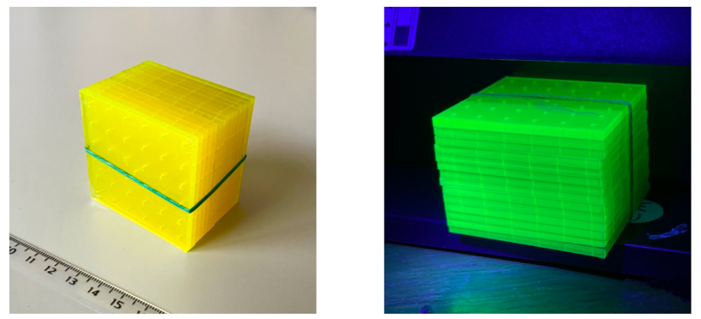below, tests with mips in the CERN H2 beamline and with cosmic rays showed a disappointing light yield from these prototypes, and laboratory tests with radioactive sources and cosmic rays demonstrated that the light yield from the scintillator was lower than expected. Two possible causes were identified:

*Figure 1* Shashlyk tiles made of CsPbBr3 nanocomposite scintillator, in ambient light (left) and under ultraviolet light (right).

1. Excessive self-absorption of the light emitted by the nanocrystals.
2. Inefficient transfer of energy deposited in the plastic matrix to the nanocrystals and/or insufficient concentration of nanocrystals for efficient stimulation by ionization energy losses from single particles.

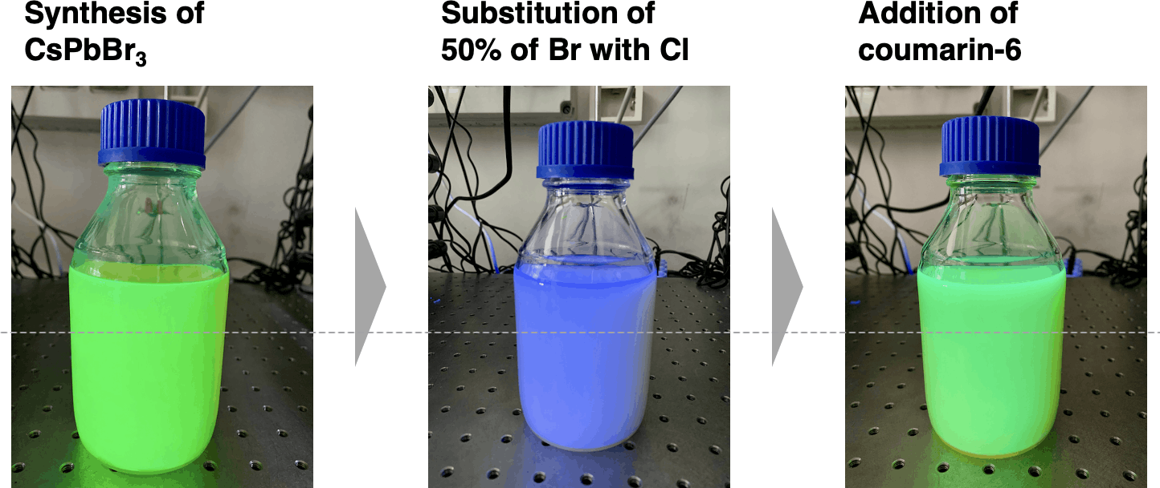The issue of self-absorption can be addressed by the addition to the composite of dyes with large Stokes shift, as in a conventional scintillator. However, because the CsPbBr3 nanocrystals emit at 520 nm, it is difficult to implement two stages of wavelength shifting (one each in the scintillator and in the readout fibres) while still maintaining good photodetector response. A possible solution is illustrated in Fig. 2: the spectral response of the CsPbBr3 nanocrystals is shifted to the blue by the substitution of about half of the bromine atoms with chlorine after production. Then, a WLS compound, coumarin-6, is added to the solution to provide a large Stokes shift, which also restores the emission of the nanocomposite to about 520 nm. A prototype based on this principle was tested, as discussed below.

Figure 2 Preparation of monomer solution for nanocomposite with caesium lead halide perovskite with coumarin-6 WLS.

Regarding the second point, PMMA does not have the aromatic structure of polystyrene (PS) or polyvinyltoluene (PVT) and so does not have the level structure for excitation by ionizing radiation and de-excitation via Foerster transfer to the nanocrystals, as occurs between the aromatic rings and primary fluors for a conventional scintillator. Fluorescence in PMMA-based nanocomposites is expected to occur primarily from the directly stimulation of the nanocrystals by the incident radiation. The simplicity of this mechanism, combined with the good optical and physical properties of PMMA gives rise to the fast deexcitation times and robust nature of PMMA-based nanocomposites. However, the concentration of the nanocrystals may be insufficient for direct stimulation. Because CsPbBr3 nanocrystals have poor thermal stability, it is convenient to produce the nanocomposites by UV polymerization, but the absorption of UV light by the nanocrystals limits their concentration to a fraction of a percent.

The poor thermal stability of CsPbBr3 nanocrystals is the result of degradation or detachment of the ligands at the surface of the nanocrystals at the temperatures required for thermal polymerization. One solution to this problem is to use surface ligand engineering techniques to passivate the surfaces of the nanocrystals with metal ions [3]. The nanocrystals with improved stability can then be used to make thermally polymerized composites, allowing not only PMMA, but also aromatic plastics such as PS or PVT, to be used for the matrix, opening the possibility of efficient Foerster energy transfer from the matrix to the nanocrystals.

To test these ideas, small samples of various scintillators were produced and exposed to 1-5 GeV electron and mip beams in the CERN PS T9 beamline in October 2023 and to 450 MeV electrons at the Frascati BTF in November 2023, as well as to cosmic rays. The scintillator samples, shown in Fig. 3, include two nanocomposites, labelled “Bic 4” and “Bic 5”, made with CsPbBr3 nanocrystals passivated with ytterbium ions (obtained from XXX) and thermally polymerized in PVT at a concentration of 1%. Both samples contain 1.5% PTP to assist with the energy transfer to the nanocomposites; the sample labelled “Bic 5” additionally contains a small amount of the perylene dye described above, which shifts the emission to orange. The figure also shows various samples of custom-produced conventional organic scintillators: “Protvino”, a PVT scintillator with 1.5% PTP and 0.04% POPOP as fluors (as in [4]), “Bic 1”, a blue scintillator using a benzothiophene dye, and “Bic 2” and “Bic 3”, two green scintillators based on coumarin-6, the dye used to shift the emission from CsPb(Br,Cl)3 from blue to green in Fig. 2. While the data are still under analysis, preliminary results indicate that the nanocomposite scintillators have a light yield of about 60% of that of the “Protvino” control sample (with 10-20% spectral corrections). An additional result is that “Bic 3”, which contains 0.04% coumarin-6 and 0.04% of the benzothiophene dye, as well as 1.5% PTP, gives 160% of the light output of the Protvino scintillator, making this sample an interesting candidate for study as a high-yield conventional green scintillator in its own right.

Figure 3 Conventional organic and nanocomposite scintillator samples tested in fall 2023 at CERN and Frascati.

The surfaces of the nanocrystals can also be passivated with a halide-rich surface layer. A series of nanocomposite scintillator samples made with fluorine passivated CsPbBr3 nanocrystals at various concentrations in PVT, with and without additional dyes, has been prepared in preparation for a series of measurements with 450 MeV electron beams at the Frascati BTF in February 2024 (Fig. 5). These measurements, together with those carried out in fall 2023, will allow a systematic optimization of the choice of nanoparticle and any additional fluors. Once a suitable nanocomposite scintillator has been identified, it will be possible to construct a test module such as those previously tested with the A group of glass jars with blue labels
PMMA-based nanocomposites, as further described in the next section.

Figure 4 Samples of CsPbBr3 nanocomposites at concentrations of 1.0-2.5% with with and without PTP and/or perylene dyes, together with control samples containing no nanocrystals Light yields for these samples will be measured at the Frascati BTF in February 2024.

### Construction of shashlyk calorimeter prototypes with innovative scintillators

To establish a baseline for the understanding of the issues involved in constructing calorimeter modules with NC scintillator, various small test assemblies have been constructed. These consist of a short, fine sampling shashlyk stack of about 5 cm in thickness (about 1.5*X*0) based on the design for the PANDA forward spectrometer electromagnetic calorimeter [5], which was originally developed for the KOPIO experiment [4]. The thicknesses of the scintillator tiles and lead absorber foils are 1.5 mm and 0.275 mm, respectively, for a sampling fraction of about 39%. The tiles are 55x55 mm2 in cross section and feature 36 1.3-mm holes for the shashlyk fibres. The first module to be constructed was a control module made with tiles of conventional extruded polystyrene scintillator from the PANDA prototypes, with 1.5% PTP and 0.04% POPOP as fluors. This scintillator has an emission peak at 425 nm; Kuraray Y-11(200) blue-to-green wavelength shifting fibres (WLS) were used for light readout.

The nanocomposite scintillators for the test modules were obtained by UV polymerization between glass plates of the solution of CsPbBr3 nanocrystals in the MMA monomer (Fig. 5, left). The shashlyk tiles (see Fig. 1) were then laser cut from the resulting sheet of material. To read out the 520-nm green light from the nanocrystals, a custom production was commissioned from Kuraray of a 1-mm single clad WLS fibre dyed with the perylene dyad described in [2] at a concentration of 200 ppm; this fibre is referred to as NCA-1(200). An additional module was constructed with Kuraray’s existing O-2(100) green-to-orange WLS fibre as a point of comparison. The light from the fibres was read out with a Hamamatsu 13360-6050 SiPMs (6×6 mm2, 50 𝜇m pixel size) and a fast amplifier with a gain of 4. The fibres were bundled into a ferrule for coupling to the SiPM with optical grease. The shashlyk stacks for a few of these modules are shown in Fig. 2.

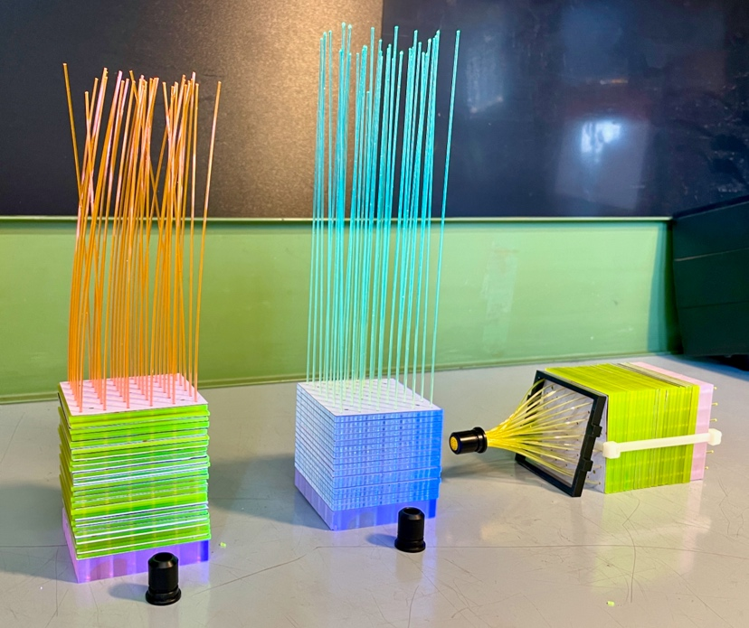The completed prototypes were tested at CERN with 80 GeV *e*− and 150 GeV *π*+ beams in the SPS H2 beamline in October 2022. A second round of tests of prototypes improved on the basis of the experience gained in October 2022 was carried out in June 2023 with 1-4 GeV *e*+ and 10 GeV *μ*+ beams in the PS T9. In this second round, a module constructed with the coumarin-6 wavelength-shifted CsPb(Br,Cl)3 nanocomposite was also tested to evaluate this strategy for overcoming light loss from self-absorption. Unfortunately, the nanocrystals aggregated into clumps between synthesis and polymerization of the solution, so that only limited conclusions may be drawn concerning the performance of this module.

Figure 6 Setup used for the measurements of light yield in beam tests in the T9 beamline. S1 and S2 are trigger scintillators, C1 and C2 are 10x10 cm2 silicon-strip tracking chambers with thickness 820 μm and position resolution 47 μm, T0 is a fast-timing detector, PbGl is a lead glass calorimeter for energy measurements, and the grey boxes are moveable tables.

Figure 4 Left: UV polymerization of a sheet of nanocomposite scintillator (CsPbBr3 0.2% in PMMA). Right: Shashlyk assemblies tested with electron and mip beams and cosmic rays, during construction: the nanocomposite scintillator with NCA-1 WLS fibres (left), conventional scintillator (1.5% PTP + 0.04% POPOP in polystyrene) with Y-11 fibres (centre), and nanocomposite scintillator with O-2 fibres (right).

A typical setup for the beam tests is shown in Fig. 6. The tracking provided by the silicon-strip chambers C1 and C2 allows the clean definition of a fiducial region for particles hitting the test module and has sufficient position and angular resolution to resolve components such as optical fibers, allowing the source of the light produced in the module to be discriminated (e.g., whether from scintillating tiles or WLS fibres). This is illustrated in Fig. 7, which shows the efficiency map obtained by illumination of the CsPb(Br,Cl)3 + WLS module with 10 GeV muons and a threshold set at 5 times the RMS of the dark noise from the SiPM. Virtually all of the light is produced in the optical fibres in the stack or in the bundle at the rear; very little of the light comes from the bulk of the nanocomposite scintillator. This result is characteristic of the PMMA-based nanocomposite scintillators tested: as a rule, when exposed to single mips, the PMMA-based nanocomposites at nanocrystal concentrations of 0.2% produce at most a few percent of the light obtained from conventional scintillators. In the particular case of the CsPb(Br,Cl)3 + WLS module, the poor performance may result from the problems encountered during production, so this nanocomposite formulation may still be viable and further investigation is planned. As noted in the previous section, PVT-based, thermally polymerized nanocomposites with surface-passivated CsPbBr3 nanocrystals show much more promise, and after further study and optimization of these materials, another round of prototypes A comparison of a graph
will be constructed and tested.

Figure 7 Response efficiency maps of shashlyk test modules illuminated with 10 GeV muons. The control module with conventional organic scintillator (“Protvino”, left) shows highly efficient and uniform response to mips over the entire surface, while for the module with the nanocomposite scintillator (right), only the WLS fibres show efficient response to mips.

# Production

## Material 1

## Material 2

## Material 3

# FUTURE PLANS / Conclusion / relation to other AIDA-2020 work

[Text to end the document, either mentioning future plans, some sort of conclusion or how this work relates to other work within the AIDAinnova project. Use your judgement to find a suitable heading for a short end-section for the deliverable]

# References

[1]. Auffray E et al. (2022)

*Test benches for testing detecting materials in picosecond and sub-picosecond domains*

AIDAinnova-Milestone 32

[2] Gandini, M., et al. (2020) “Efficient, fast and reabsorption-free perovskite nanocrystal-based sensitized plastic scintillators”, Nat. Nanotechnol. 15, pp. 462-468.

[3] Zhang, C., et al. (2019) “Critical role of metal ions in surface engineering toward brightly luminescent and stable cesium lead bromide perovskite quantum dots”, ***Nanoscale* 11**, pp. 2602-2607.

[4] Atoian, G.S., et al. (2008) “An improved shashlyk calorimeter”, Nucl. Instrum. Meth A 584, pp. 291-303.

[5] Singh, B. et al. [PANDA Collaboration] (2017) “Technical Design Report for the PANDA Forward Spectrometer Calorimeter”, <http://arxiv.org/abs/1704.02713v1>.

AIDAinnova references are based loosely on the Harvard System of referencing. In the text, references should be marked by numbers in square brackets [x]. Then in this “references” section, they are listed by number using the following styles:

JOURNAL ARTICLES:

[x] Author’s surname, Author’s initials. (Year of publication) Article title, *Journal title*, volume (issue), page numbers.

e.g. [1] Katz, U.F. (2006) KM3NeT: Towards a km3 Mediterranean neutrino telescope, *Nuclear Instruments and Methods in Physics Research Section A: Accelerators, Spectrometers, Detectors and Associated Equipment*, 567 (2), pp 457-461.

CONFERENCE PAPERS

[x] Author’s surname, Author’s initials. (Year of publication) Title of contribution. In: Editor of Conference proceeding (Initials, Surname with ed(s) if relevant/available). *Title of Conference proceeding*, date and/or place of conference. Place of publication: Publisher (if known), Page(s) of contribution if available.

e.g. [2] Medjoubi, K. et al. (2011) Performance and Applications of the CdTe- and Si-XPAD3 photon counting 2D detector. In: *Journal of Instrumentation (JINST) Open Access Conference Proceedings of 12th International Workshop on Radiation Imaging Detectors (IWORLD)*, 11-15 July 2010, Cambridge, UK. UK: Institute of Physics (IOP), 6 C01080 <http://iopscience.iop.org/1748-0221/6/01/C01080/>

REPORTS

Author’s surname, Author’s initials, (Year of report) *Title in italics*, Issuing organisation, report number, pages.

e.g. [3] SuperB Collaboration (2007) *Super-B, a High Luminosity Super Flavour Factory, Conceptual Design Report*, INFN/AE - 07/2, SLAC-R-856, LAL 07-15 <http://arxiv.org/abs/0709.0451v2>

BOOKS:

[x] Author’s surname, Author’s initials. (Year of publication) *Title in italics*. Edition (if not the first). Place of publication: Publisher.

e.g. [4] Grupen, C. and Shwartz, B. (2011) *Particle Detectors (Cambridge Monographs on Particle Physics, Nuclear Physics and Cosmology)*, Paperback, 2 edition, UK: Cambridge University Press

EDITED BOOKS

[x] Author’s surname, Author’s initials. (Year of publication) Title of chapter. In Editor’s surname, Editor’s initials (ed.) *Title in italics*. Edition (if not the first). Place of publication: Publisher, Page numbers of chapter.

e.g. [5] Charpak, G. (2010) Particle detectors and society. In Cashmore, R., Maiani, L. and Revol, J-P (eds.) *Prestigious Discoveries at CERN: 1973 Neutral Currents. 1983 W & Z Bosons*, Paperback, Germany: Springer, pp. 135-146.

WORLD WIDE WEB DOCUMENTS

Author’s surname, Author’s initials. (Year) *Title or main heading of web page in italics* [online]. Available from: URL. [Accessed date].

The URL should be given to the specific page, not a generic website for the organisation.

If an author is not available it is common to use the organisation name e.g. BBC or Anon.

e.g. [6] Wyles, N. (2011) *AIDA - Advancing European particle detector research* [online]. Available from: <http://www.alphagalileo.org/ViewItem.aspx?ItemId=94835&CultureCode=en> [Accessed 18 February 2011].

NEWS ARTICLE

Author’s surname, Author’s initials. (Year of publication) Title of Article. *Title of Newspaper in italics*. Day published, page number (if available).

e.g. [7] Wyles, N. (2011) AIDA – pushing the boundaries of European particle detector research, *CERN Bulletin*, 11 February 2011, p. 6.

# Annex: Glossary

|  |  |
| --- | --- |
| Acronym | Definition |
| xxx | Definition of xxx |
|  |  |
|  |  |
|  |  |