Grant Agreement No: 101057511
EURO-LABS
EUROpean Laboratories for Accelerator Based Science
HORIZON-INFRA-2021-SERV-01-07 Project EURO-LABS

Milestone report

Facilities ready to receive TA requests

milestone: MS17
Document identifier: | EURO-LABS_Milestone_MS17_v0.1.docx
Due date of deliverable: | End of Month 6 (Febuary 2023)
Justification for delay: | [if delays occurred]
Report release date: | dd/mm/yyyy
Work package: | WP 3 : Access to RIs for Accelerator R&D
Document status: | Draft

Abstract:
The present document reports on the readings of the Research Infrastructures participating to the Work Package 3 of EURO-LABS. .

EURO-LABS Consortium, 2023
For more information on EURO-LABS, its partners and contributors please see https://web.infn.it/EURO-LABS/

The EUROpean Laboratories for Accelerator Based Science (EURO-LABS) project has received funding from the European Union’s Horizon 2020 Research Infrastructure (RI) services advancing frontier knowledge under Grant Agreement no. 101057511. EURO-LABS began in September 2022 and will run for 4 years.

Delivery Slip
 | Name | Partner | Date
Authored by | ??? | [Short name] | 15/01/2023
Edited by | N. Charitonidis [Task 3.1]  Sylvie Leray [Task 3.2]  Anthony Gleeson [Task 3.3]  Urszula Gryczka [Task 3.4] | CERN  CEA  UKRI  INCT | dd/mm/yy
Reviewed by | I. Efthymiopoulos [WP3 coordinator] | CERN | dd/mm/yy
Approved by | A. Navin [Scientific coordinator]  Steering Committee |  | dd/mm/yy

TABLE OF CONTENTS
1. Introduction 5
2. WP3 – Task 3.1 6
1.1. USP 6
2.1.1. Facilities 6
3. WP3 – Task 3.2 7
1.2. USP 7
3.1.1. Facilities 7
Annex: Glossary 9

Executive summary
The key goal of the EURO-LABS project is to provide Transnational Access (TA) to major Research Infrastructures (RI) in Europe. WP3 groups thirteen facilities focused on High-Energy Accelerator Research. The document provides the status of the facilities at the startup of the project, and the readiness to receive and provide TA requests.

The document includes sections per Task. For what concerns the composition of the USP, the document will be updated in the course of the project if changes occur.

Introduction
EURO-LABS is a network of 33 research and academic institutions (25 beneficiaries and 8 associated partners) from 18 European and non-EU countries, involving 47 Research Infrastructures within the Nuclear physics, Accelerators and Detectors pillars. In this large network, EURO-LABS will ensure diversity and actively support researchers from different nationalities, gender, age, and variety of professional expertise.

EURO-LABS aims at fostering the sharing of knowledge and technologies across scientific fields to enhance synergies and collaborations between the RIs of the Nuclear and High Energy communities. Within EURO-LABS the Work-Package 3 (WP3) will provide Transnational Access (TA) to Research Infrastructures for Accelerator R&D.

WP3 will provide TA to a broad spectrum of installations, to test concepts for future accelerators, based on improving the present facilities, and for R&D studies for future colliders like CERN/FCC or the Muon Collider. These facilities will provide beam lines for testing advanced accelerator materials, superconducting or normal Radio-Frequency cavities, magnets and acceleration schemes. These tests use different particles and energies (low-energy protons, low-energy electrons, ultra-soft electron bunches and high-intensity high-energy electrons and could also have connections to industrial applications.

WP3 – Task 3.1

USP
Explain Composition
Frequency of meetings

Facilities

HiRadMat
Photo of the facility
Figure 1- View of the facility

Paragraph 1 : Short description of the facility

Paragraph 2 : Status of the facility

Paragraph 3 : Expected users – “publicity” done or planned to promote the TAs

WP3 – Task 3.2

USP

Explain Composition
Frequency of meetings

Facilities

FREIA
Photo of the facility
Figure 1- View of the facility

Paragraph 1 : Short description of the facility

Paragraph 2 : Status of the facility

Paragraph 3 : Expected users – “publicity” done or planned to promote the TAs

INFN-LASA
Photo of the facility
Figure 1- View of the facility

Paragraph 1 : Short description of the facility

Paragraph 2 : Status of the facility

Paragraph 3 : Expected users – “publicity” done or planned to promote the TAs

INFN-THOR
Photo of the facility
Figure 1- View of the facility

Paragraph 1 : Short description of the facility

Paragraph 2 : Status of the facility

Paragraph 3 : Expected users – “publicity” done or planned to promote the TAs

IJCLAB-SUPRATECH
Photo of the facility
Figure 1- View of the facility

Paragraph 1 : Short description of the facility

Paragraph 2 : Status of the facility

Paragraph 3 : Expected users – “publicity” done or planned to promote the TAs

CEAR/irfu-synergium
Photo of the facility
Figure 1- View of the facility

Paragraph 1 : Short description of the facility

Paragraph 2 : Status of the facility

Paragraph 3 : Expected users – “publicity” done or planned to promote the TAs

XBOX
Photo of the facility
Figure 1- View of the facility

Paragraph 1 : Short description of the facility

Paragraph 2 : Status of the facility

Paragraph 3 : Expected users – “publicity” done or planned to promote the TAs

WP3 – Task 3.1
………………….

WP3 – Task 3.4

USP
The following persons were invited and agreed to be members of TASK 3.4 Users selection panel:
- Ilias Efthymiopoulos – coordinator of WP 3
- Urszula Gryczka – RAPID facility coordinator
- Roberto Corsini – CLEAR facility coordinator
- Angeles Faus-Golfe – external expert (CNRS/In2p3-Orsay)
- Rob Edgecock – external expert (HUD)
The members of the USP, apart from the representative of the facilities, are external experts, specialized in development of accelerators and electron beam applications.
The meetings of the TASK 3.4 USP are planned to be organised every 3 months, or more often, depending on the number of submitted projects. The meetings will be organised virtually, but also evaluation of each project by USP members via emails is considered, to avoid delays in project evaluation. The first USP task 3.4 meeting is planned to be organised in March 2023.

Facilities

RAPID
a) b)
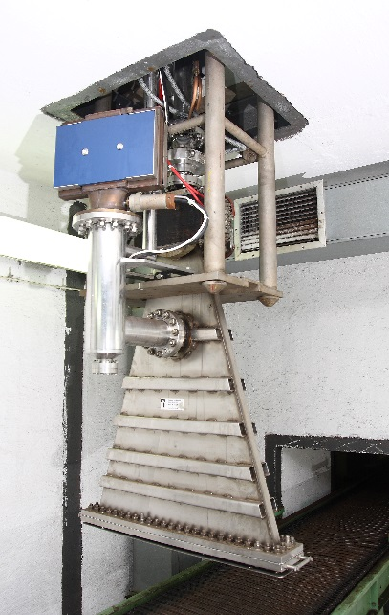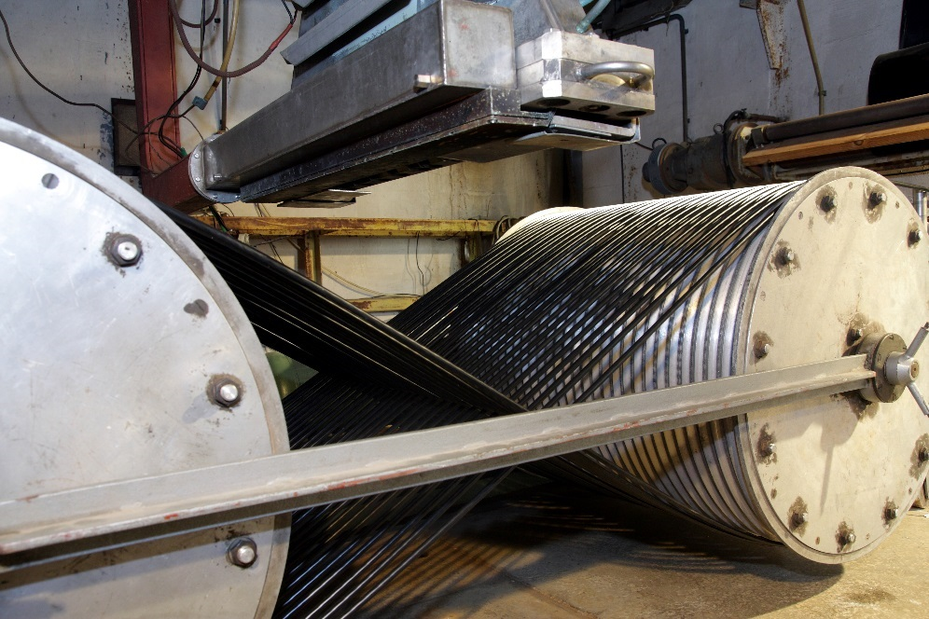
c)
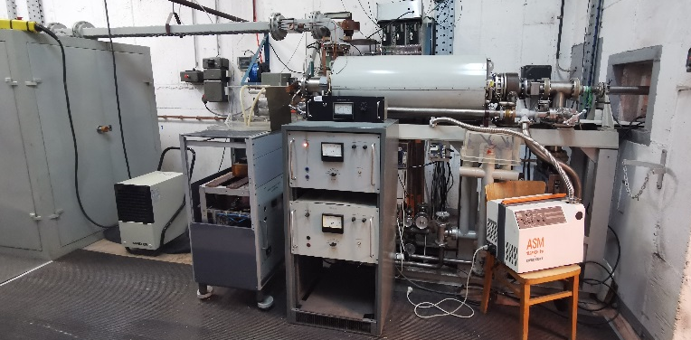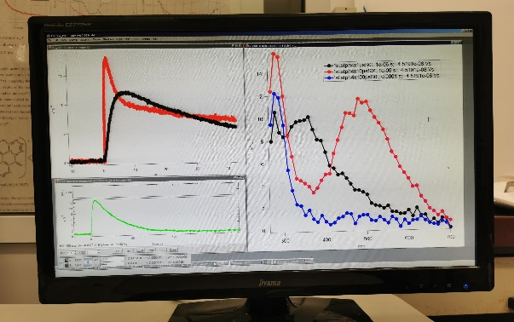
d)
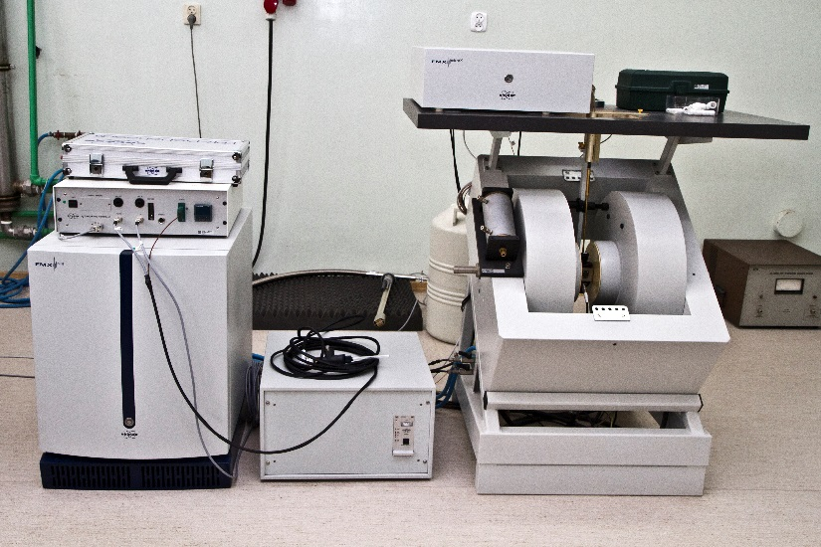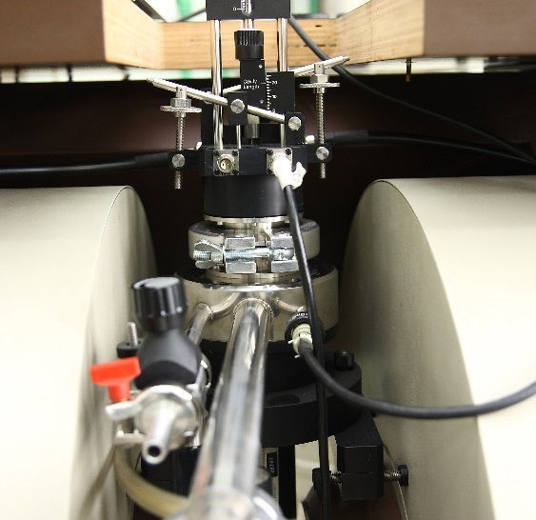
Figure 1- View of the RAPID facility: a) Elektronika 10-10 electron beam accelerator b) ILU-6 electron beam accelerator with wire crosslinking instalation, c) LAE 10 accelerator for nano-second pulse radiolysis experiments, d)Electron Spin Resonance spectroscopy.
Short description of the facility
The RAPID Centre for Radiation Research and Technology facility is part of the INCT infrastructure localised in Warsaw, Poland. With the EURO-LABS project WP 3 “Access for Accelerators” Task 3.4 “Application” INCT offers access to:
- linear electron beam accelerator LAE 10 with nanosecond pulse radiolysis UV/VIS detection set-up. Pulse radiolysis is an invaluable tool for studying the kinetics and spectra of transient chemical species in chemistry and biochemistry.
- ELEKTRONIKA 10-15 linear electron beam accelerator (Toriy, Russia) which emits beam of electron of energy 10 MeV, beam power up to 15 kW. The processing parameters with the electron beam of energy 10 MeV allows to irradiation bulk materials having high density, with the dose ranging from 0,5 to 40 kGy in one pass or as accumulated dose ranging hundreds of kGy. The installation is used for radiation sterilization and microbial decontamination of solids and liquids, for modification and degradation of polymeric materials.
- A pilot plant facility equipped in ILU 6 accelerator. The accelerator can emit a beam of electrons of energy ranging from 0,15 to 2 MeV, beam power up to 20 kW. The experimental works and demonstration, which can be performed with the use of ILU-6 accelerator and additional systems include irradiation of gas, liquid and solid type of products. The area of research supported by ILU 6 includes environmental applications to eliminate chemical or microbial contaminants from different media.
Additional infrastructure to support experiments: electron spin resonance spectroscopy, gamma cells, infrastructure of the Laboratory for Measurements of Technological Doses (ISO Accredited), apparatus for material characterization – DSC, TGA, GC, DRS, gas chromatography (GC), mechanical and rheological tests, dynamic contact angle measurements.

Status of the facility
The facility is ready to accept proposals for TA. The projects submitted will be evaluated by EURO-LABS INCT Scientific Committee. The members of the committee are representatives of each unit (4 persons) and facility coordinator. The Scientific Committee is responsible for evaluation of the scientific value of the project and allocation of the beam time.

Promotion of the project
The inflation on the project and application procedure is posted on the INCT web page: http://www.ichtj.waw.pl/drupal/?q=node/1267
The inflation on the EURO-LABS project was shared with the community involved in research and development activities in the field of radiation processing such as participants of the IAEA projects (RAR 1021, CRP 61025).
Also the project was promoted on the webpage of the Polish Nuclear Society: https://ptnukleoniczne.pl/2022/10/03/rusza-projekt-euro-labs/
It is planned to promote EURO-LABS project during NUTECH2023 conference, organised on 20-22 of September 2023 in Cracow, Poland.

CLEAR

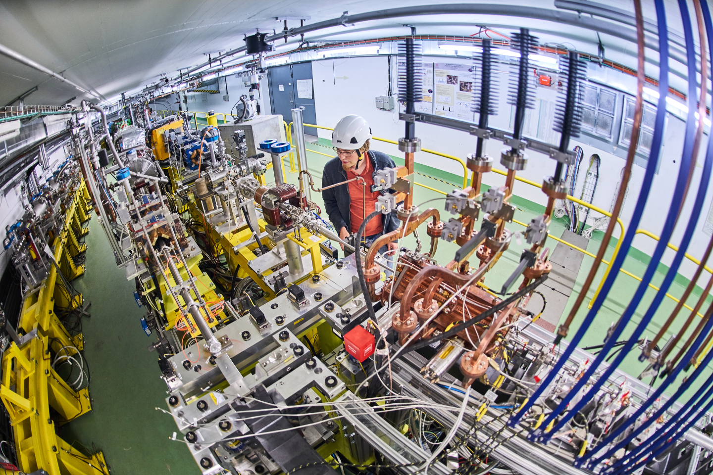
Figure 1- View of the CLEAR facility
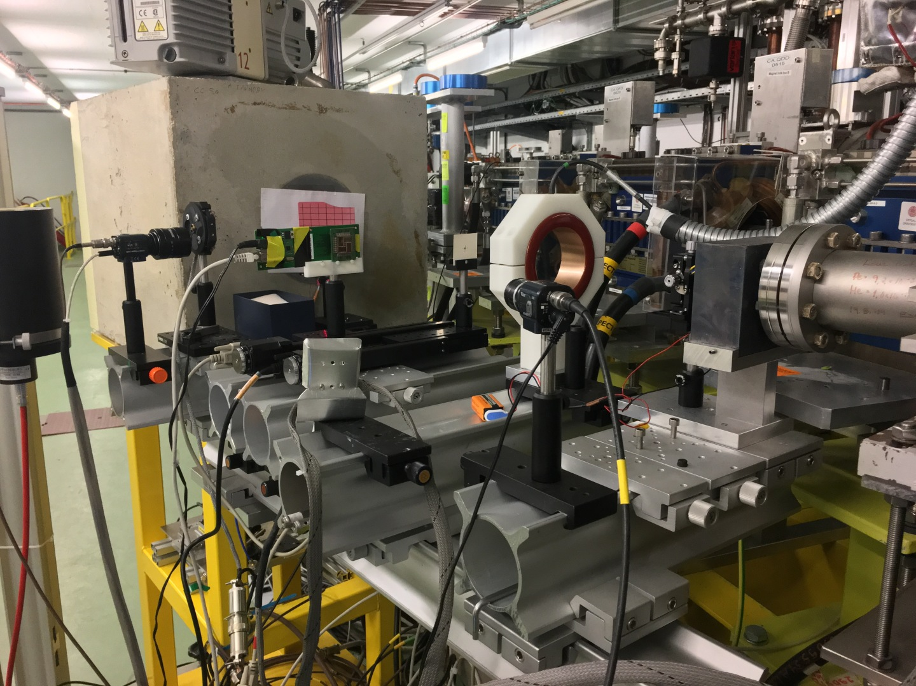
Figure 2 – The VESPER beam line in CLEAR

Short description of the facility
The CERN Linear Electron Accelerator for Research (CLEAR) is an electron test facility aimed at developing instruments and components for existing and future accelerators, testing novel concepts as plasma and THz acceleration, investigating medical applications of electron beams including dosimetry and FLASH radiotherapy, studying radiation hardness of electronics for aerospace and high energy applications, and training the next generations of accelerator physicists.
CLEAR is composed by a versatile 200 MeV electron linac + a 20 m experimental beamline, and it is operated at CERN as a multi-purpose user facility.
Additional information is available on the CLEAR web site: https://clear.cern

Status of the facility
The facility is ready to accept proposals for TA.
The present planning of the facility operation includes:
Beam Commissioning: ~27/02/2023 - ~03/03/2023
Beam for Users: ~06/03/2023 - ~01/12/2023.
Any user willing to access the facility has to fill-up a beam time request form (https://clear.cern/content/beam-time-request), specifying experiment description, scientific aim and justification, needed beam parameters, experimental apparatus and logistics.
The CLEAR Scientific Board (CSB) periodically reviews the progress of the experimental program, steers the experimental program, and gives recommendations on proposed experiments and activities based on their scientific interest and the availability of the facility. The Scientific Board members participate to the formal approval process of the beam time requests.
The CLEAR Technical Board is responsible to give the final authorization and allocate the beam time in the schedule, after checking technical feasibility and scientific interest and safety and RP issues, following guidelines by the CLEAR Scientific Board.

Promotion of the project

- The aim of the project and details about eligibility and application procedure are posted on the CLEAR web page:
https://clear.cern/content/euro-labs
https://clear.cern/content/beam-time-request
- A mail has been sent to the mailing list of the CLEAR User community, including past and projected users, also detailing the project and the application procedure.
- It is planned to promote EURO-LABS during the VHEE/FLASH Workshop, being organised at DESY in June 2023.
- Information on EURO-LABS and application formalities to CLEAR will also be disseminated at the IPAC23 Conference, 7 - 12 May 2023, Venice, Italy.

Annex: Glossary

Acronym | Definition
TA | Transnational Access
VA | Virtual Access
RI | Research Infrastructure

