Grant Agreement No: 101057511
EURO-LABS
EUROpean Laboratories for Accelerator Based Science
HORIZON-INFRA-2021-SERV-01-07 Project EURO-LABS

Milestone report

Facilities ready to receive TA requests

milestone: MS19
Document identifier: | EURO-LABS_Milestone_MS19_v0.1.docx
Due date of deliverable: | End of Month 6 (Febuary 2023)
Justification for delay: | [if delays occurred]
Report release date: | dd/mm/yyyy
Work package: | WP 3 : Work on Service Improvements Started
Document status: | Draft

Abstract:
The present document reports on the service improvements planned for the RI Facilities participating to the Work Package 3 of EURO-LABS. Detais of the proposed activities, budget and schedule are presented.

EURO-LABS Consortium, 2023
For more information on EURO-LABS, its partners and contributors please see https://web.infn.it/EURO-LABS/

The EUROpean Laboratories for Accelerator Based Science (EURO-LABS) project has received funding from the European Union’s Horizon 2020 Research Infrastructure (RI) services advancing frontier knowledge under Grant Agreement no. 101057511. EURO-LABS began in September 2022 and will run for 4 years.

Delivery Slip
 | Name | Partner | Date
Authored by | ??? | [Short name] | 15/01/2023
Edited by | N. Charitonidis [HiRadMat]  Rocio Santiago Kern, Tommaso Bagni [FREIA]  Dario Giove [INFN-LASA]  Umberto Gambardella [INFN-THOR]  Sylvie Leray [CER/lrfu-Synergium]  Robert Ruprecht [KIT-ALFA]  Sandrine Dobosz Dufrénoy [LIDYL-LPA-UHI100] | CERN  UU  INFN-MI  INFN-USa  CEA  KIT  CEA | dd/mm/yy
Reviewed by | I. Efthymiopoulos [WP3 coordinator] | CERN | dd/mm/yy
Approved by | A. Navin [Scientific coordinator]  Steering Committee |  | dd/mm/yy

TABLE OF CONTENTS
1. Introduction 5
2. DATA SUMMARY 7
2.1. DATA PRODUCED WITHIN EUROLABS WORKPACKAGES 7
2.1.1. WP 1 7
2.1.2. WP 2 8
2.1.3. WP 3 8
2.1.4. WP 4 8
2.1.5. WP 5 8
2.2. Data from Research InfraStructures 9
3. FAIR DATA 10
3.1. Making data findable, including provisions for metadata 10
3.2. Making data accessible 10
3.3. Making data interoperable 10
3.4. Increase data re-use 10
4. Data Security 10
5. Ethics 10
Annex: Glossary 14

Executive summary
The key goal of the EURO-LABS project is to provide Transnational Access (TA) to major Research Infrastructures (RI) in Europe. WP3 groups thirteen facilities focused on High-Energy Accelerator Research. The document details the proposed work to improve the existing facilitys to the profit of the users. The expected budget, resources and schedule for the planed activities is presented.

The document includes sections per facility having proposed service improvements. For what concerns the composition of the USP, the document will be updated in the course of the project if changes occur.

Introduction
EURO-LABS is a network of 33 research and academic institutions (25 beneficiaries and 8 associated partners) from 18 European and non-EU countries, involving 47 Research Infrastructures within the Nuclear physics, Accelerators and Detectors pillars. In this large network, EURO-LABS will ensure diversity and actively support researchers from different nationalities, gender, age, and variety of professional expertise.

EURO-LABS aims at fostering the sharing of knowledge and technologies across scientific fields to enhance synergies and collaborations between the RIs of the Nuclear and High Energy communities. Within EURO-LABS the Work-Package 3 (WP3) will provide Transnational Access (TA) to Research Infrastructures for Accelerator R&D.

WP3 will provide TA to a broad spectrum of installations, to test concepts for future accelerators, based on improving the present facilities, and for R&D studies for future colliders like CERN/FCC or the Muon Collider. These facilities will provide beam lines for testing advanced accelerator materials, superconducting or normal Radio-Frequency cavities, magnets and acceleration schemes. These tests use different particles and energies (low-energy protons, low-energy electrons, ultra-soft electron bunches and high-intensity high-energy electrons and could also have connections to industrial applications.

LPA-UHI100

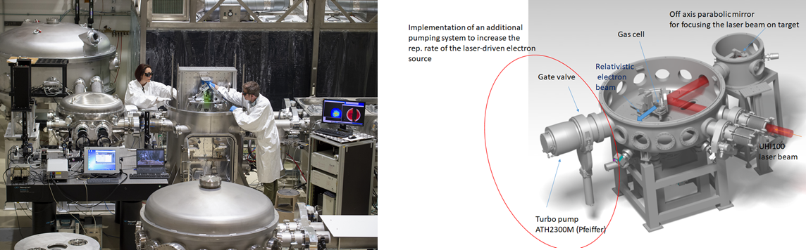
Figure 1- left: view of the radioprotected experimental room for electron source acceleration- © L. Godart/CEA , right: sketch of a part of the service improvements (increase of the pumping speed to increase the repetition rate)

The LPA-UHI100 facility delivers electron source in the 100MeV range, issued from laser-plasma acceleration mechanism. The maximum repetition rate of the source is directly linked to the repetition rate of the laser itself. Most of the laser-driven electron source are generated from Ti:Sapphire laser system, delivering from few to 100’s of TW power. The maximum repetition rate of such system is generally around 10 Hz, but the electron source doesn’t often exploit this property as it requires a specifically designed target coupled to very demanding pumping system.
Increasing the frequency of the electron source is a big issue, in particular for medical applications or even for material testing. We propose to boost the pumping system of the interaction chamber hosting the acceleration process to work at 1Hz (instead of 0,03Hz which is our actual rep. rate). This will offer new possibilities for data accumulation and then could attract more users on the facility. And in addition, this is the less costly solution before changing the driving laser for higher frequency system, keeping the same level of power. If the addition of one new turbo pump to the existing system is not enough to reach the 1 Hz repetition rate, we plan to design and implement a differential pumping system. The last point to take care to is the loss of reflectivity of the last compressor grating (meaning degradation of the electron acceleration process) due to a potential carbon burns that can be due to pollution of the vacuum chambers combined to the high repetition rate.
To overcome this problem, we investigate a new solution consisting to implement a system that deliver oxygen leakage in the compressor chamber to avoid the carbon deposition on gratings.

22k€ allocated for service improvement on LPA-UHI100
Planning | Budget | Tasks
April 2023 | 5k€ | Overall maintenance, and cleaning of a turbo pump ATH2300M Pfeiffer that has been given to our team (reorganization and retirement…)
May 2023 | 7k€ | Design and implementation of the turbo pump (gate valve, connectors, pump) on the experimental chamber dedicated to laser-driven electron source
Sept 2023 | 5k€ | Differential pumping system design and implementation if 1Hz is not yet accessible after the addition of the turbo pump ATH2300M
Dec. 2023 | 5k€ | Implementation of a cleaning system on the compressor to preserve the reflectivity of the overall ensemble and guarantee the efficiency of laser-driven particle source generation.

Annex: Glossary

Acronym | Definition
TA | Transnational Access
VA | Virtual Access
RI | Research Infrastructure

