Grant Agreement No: 101057511
EURO-LABS
EUROpean Laboratories for Accelerator Based Science
HORIZON-INFRA-2021-SERV-01-07 Project EURO-LABS

Milestone report

Facilities ready to receive TA requests

milestone: MS17
Document identifier: | EURO-LABS_Milestone_MS17_v0.1.docx
Due date of deliverable: | End of Month 6 (Febuary 2023)
Justification for delay: | [if delays occurred]
Report release date: | dd/mm/yyyy
Work package: | WP 3 : Access to RIs for Accelerator R&D
Document status: | Draft

Abstract:
The present document reports on the readings of the Research Infrastructures participating to the Work Package 3 of EURO-LABS. .

EURO-LABS Consortium, 2023
For more information on EURO-LABS, its partners and contributors please see https://web.infn.it/EURO-LABS/

The EUROpean Laboratories for Accelerator Based Science (EURO-LABS) project has received funding from the European Union’s Horizon 2020 Research Infrastructure (RI) services advancing frontier knowledge under Grant Agreement no. 101057511. EURO-LABS began in September 2022 and will run for 4 years.

Delivery Slip
 | Name | Partner | Date
Authored by | ??? | [Short name] | 15/01/2023
Edited by | N. Charitonidis [Task 3.1]  Sylvie Leray [Task 3.2]  Anthony Gleeson [Task 3.3]  Urszula Gryczka [Task 3.4] | CERN  CEA  UKRI  INCT | dd/mm/yy
Reviewed by | I. Efthymiopoulos [WP3 coordinator] | CERN | dd/mm/yy
Approved by | A. Navin [Scientific coordinator]  Steering Committee |  | dd/mm/yy

TABLE OF CONTENTS
1. Introduction 5
2. DATA SUMMARY 7
2.1. DATA PRODUCED WITHIN EUROLABS WORKPACKAGES 7
2.1.1. WP 1 7
2.1.2. WP 2 8
2.1.3. WP 3 8
2.1.4. WP 4 8
2.1.5. WP 5 8
2.2. Data from Research InfraStructures 9
3. FAIR DATA 10
3.1. Making data findable, including provisions for metadata 10
3.2. Making data accessible 10
3.3. Making data interoperable 10
3.4. Increase data re-use 10
4. Data Security 10
5. Ethics 10
Annex: Glossary 14

Executive summary
The key goal of the EURO-LABS project is to provide Transnational Access (TA) to major Research Infrastructures (RI) in Europe. WP3 groups thirteen facilities focused on High-Energy Accelerator Research. The document provides the status of the facilities at the startup of the project, and the readiness to receive and provide TA requests.

The document includes sections per Task. For what concerns the composition of the USP, the document will be updated in the course of the project if changes occur.

Introduction
EURO-LABS is a network of 33 research and academic institutions (25 beneficiaries and 8 associated partners) from 18 European and non-EU countries, involving 47 Research Infrastructures within the Nuclear physics, Accelerators and Detectors pillars. In this large network, EURO-LABS will ensure diversity and actively support researchers from different nationalities, gender, age, and variety of professional expertise.

EURO-LABS aims at fostering the sharing of knowledge and technologies across scientific fields to enhance synergies and collaborations between the RIs of the Nuclear and High Energy communities. Within EURO-LABS the Work-Package 3 (WP3) will provide Transnational Access (TA) to Research Infrastructures for Accelerator R&D.

WP3 will provide TA to a broad spectrum of installations, to test concepts for future accelerators, based on improving the present facilities, and for R&D studies for future colliders like CERN/FCC or the Muon Collider. These facilities will provide beam lines for testing advanced accelerator materials, superconducting or normal Radio-Frequency cavities, magnets and acceleration schemes. These tests use different particles and energies (low-energy protons, low-energy electrons, ultra-soft electron bunches and high-intensity high-energy electrons and could also have connections to industrial applications.

WP3 – Task 3.1

USP

Composition
Frequency of meetings

Facilities

HiRadMat @ CERN
Photo of the facility
Figure 1- View of the facility

Paragraph 1 : Short description of the facility

Paragraph 2 : Status of the facility

Paragraph 3 : Expected users – “publicity” done or planned to promote the TAs

WP3 – Task 3.3

USP

Following discussion with the Task 3 Facility coordinators and wider EUROLABS management, the following nominations have been put forward for the composition of the WP3.3 User Selection Panel (USP):

- Florian Burkart (DESY)
- Sandrine Dobosz Dufrenoy (CEA)
- Leonida Gizzi (CNR-INO)
- Anthony Gleeson (STFC)
- Shaukat Khan (Dortmund)
- Riccardo Pompili (INFN-LNF)
- Markus Ries (HZB)
- Robert Ruprecht (KIT)

Ilias Efthymiopoulos (CERN) will monitor USP meetings to provide oversight of the process and ensure compliance with EUROLABS selection criteria.

Once formally accepted, any subsequent changes to the make-up of the panel (e.g. due to retirement, re-allocation, illness) will be by mutual agreement of the USP. The USP will meet regularly (at least every six months) to review TA applications across all the facilities covered in Task 3.. Interim ad-hoc meetings may be required if a rapid decision is critical in order to enable a User Group access to a facility. The USP will endeavour to make use of suitable tools to make the review process as efficient and effective as possible.

The USP will be responsible for determining suitability and eligibility for access to EUROLAB transnational funding to undertake user experiments. Technical suitability, safety assessment and scheduling will remain the responsibility of the individual facilities.

. Facilities

CLARA @ UKRI STFC Daresbury
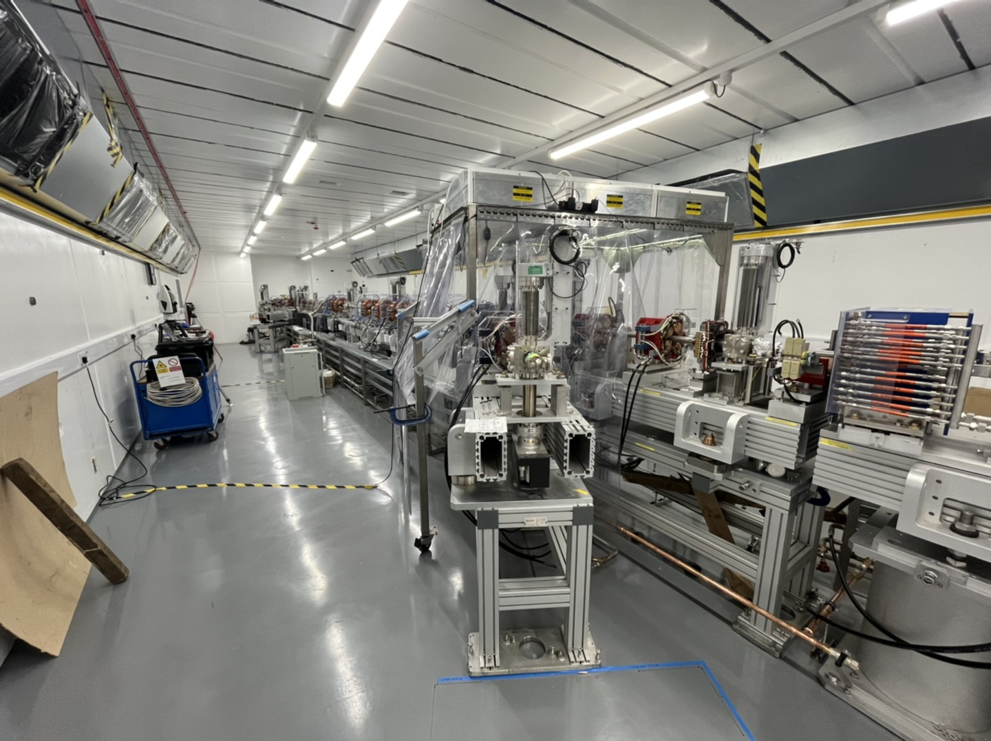
Figure 1- View of the CLARA facility (phase 2 construction)

CLARA (Compact Linear Accelerator for Research and Applications) is a high performance, modular injector facility capable of delivering a highly stable, highly customisable, short pulse, high quality electron beam to a series of test enclosures. The principal aim of CLARA is to test advanced free-electron laser (FEL) schemes, which can later be implemented on existing and future short wavelength FELs. CLARA will facilitate research into the underlying beam dynamics and accelerator technology sub-system challenges in photoinjector, RF acceleration, timing and synchronisation, beam diagnostics, accelerator controls and feedback processes. The facility uniquely combines a highly customisable femtosecond electron beam with fully configurable test enclosures. In addition, access can be offered to the accelerator hall to allow direct adaptation of the accelerator system to trial new accelerator technology solutions or novel concepts.

The CLARA team are currently commissioning the in-house designed high repetition rate electron gun. Other progress is focussed upon preparation for the shutdown to ensure efficient and effective progress through this period and into the subsequent commissioning period. The shutdown is planned between March and October 2023, leading to a twelve-month commissioning period of the entire CLARA facility. The earliest anticipated initial experimental period for CLARA is September 2024.

For each beamtime allocation period (6 months) beamtime, whether academic, industrial or internal R&D is allocated under review by an STFC internal panel against agreed assessment criteria. It can be expected that Transnational Access would be allocated a ring-fenced number of days in each allocation period, dependent on the level of funding provided, for their dedicated use. If the number of allocations fell short of the assigned limit, the days would be left available for short-notice experiments. From an industrial perspective, usage of CLARA is not restricted to any market sector or size of business – all are eligible to apply for access. Academic usage will be broadened through the publication of regular calls for applications. STFC will use its well-developed global presence (web, social media, conferences and workshops) to publicise such calls, as well as notification of the availability of transnational funding schemes to encourage their uptake.

INFN @ Milano
Photo of the facility
Figure 1- View of the facility

Paragraph 1 : Short description of the facility

Paragraph 2 : Status of the facility

Paragraph 3 : Expected users – “publicity” done or planned to promote the TAs

Annex: Glossary

Acronym | Definition
TA | Transnational Access
VA | Virtual Access
RI | Research Infrastructure

