Grant Agreement No: 101057511
EURO-LABS
EUROpean Laboratories for Accelerator Based Science
HORIZON-INFRA-2021-SERV-01-07 Project EURO-LABS

Milestone report

Work on Service Improvements Started

milestone: MS19
Document identifier: | EURO-LABS_Milestone_MS19_v0.1.docx
Due date of deliverable: | End of Month 6 (Febuary 2023)
Justification for delay: | [if delays occurred]
Report release date: | dd/mm/yyyy
Work package: | WP 3 : Access to RI for Accelerator R&D
Document status: | Draft

Abstract:
The present document reports on the service improvements planned for the RI Facilities participating to the Work Package 3 of EURO-LABS. Details of the proposed activities, budget and schedule are presented.

EURO-LABS Consortium, 2023
For more information on EURO-LABS, its partners and contributors please see https://web.infn.it/EURO-LABS/

The EUROpean Laboratories for Accelerator Based Science (EURO-LABS) project has received funding from the European Union’s Horizon 2020 Research Infrastructure (RI) services advancing frontier knowledge under Grant Agreement no. 101057511. EURO-LABS began in September 2022 and will run for 4 years.

Delivery Slip
 | Name | Partner | Date
Authored by | ??? | [Short name] | 15/01/2023
Edited by | N. Charitonidis [HiRadMat]  Rocio Santiago Kern [FREIA]  Dario Giove [INFN-LASA]  Umberto Gambardella [INFN-THOR]  Sylvie Leray [CER/lrfu-Synergium]  Robert Ruprecht [KIT-ALFA]  Sandrine Dobosz [LIDyl-LPA-UHI100] | CERN  UU  INFN-MI  INFN-USa  CEA  KIT  CEA | dd/mm/yy
Reviewed by | I. Efthymiopoulos [WP3 coordinator] | CERN | dd/mm/yy
Approved by | A. Navin [Scientific coordinator]  Steering Committee |  | dd/mm/yy

TABLE OF CONTENTS
1. Introduction 5
2. Hiradmat - cern 6
3. FREIA – UU 7
4. INFN-LASA – IT 8
5. INFN-THOR – IT 9
6. CEa/lrfu-Synergium – fR 10
7. KIT-ALFA(KARA – FLUTE) – GE 11
8. CEA/LIDyl-LPA-UHI100 – FR 12
Annex: Glossary 13

Executive summary
The key goal of the EURO-LABS project is to provide Transnational Access (TA) to major Research Infrastructures (RI) in Europe. WP3 groups thirteen facilities focused on High-Energy Accelerator Research. The document details the proposed work to improve the existing facilities to the profit of the users. The expected budget, resources and schedule for the planned activities is presented.

Introduction
EURO-LABS is a network of 33 research and academic institutions (25 beneficiaries and 8 associated partners) from 18 European and non-EU countries, involving 47 Research Infrastructures within the Nuclear physics, Accelerators and Detectors pillars. In this large network, EURO-LABS will ensure diversity and actively support researchers from different nationalities, gender, age, and variety of professional expertise.

EURO-LABS aims at fostering the sharing of knowledge and technologies across scientific fields to enhance synergies and collaborations between the RIs of the Nuclear and High Energy communities. Within EURO-LABS the Work-Package 3 (WP3) will provide Transnational Access (TA) to Research Infrastructures for Accelerator R&D.

WP3 will provide TA to a broad spectrum of installations, to test concepts for future accelerators, based on improving the present facilities, and for R&D studies for future colliders like CERN/FCC or the Muon Collider. These facilities will provide beam lines for testing advanced accelerator materials, superconducting or normal Radio-Frequency cavities, magnets and acceleration schemes. These tests use different particles and energies (low-energy protons, low-energy electrons, ultra-soft electron bunches and high-intensity high-energy electrons and could also have connections to industrial applications.

Hiradmat - cern

Paragraph 1 : Short description of the facility, justification of the proposed improvement

Photos or graphs of the facility relevant to the service improvements
Figure 1- Graphs or photos to show or justify the proposed improvements

Paragraph 2 : Details on the planned activities

Paragraph 3 : Budget planning

Paragraph 4 : Schedule

FREIA – UU

Photos or graphs of the facility relevant to the service improvements

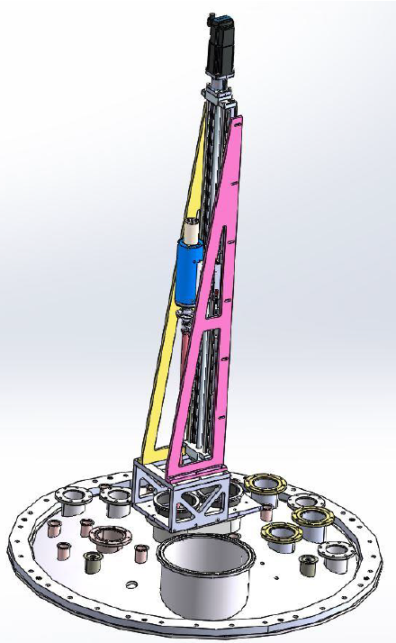
Anticryostat
Figure 1- Graphs or photos to show or justify the proposed improvements

- Anticryostat: to be used in Gersemi’s magnet insert. Is a magnetic-measurement test bench to qualify superconducting magnets. It will measure the magnetic flux density field and field quality of superconducting magnets with a minimum of 50 mm diameter bore operated at cryogenic temperatures. It uses a rotating coil scanner working at room temperature and pressure.
This is custom-made equipment and a current project with CERN.
- A magnetic flux sensor for cavity testing. This equipment would be used to measure the presence of low magnetic fields on the cavity during and after cooldown, if any. Could be placed at Gersemi or HNOSS.
- Solid state amplifier for cavity testing, for either HNOSS or Gersemi.
- LLRF for cavity testing, for either HNOSS or Gersemi.

Equipment | Specific Item | Price/Unit | # Units | Price Total
Anticryostat |  | 123 k€ | 1 | 123 k€
Magnetic Flux sensor | 3-axis sensor head | 2 850 GBP | 3 | 8 550 GBP
 | Cryogenic cable (5m) | 255 GBP |  | 765 GBP
 | Power supply and display unit | 2 555 GBP |  | 7 665 GBP
RF Amplifier | 0.7-2.7 GHz, 126-158 W | 15 813 € | 1 | 15 813 €
Digital FPGA* | Up to 6 GHz | 718 000 SEK | 1 | 718 000 SEK

* This equipment will not be part of the improvement services if the anticryostat is approved as being a service.

Equipment | Schedule
Anticryostat | Q4 2025
Magnetic Flux sensor | Q3 2023
RF Amplifier | Q3 2023
Digital FPGA* | Q1 2024

INFN-LASA – IT
Paragraph 1 : Short description of the facility, justification of the proposed improvement

Photos or graphs of the facility relevant to the service improvements
Figure 1- Graphs or photos to show or justify the proposed improvements

Paragraph 2 : Details on the planned activities

Paragraph 3 : Budget planning

Paragraph 4 : Schedule

INFN-THOR – IT
Paragraph 1 : Short description of the facility, justification of the proposed improvement

Photos or graphs of the facility relevant to the service improvements
Figure 1- Graphs or photos to show or justify the proposed improvements

Paragraph 2 : Details on the planned activities

Paragraph 3 : Budget planning

Paragraph 4 : Schedule

CEa/lrfu-Synergium – fR
Paragraph 1 : Short description of the facility, justification of the proposed improvement

Photos or graphs of the facility relevant to the service improvements
Figure 1- Graphs or photos to show or justify the proposed improvements

Paragraph 2 : Details on the planned activities

Paragraph 3 : Budget planning

Paragraph 4 : Schedule

KIT-ALFA(KARA – FLUTE) – GE
Paragraph 1 : Short description of the facility, justification of the proposed improvement

Photos or graphs of the facility relevant to the service improvements
Figure 1- Graphs or photos to show or justify the proposed improvements

Paragraph 2 : Details on the planned activities

Paragraph 3 : Budget planning

Paragraph 4 : Schedule

CEA/LIDyl-LPA-UHI100 – FR
Paragraph 1 : Short description of the facility, justification of the proposed improvement

Photos or graphs of the facility relevant to the service improvements
Figure 1- Graphs or photos to show or justify the proposed improvements

Paragraph 2 : Details on the planned activities

Paragraph 3 : Budget planning

Paragraph 4 : Schedule

Annex: Glossary

Acronym | Definition
TA | Transnational Access
VA | Virtual Access
RI | Research Infrastructure

