Grant Agreement No: 101057511
EURO-LABS
EUROpean Laboratories for Accelerator Based Science
HORIZON-INFRA-2021-SERV-01-07 Project EURO-LABS

Milestone report

Facilities ready to receive TA requests

milestone: MS17
Document identifier: | EURO-LABS_Milestone_MS17_v0.1.docx
Due date of deliverable: | End of Month 6 (Febuary 2023)
Justification for delay: | [if delays occurred]
Report release date: | dd/mm/yyyy
Work package: | WP 3 : Access to RIs for Accelerator R&D
Document status: | Draft

Abstract:
The present document reports on the readings of the Research Infrastructures participating to the Work Package 3 of EURO-LABS. .

EURO-LABS Consortium, 2023
For more information on EURO-LABS, its partners and contributors please see https://web.infn.it/EURO-LABS/

The EUROpean Laboratories for Accelerator Based Science (EURO-LABS) project has received funding from the European Union’s Horizon 2020 Research Infrastructure (RI) services advancing frontier knowledge under Grant Agreement no. 101057511. EURO-LABS began in September 2022 and will run for 4 years.

Delivery Slip
 | Name | Partner | Date
Authored by | ??? | [Short name] | 15/01/2023
Edited by | N. Charitonidis [Task 3.1]  Sylvie Leray [Task 3.2]  Anthony Gleeson [Task 3.3]  Urszula Gryczka [Task 3.4] | CERN  CEA  UKRI  INCT | dd/mm/yy
Reviewed by | I. Efthymiopoulos [WP3 coordinator] | CERN | dd/mm/yy
Approved by | A. Navin [Scientific coordinator]  Steering Committee |  | dd/mm/yy

TABLE OF CONTENTS
1. Introduction 5
2. WP3 – Task 3.1 6
1.1. USP 6
2.1.1. Facilities 6
3. WP3 – Task 3.2 7
1.2. USP 7
3.1.1. Facilities 7
Annex: Glossary 9

Executive summary
The key goal of the EURO-LABS project is to provide Transnational Access (TA) to major Research Infrastructures (RI) in Europe. WP3 groups thirteen facilities focused on High-Energy Accelerator Research. The document provides the status of the facilities at the startup of the project, and the readiness to receive and provide TA requests.

The document includes sections per Task. For what concerns the composition of the USP, the document will be updated in the course of the project if changes occur.

Introduction
EURO-LABS is a network of 33 research and academic institutions (25 beneficiaries and 8 associated partners) from 18 European and non-EU countries, involving 47 Research Infrastructures within the Nuclear physics, Accelerators and Detectors pillars. In this large network, EURO-LABS will ensure diversity and actively support researchers from different nationalities, gender, age, and variety of professional expertise.

EURO-LABS aims at fostering the sharing of knowledge and technologies across scientific fields to enhance synergies and collaborations between the RIs of the Nuclear and High Energy communities. Within EURO-LABS the Work-Package 3 (WP3) will provide Transnational Access (TA) to Research Infrastructures for Accelerator R&D.

WP3 will provide TA to a broad spectrum of installations, to test concepts for future accelerators, based on improving the present facilities, and for R&D studies for future colliders like CERN/FCC or the Muon Collider. These facilities will provide beam lines for testing advanced accelerator materials, superconducting or normal Radio-Frequency cavities, magnets and acceleration schemes. These tests use different particles and energies (low-energy protons, low-energy electrons, ultra-soft electron bunches and high-intensity high-energy electrons and could also have connections to industrial applications.

WP3 – Task 3.1

USP
Explain Composition
Frequency of meetings

Facilities

HiRadMat
Photo of the facility
Figure 1- View of the facility

Paragraph 1 : Short description of the facility

Paragraph 2 : Status of the facility

Paragraph 3 : Expected users – “publicity” done or planned to promote the TAs

WP3 – Task 3.2

USP

Explain Composition
Frequency of meetings

Facilities

FREIA
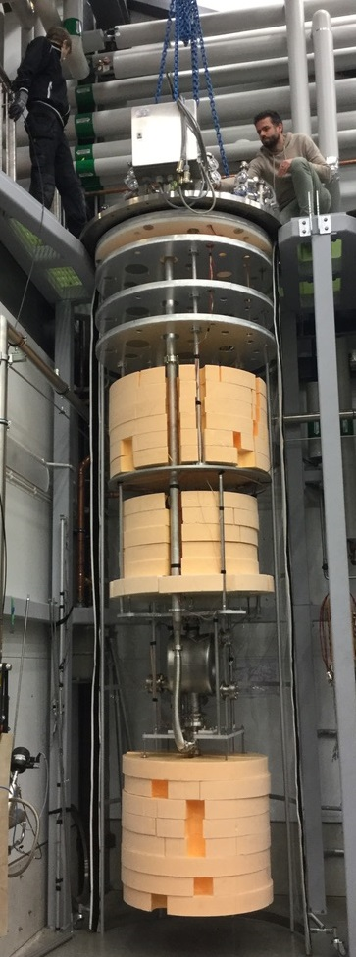
Gersemi. Vertical cryostat with pressure vessel (left), liquid insert (center) and magnet insert (right)
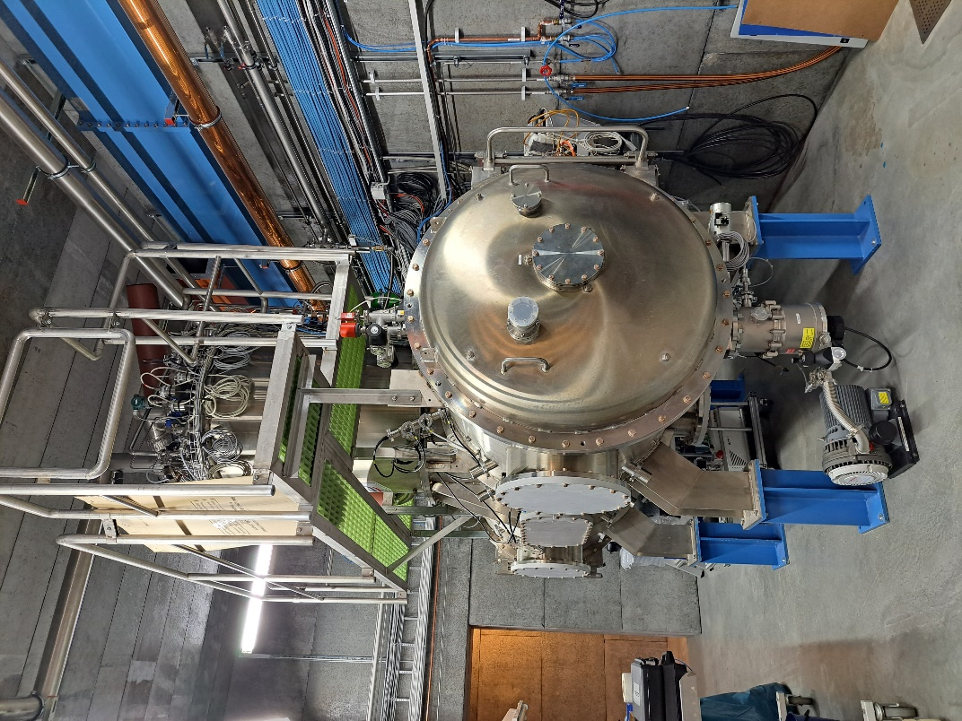
HNOSS (Horizontal cryostat)
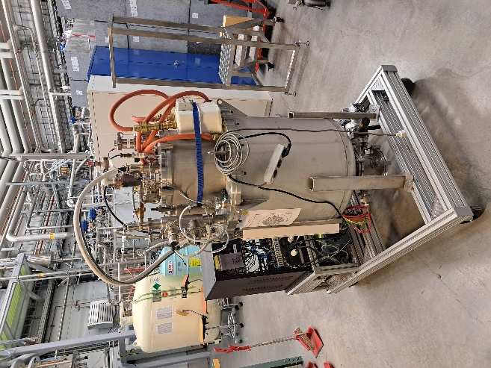
CoW (Cryostat on Wheels, portable)
Figure 1- View of the facility

FREIA has three different types of cryostat to be used depending on the experiments:
- Gersemi: a vertical cryostat that can test bare cavities or superconducting magnets between 4.2 K and 1.8 K
- HNOSS: a horizontal cryostat to test maximum two jacketed cavities between 4.2 K and 1.8 K.
- CoW: a portable cryostat to test small equipment at 4.2 K

The current status of the three cryostats is as follows:
- Gersemi: This cryostat is ready for operation from w. 8, but its availability is subjectable to in between main projects at FREIA
- HNOSS: For tests at low power 3 weeks would be needed to be ready, while at high power it would be closer to 5. Its availability is the same as with Gersemi, in between main projects.
- CoW. Due to it being portable, it is ready to be used at any time. Its availability depends only on the quantity of liquid helium available.

FREIA is constantly and actively promoting our facility at departmental meetings within the university, at future conferences in both talks and posters and by targeted conversations with colleagues from other institutions or companies with an interest in either superconducting equipment or low temperature cryogenics.

INFN-LASA
Photo of the facility
Figure 1- View of the facility

Paragraph 1 : Short description of the facility

Paragraph 2 : Status of the facility

Paragraph 3 : Expected users – “publicity” done or planned to promote the TAs

INFN-THOR
Photo of the facility
Figure 1- View of the facility

Paragraph 1 : Short description of the facility

Paragraph 2 : Status of the facility

Paragraph 3 : Expected users – “publicity” done or planned to promote the TAs

IJCLAB-SUPRATECH
Photo of the facility
Figure 1- View of the facility

Paragraph 1 : Short description of the facility

Paragraph 2 : Status of the facility

Paragraph 3 : Expected users – “publicity” done or planned to promote the TAs

CEAR/irfu-synergium
Photo of the facility
Figure 1- View of the facility

Paragraph 1 : Short description of the facility

Paragraph 2 : Status of the facility

Paragraph 3 : Expected users – “publicity” done or planned to promote the TAs

XBOX
Photo of the facility
Figure 1- View of the facility

Paragraph 1 : Short description of the facility

Paragraph 2 : Status of the facility

Paragraph 3 : Expected users – “publicity” done or planned to promote the TAs

Annex: Glossary

Acronym | Definition
TA | Transnational Access
VA | Virtual Access
RI | Research Infrastructure

