Grant Agreement No: 101057511

**EURO-LABS**

EUROpean Laboratories for Accelerator Based Science

HORIZON-INFRA-2021-SERV-01-07 Project EURO-LABS

Milestone report

Facilities ready to receive TA requests

milestone: MS17

|  |  |
| --- | --- |
| Document identifier: | EURO-LABS_Milestone_MS17_v0.1.docx |
| Due date of deliverable: | End of Month 6 (Febuary 2023) |
| Justification for delay: | [if delays occurred] |
| Report release date: | dd/mm/yyyy |
| Work package: | WP 3 : Access to RIs for Accelerator R&D |
| Document status: | Draft |

Abstract:

*The present document reports on the readings of the Research Infrastructures participating to the Work Package 3 of EURO-LABS. .*

EURO-LABS Consortium, 2023

For more information on EURO-LABS, its partners and contributors please see <https://web.infn.it/EURO-LABS/>

The EUROpean Laboratories for Accelerator Based Science (EURO-LABS) project has received funding from the European Union’s Horizon 2020 Research Infrastructure (RI) services advancing frontier knowledge under Grant Agreement no. 101057511. EURO-LABS began in September 2022 and will run for 4 years.

Delivery Slip

|  |  |  |  |
| --- | --- | --- | --- |
|  | Name | Partner | Date |
| Authored by | ??? | [Short name] | 15/01/2023 |
| Edited by | N. Charitonidis [Task 3.1]  Sylvie Leray [Task 3.2]  Anthony Gleeson [Task 3.3]  Urszula Gryczka [Task 3.4] | CERN  CEA  UKRI  INCT | dd/mm/yy |
| Reviewed by | I. Efthymiopoulos [WP3 coordinator] | CERN | dd/mm/yy |
| Approved by | A. Navin [Scientific coordinator]  Steering Committee |  | dd/mm/yy |

TABLE OF CONTENTS

1. Introduction 5

2. WP3 – Task 3.1 6

1.1. USP 6

2.1.1. Facilities 6

3. WP3 – Task 3.2 7

1.2. USP 7

3.1.1. Facilities 7

Annex: Glossary 9

Executive summary

*The key goal of the EURO-LABS project is to provide Transnational Access (TA) to major Research Infrastructures (RI) in Europe. WP3 groups thirteen facilities focused on High-Energy Accelerator Research. The document provides the status of the facilities at the startup of the project, and the readiness to receive and provide TA requests.*

*The document includes sections per Task. For what concerns the composition of the USP, the document will be updated in the course of the project if changes occur.*

# Introduction

EURO-LABS is a network of 33 research and academic institutions (25 beneficiaries and 8 associated partners) from 18 European and non-EU countries, involving 47 Research Infrastructures within the Nuclear physics, Accelerators and Detectors pillars. In this large network, EURO-LABS will ensure diversity and actively support researchers from different nationalities, gender, age, and variety of professional expertise.

EURO-LABS aims at fostering the sharing of knowledge and technologies across scientific fields to enhance synergies and collaborations between the RIs of the Nuclear and High Energy communities. Within EURO-LABS the Work-Package 3 (WP3) will provide Transnational Access (TA) to Research Infrastructures for Accelerator R&D.

WP3 will provide TA to a broad spectrum of installations, to test concepts for future accelerators, based on improving the present facilities, and for R&D studies for future colliders like CERN/FCC or the Muon Collider. These facilities will provide beam lines for testing advanced accelerator materials, superconducting or normal Radio-Frequency cavities, magnets and acceleration schemes. These tests use different particles and energies (low-energy protons, low-energy electrons, ultra-soft electron bunches and high-intensity high-energy electrons and could also have connections to industrial applications.

# WP3 – Task 3.1

## USP

The user selection panel of HiRadMat consists of 4 persons :

* Dr. Bernie RIEMER (Oak Ridge National Laboratory, USA)
* Prof. David SPROUSTER (Stonybrook University, USA)
* Dr. Pascal SIMON (HiRadMat operations manager, CERN)
* Dr. Nikolaos Charitonidis (HiRadMat responsible, CERN)

The user selection panel, that consists of 2 external experts that are not beneficiaries of TA units, meets in ad-hoc dates, and when informed by the facility management that TA requests have been received. There is a dedicated indico category with all the meetings, the agenda and their minutes available at : <https://indico.cern.ch/category/15888/> . The user selection panel also approves the in-person meetings for the Scientific Board.

## Facilities

### HiRadMat

|  |
| --- |
|  |
|  |

Figure 1- View of the facility during the installation of an experiment

*Paragraph 1 : Short description of the facility*

HiRadMat (High Irradiation to Materials) is a facility at CERN designed to provide high-intensity pulsed beams to an irradiation area where material samples as well as accelerator component assemblies can be tested. HiRadMat uses the extracted beam from the CERN-SPS (Super Proton Synchrotron) with up to a few 1013 protons/pulse to a momentum of 440 GeV/c. The fast (single turn) extracted beam is transported into the HiRadMat experimental area where the materials test setups are installed. The beam spot size at the focal point at the experiment can be varied from 0.25 to 4 mm2 to offer sufficient flexibility to test materials at different deposited energy densities. The facility can also provide heavy ion beams like Pb82+ with a beam energy of 177.4 GeV/nucleon (36.9 TeV per ion) resulting in a pulse energy of up to 21 kJ. HiRadMat as a dedicated facility for material and component testing with LHC type particle beam parameters is unique today. A maximum of 6x1016 protons per year can be delivered to the facility, due to RP limitations.

*Paragraph 2 : Status of the facility*

The facility is fully operational in order to accept the 2023 experiments. 4 slots have been allocated for this (short) year. Out of the approved experiments, 3 have requested partially Transnational Access support from EURO-LABS. Two USPs have been already completed :

* <https://indico.cern.ch/event/1200172/> (USP #1)
* <https://indico.cern.ch/event/1229706/> (USP #2)

The minutes from the USP have been attached to the agendas and (electronically) signed by all the USP members. A breakdown of the approved users and collaborators status is shown in Figure 2 :

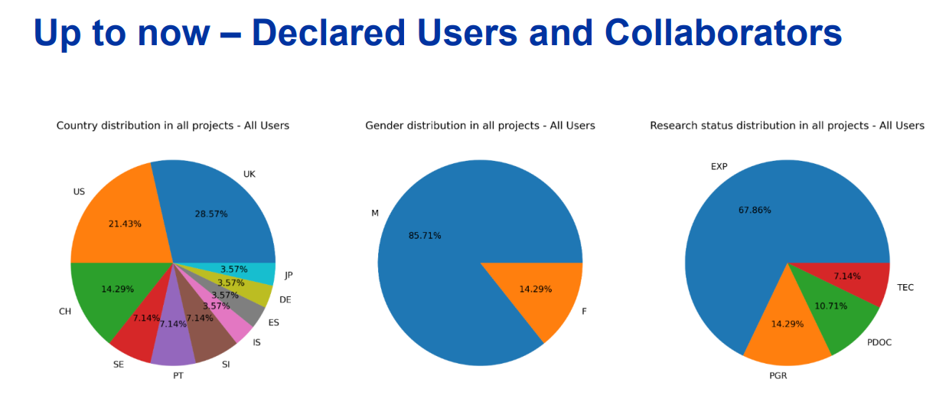

Figure 2: Statistics on the approved users and collaborators for EURO-LABS TA requests.

*Paragraph 3 : Expected users – “publicity” done or planned to promote the TAs*

Due to COVID19 regulations, conferences and workshops were cancelled or postponed in the last years. New peer-reviewed publications in journals publicised research at HiRadMat supported by EURO-LABS are already being drafted. The ten year anniversary of the HiRadMat facility has been commemorated as a [CERN bulletin article](https://home.cern/news/news/experiments/flexible-and-accessible-hiradmat-facility-celebrates-its-tenth-anniversary) and has been covered in the [38th issue of Accelerating News](https://acceleratingnews.web.cern.ch/news/issue-38/aries-ari/flexible-and-accessible-hiradmat-facility-celebrates-its-tenth-anniversary). However, within 2023 two important events for the facility will take place :

1. An *in-person* User Selection Panel and Scientific Board, towards the Q3 of 2023.
2. Strong participation of the facility in the [8th High Power Targery Workshop,](https://indico2.riken.jp/event/3102/) where many potential groups and collaborators participate.

# WP3 – Task 3.2

## USP

*Explain Composition*

*Frequency of meetings*

## Facilities

### FREIA

|  |
| --- |
| Photo of the facility |
|  |

Figure 1- View of the facility

*Paragraph 1 : Short description of the facility*

*Paragraph 2 : Status of the facility*

*Paragraph 3 : Expected users – “publicity” done or planned to promote the TAs*

### INFN-LASA

|  |
| --- |
| Photo of the facility |
|  |

Figure 1- View of the facility

*Paragraph 1 : Short description of the facility*

*Paragraph 2 : Status of the facility*

*Paragraph 3 : Expected users – “publicity” done or planned to promote the TAs*

### INFN-THOR

|  |
| --- |
| Photo of the facility |
|  |

Figure 1- View of the facility

*Paragraph 1 : Short description of the facility*

*Paragraph 2 : Status of the facility*

*Paragraph 3 : Expected users – “publicity” done or planned to promote the TAs*

### IJCLAB-SUPRATECH

|  |
| --- |
| Photo of the facility |
|  |

Figure 1- View of the facility

*Paragraph 1 : Short description of the facility*

*Paragraph 2 : Status of the facility*

*Paragraph 3 : Expected users – “publicity” done or planned to promote the TAs*

### CEAR/irfu-synergium

|  |
| --- |
| Photo of the facility |
|  |

Figure 1- View of the facility

*Paragraph 1 : Short description of the facility*

*Paragraph 2 : Status of the facility*

*Paragraph 3 : Expected users – “publicity” done or planned to promote the TAs*

### XBOX

|  |
| --- |
| Photo of the facility |
|  |

Figure 1- View of the facility

*Paragraph 1 : Short description of the facility*

*Paragraph 2 : Status of the facility*

*Paragraph 3 : Expected users – “publicity” done or planned to promote the TAs*

# Annex: Glossary

|  |  |
| --- | --- |
| Acronym | Definition |
| TA | Transnational Access |
| VA | Virtual Access |
| RI | Research Infrastructure |