# Questions

1. **Lower/Upper cola** 
   * In the delivered Step Model, the Cupolas are not designed as Carbon Sandwiches, both skins are missing.
   * Do you want me to design them/will you deliver them or was it on purpose since the main goal of the Quarter Model is to verify the internal structure?

1. **Fixation Brackets (green) – Bolts (blue) – Radiators (orange)**
   * In the first iteration I would assume that the fixation brackets and the bolts are done out of 1 part. Do you agree?

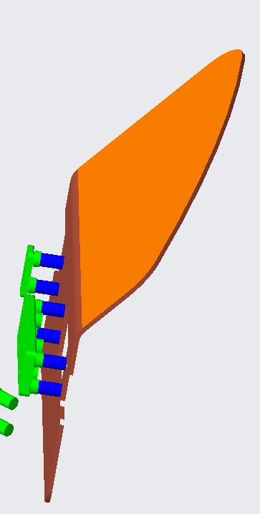

1. **Material list**
   * Could you confirm this material list? I highlighted in red the components not indicated in the document you sent, but partly discussed in the meeting of Wednesday.

|  |  |
| --- | --- |
| Component | Material |
| Shaker feet | Aluminum |
| Radiator | Aluminum |
| Radiator to radiator fixation | Aluminum |
| Upper/Lower cupola (Core only) | Hexcel CRIII-3/15-5056-.001-3.1 |
| Carbon octo frame | M46/EX-1515 |
| Octo Frame to frame fixation | M46/EX-1515 |
| Backplate reinforcement/ Vibration brackets/ octoframe to fix shaker feet/radiators | Aluminum |
| Mechanical structure – Top/Bottom skin | M55J/EX1515 |
| Mechanical structure – Honeycomb t= 70 mm | Carbon Fibre – Assume Hexcel CRIII? |
| QLCS – Top/Bottom skin | M55J/EX1515 |
| QLCS – Honeycomb t= 5 mm | Carbon Fibre – Assume Hexcel CRIII? |
| Ladders – Silicone Sensors t = 0.3 mm | PCB - FR4 |
| Ladders – Silicone LEF t = 1.35 mm | PCB - FR4 |
| Ladders – Attachment LBB t= 0.17 mm | PCB - FR4 |

1. **Ladders** 
   * As discussed in the meeting I assume the QLCS as following single components. Do you agree?
   * Silicone Sensors (red); Silicone LEF (grey), Ladder attachment (bottom view, yellow)
   * The “y-plane” is analogue but remains out of a left and a right half

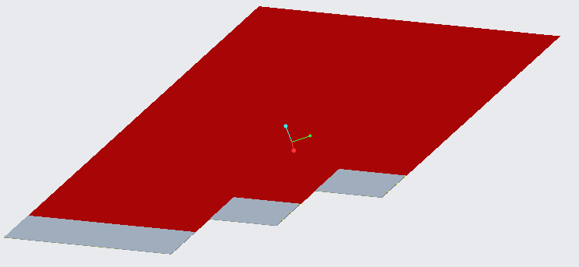

1. **Radiator to radiator fixation**
   * Are these fixations welded to the radiators? There are no holes in the step model

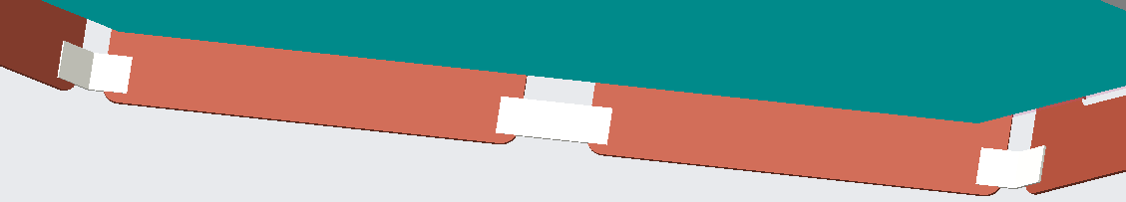

1. **QLCS** 
   * Can I correct these displacements between the attachment holes of the core and skin? Or do they have a reason?  
     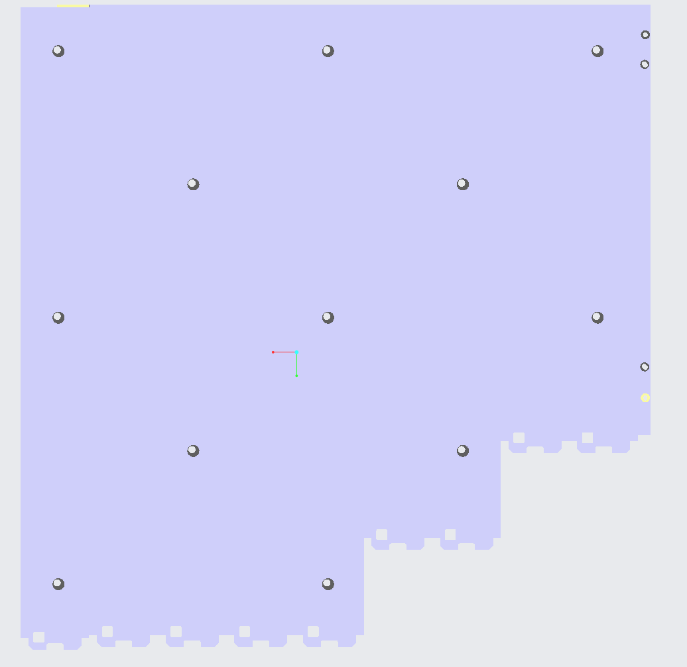 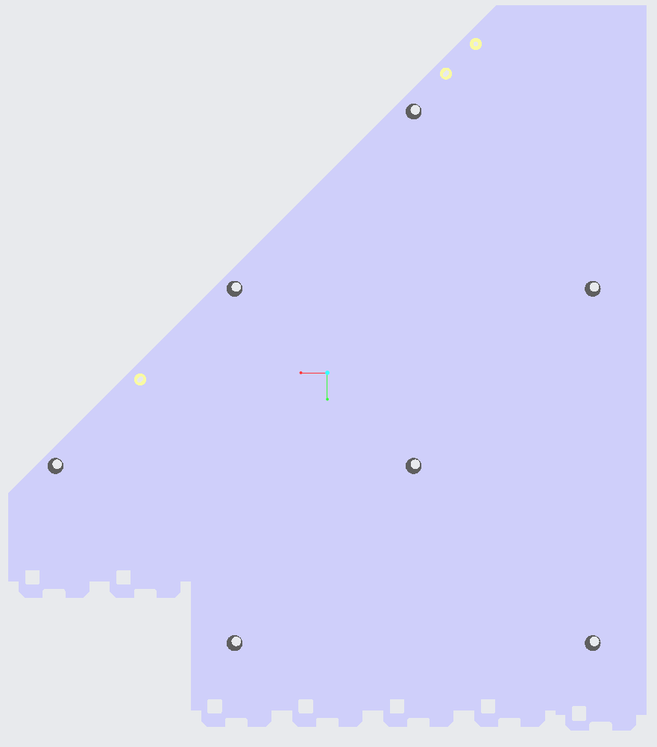
2. **Glue** 
   * Since one of the goals of the Analysis is to define the damping properties of the unknown glue, wouldn't it be meaningful to simulate the glue also as a solid body and adapting its properties?
   * Or do you want to assume in a first iteration a bounded contact only?
   * Could you send me a picture of the slide of the glue layers, that you showed us? Even if I do not have to model them I need to know where it is glued to chose the right contact boundaries in FEM (e.g., are the LBB ladders glued to the top skin – no attachment holes)