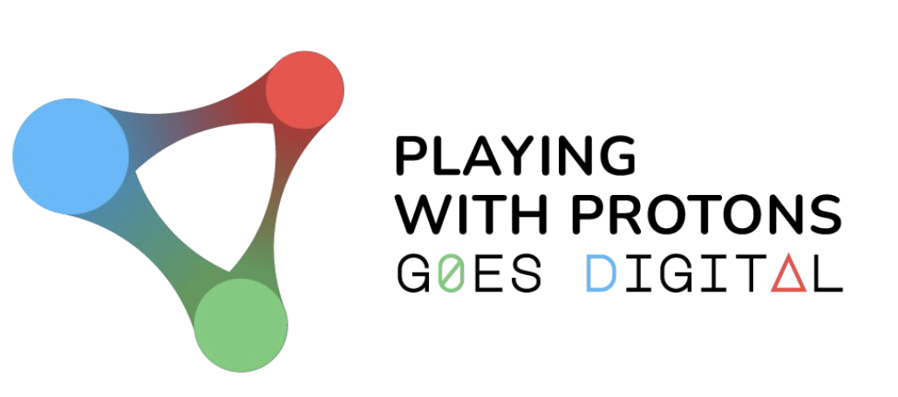 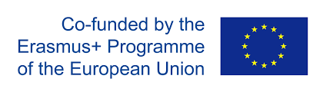

*Napoli, July 2021*

PLAYING WITH PROTONS GOES DIGITAL

MANAGEMENT Plan

AUTHORS

Pierluigi Paolucci, Giuseppe Bagliesi and Angelos Alexopoulos

This project has received funding from the European Union’s ERASMUS+ Programme under agreement No 2020-1-IT02-KA226-SCH-095525

The European Commission is not responsible for the content of this document.

**TABLE OF CONTENTS**

1. **Introduction.......................................................................................................................... 3**
2. **intellectual outputs …................................................................................................... 3**
3. **multiplier events 4**
4. **indicators and milestones 4**
5. **communication 5**

5.1 Transnational project meetings 5

5.2 Internal communication channels and shared workspace 6

1. **project management and monitoring 7**
2. **reporting 7**
3. **finances 7**

8.1 Invoices 7

8.2 Accounting and payments 8

# INTRODUCTION

This document is intended to be used as a guide to the PLAYING WITH PROTONS GOES DIGITAL consortium partners by outlining the project’s intellectual outputs, multiplier events and other relevant activities, deliverables and milestones, as described in the project proposal[1]. It also presents the internal communication mechanisms in place, the project management and monitoring process, followed by reporting and financing matters.

The PLAYING WITH PROTONS GOES DIGITAL project will commence on 1st June 2021 and will have a duration of 24 months, ending on 31st May 2023. The present document is and should be treated as an initial version of the project management plan, therefore it may be subject to changes, adaptations and updates, when this is deemed necessary, as the project evolves.

# intellectual outputs

The PLAYING WITH PROTONS GOES DIGITAL project is framed around five intellectual outputs (IOs), each of which having specific start and end dates (Table 1).

|  |  |  |
| --- | --- | --- |
| intellectual output (IO) | start date | end date |
| IO1: The Playing with Protons Goes Digital Conceptual and Methodological Framework | M1 | M12 |
| IO2: The Playing with Protons Goes Digital Handbook of Resources | M4 | M23 |
| IO3: The Playing with Protons Goes Digital Online Platform | M4 | M24 |
| IO4: The Playing with Protons Goes Digital Assessment Guide and eTwinning toolkit | M12 | M24 |
| IO5: The Playing with Protons Goes Digital Recommendations Handbook for School Leaders, Policy Makers & Stakeholders | M12 | M24 |

Table 1: Intellectual outputs.

All partners are involved in all IO. Yet each partner is assigned according to their expertise to coordinate a specific intellectual IO. Table 2 presents the IO leaders and allocated effort (staff days) per IO.

|  |  |  |  |  |  |  |  |
| --- | --- | --- | --- | --- | --- | --- | --- |
| IO | leader | INFN | EA | UB | IDIS-CDS | CTIC | TOTAL |
| IO1 | INFN | **80+5[2]** | 60 | 40 | 40 | 40 | 265 |
| IO2 | UB | 50+52 | 60 | **80** | 40 | 40 | 275 |
| IO3 | EA | 60+52 | **80** | 30 | 30 | 50 | 255 |
| IO4 | INFN | **70+52** | 40 | 40 | 40 | 40 | 235 |
| IO5 | IDIS | 30+52 | 40 | 20 | **60** | 20 | 175 |
| TOTAL |  | 315 | 280 | 210 | 210 | 190 | 1205 |

Table 2: Intellectual output leaders and number of allocated

staff days per partner for each intellectual output.

# multiplier events

The project will run eight multiplier events which will focus on scanning the educational horizon, sharing the PLAYING WITH PROTONS GOES DIGITAL approach and activities, receive feedback on them and ultimately invite teachers to implement them in their school. Each event is expected to have 20 local participants. The multiplier events are shown in Table 3.

Specifically, the first round of multiplier events will take place from mid-January to mid-March 2022, aimed at introducing teachers to IO1 as well as presenting aspects of IO2 and IO3 while giving teachers time to pilot activities in their schools according to the PLAYING WITH PROTONS GOES DIGITAL conceptual framework, proposed methodology and tools. In the second round of multiplier events, which are scheduled for the first quarter of 2023, invited teachers will be updated on final developments in IO2 and IO3 by placing emphasis on training that will enable them to design and customize PLAYING WITH PROTONS GOES DIGITAL activities according to their needs.

|  |  |  |  |
| --- | --- | --- | --- |
| multiplier events (e) | Leading organisation | start date | end date |
| E1: Playing with Protons Goes Digital in Action | INFN | 15.01.2022 | 15.03.2022 |
| E2: Playing with Protons Goes Digital in Action | EA | 15.01.2022 | 15.03.2022 |
| E3: Playing with Protons Goes Digital in Action | UB | 15.01.2022 | 15.03.2022 |
| E4: Playing with Protons Goes Digital in Action | CTIC | 15.01.2022 | 15.03.2022 |
| E5: Playing with Protons Goes Digital in Action II | INFN | 15.01.2023 | 15.03.2023 |
| E6: Playing with Protons Goes Digital in Action II | EA | 15.01.2023 | 15.03.2023 |
| E7: Playing with Protons Goes Digital in Action II | UB | 15.01.2023 | 15.03.2023 |
| E8: Playing with Protons Goes Digital in Action II | IDIS-CDS | 15.01.2023 | 15.03.2023 |

Table 3: Multiplier events.

# indicators and milestones

The success of PLAYING WITH PROTONS GOES DIGITAL depends on the extent to which the project’s objectives will be met based on continuous assessment according to the following quantitative and qualitative indicators:

1. *Quantitative* indicators:
   * Number of schools per partner: 10 (50 in total)
   * Number of rural and remote schools (out of the 50 set): 10
   * Number of students engaged: 500 in total
   * Number of teachers engaged per partner: 20 (100 in total)
   * Number of teachers reached through multiplier events: 160 (20 teachers in 8 MEs).
   * Number of teachers/educators and other individuals reached through other events: 2000.
   * Other Dissemination events (including project presentations, round table discussions and hands-on workshops in international conferences, science fairs and similar outreach events): 8 (two in each country).
   * Publications (blog entries, scientific papers, magazines, science education newsletter): 10 (2 by each partner).
   * Number of Educational Policy stakeholders: 15.
2. *Qualitative* indicators:
   * Engagement of students in the implementation.
   * Identification of success stories from pilot schools.
   * Satisfaction of participants in events (particularly in MEs).

Besides the aforementioned indicators, a set of milestones (MSs) has been set (Table 4).

|  |  |  |
| --- | --- | --- |
| milestone (mS) | related work OUTPUT | due date (in month) |
| MS1 | A1: Project management plan  A2: Quality assurance plan  A3: Dissemination plan  A4: Needs analysis  A5: Project website  A6: Online environment specifications and features  A7: Pilot implementation plan | M2  M2  M2  M4  M5  M6  M6 |
| MS2 | Beta version of the online platform (IO3)  Completion of first round of MEs  Finalization of IO1  Finalization of initial set of activities  Completion of teacher international school | M10  M12  M12  M12  M12 |
| MS3 | Initial versions of IO4 and IO5  Finalization of IO2  Completion of second round of MEs  Final version of the online platform (IO3)  Final versions of IO4 and IO5 | M18  M23  M23  M24  M24 |

Table 4: Project milestones.

# communication

* 1. TRANSNATIONAL PROJECT MEETINGS

In order to ensure a smooth running and monitoring of the project, five transnational project meetings (TPMs) will be organised as follows:

|  |  |  |
| --- | --- | --- |
| Transnational project meeting (TPM) | TPM Coordination Partner, City, Country | TPM Date |
| Kick-off TPM | INFN, Naples, Italy | June 2021 |
| 2nd TPM | CTIC, Bilbao, Spain | November 2021 |
| 3rd TPM | UB, Birmingham, UK | June 2022 |
| 4th TPM | EA, Athens, Greece | December 2022 |
| Final TPM | IDIS-CDS, Naples, Italy | May 2023 |

Table 4: Transnational project meetings.

The TPMs, as shown in Table 4, are the most important events where the status of the project will be reviewed and assessed and plans for the future phases put in place. Each partner have an allocated budget for two participants per TMP. The travel budget applies only when the TPM is taking place outside of the partner country. Each partner should send to the TPMs person(s) that is in charge of their national coordination of PLAYING WITH PROTONS GOES DIGITAL. The meetings are foreseen to last for one to three days depending on the specific stage of the project and the necessary steps to be taken. The minutes of each meeting will be shared among the participants. An attendance certificate will be delivered to the participants.

To note that due to possible COVID-19 related travel restrictions, face-to-face TPMs may be replaced with virtual meetings. This has been the case for the kick-off TPM that took place virtually on 29th June 2021.

* 1. INTERNAL COMMUNICATION CHANNELS AND SHARED WORKSPACE

There are three main channels to ensure smooth and effective communication among the partners throughout the duration of the project. These are:

* *Partners email distribution list*. An email distribution list has been set up to facilitate the communication among project partners.
* *Online meetings*. These meetings will be held normally on a monthly basis (or biweekly basis when deemed necessary) by using an online platform (e.g., Zoom). The agenda and the related materials (slides, documents and videos) are available at the “INFN agenda” WEB page <https://agenda.infn.it/category/1576/>. All meetings are recommended to be recorded and the respective links to be available to all partners. Minutes will be taken for each meeting and distributed among all partners.
* *Shared workspace*. A shared workspace has been created by the project coordinator in Microsoft Teams to which all partners have full access. The partners responsible for a certain IO must make sure to upload all relevant documentation to a dedicated folder created in the shared workspace. In addition, the shared workspace will include all project management documents, including the reporting templates.

# project management and monitoring

The project will be managed by the project coordinator (INFN) with the support of the steering committee (SC). The SC is composed by the representative of each partner (Table 5).

|  |  |
| --- | --- |
| Partner | Representative |
| INFN | Pierluigi Paolucci |
| EA | Angelos Alexopoulos |
| UB | Konstantinos Nikolopoulos |
| IDIS-CDS | Rossella Parente |
| CTIC | Jorge López Benito |

Table 5: Steering Committee.

The steering committee will serve as the consulting body in charge of ensuring the effective and efficient implementation of the project. The SC will be responsible for conflict resolutions, progress monitoring, quality management of the IOs and all events associated with them.

# reporting

According to its contractual obligations, the project has one formal reporting deadline to the National Agency (NA) as follows:

***Final report - within 60 days after the end date of the project****.* Each partner needs to provide the Coordinator with any information and document required for the preparation of the final report and, where appropriate, with copies of all the necessary supporting documents completed and signed by the legal representative by 15.06.2023 at the latest, covering the period 01.06.2021 – 31.05.2023.

# finances

* 1. INVOICES

The transfer of funding will be documented via invoices or proof of payment that will be delivered to the coordinator. These invoices are provided in a separate document. The main purpose of these document is to properly document each expense and should be filled according to the distribution presented in the accounting topic.

Each partner needs to provide supporting documents specified for each budget category as follows:

* *Transnational project meetings (TPMs)*: travel invoices and boarding passes for the international travels, certified copy of documents proving the connection between the partner organization and the person involved in the mobilities. Certificates signed by the legal representative of the host organization for each person participating in the event. List of all the participants, agenda and materials will be provided.
* *Intellectual outputs (IOs*): certified copy of documents proving the connection between the partner organization and the person involved in the production of the intellectual outputs. Monthly time sheets for each person involved in the production of the intellectual outputs, signed by the dedicated officer in each of the partner organisations.
* *Multiplier events (Es)*: Place, date, agenda, materials and the official attendance list signed by each participant will be provided.
  1. ACCOUNTING AND PAYMENTS

Each partner will be responsible for the appropriate accounting of the expenses in their institutions. The partners’ financial department should follow institutional, national and EU financial policy. The INFN financial department will assure the overall budget control.

Payments will be made according to the following schedule:

* *National Agency (NA) pre-payment:* Within 30 days of the entry into force of the Agreement, the NA shall pay the coordinator a first pre-financing payment, corresponding to 80% of the maximum amount of the grant.
* *1st payment:* Within 30 days from the signing of the Partnership Agreement, INFN shall pay the partners a first advance payment corresponding to 100% of the NA pre-payment.

*2nd and final payment:* The balance up to 20 % will be paid once the partners’ contractual agreements have been fully met, all the necessary supporting documentation has been received, and the NA has approved the final report.

1. Form ID: KA226-0042D0DC
2. Administrative support staff