Effective reinforcemenT IN GRAPHite Nanoplatelets biomimetic films

Fabrizia Cilentoª, Alfonso Martone*^{b}, Maria Giovanna Pastore Carbone^{c},

Michele Giordanoª, Francesco Bertocchi^{d}, Costas Galiotis^{c}

ª Department of Chemical, Materials and Production Engineering, University of Naples Federico II, Napoli, Italy P.le Tecchio, 80125 Naples, Italy
^{b} CNR-IPCB, Institute of Polymers, Composite and Biomaterials, Consiglio Nazionale delle Ricerche, P.le E Fermi, 80055 Portici (Naples), Italy
^{c} Foundation of Research and Technology Hellas, Institute of Chemical Engineering Sciences (FORTH/ICEHT), Stadiou Str., P.O. Box 1414, Rio-Patras, Greece;
^{d} Jaber Innovation srl, Rome, Italy
*corresponding author: alfonso.martone@cnr.it
Freestanding paper-like materials base on nanoscale lamellar fillers have attracted extensive interest thank to their intrinsic properties. In fact, such class of materials borrows specific properties from the two dimensional (2D) nano-filler together with special features related to the material architecture[1–3]. The challenge is then to retain at the macroscale the properties of the filler. In the case of lamellar fillers, paper-like structures allow to reproduce, on the macroscopic scale, the behaviour of the nanoscale reinforcement. Due to its multifunctional properties, graphene based two-dimensional sheets are ideal candidate for developing protective layers, chemical filters, adhesive layers, flexible sensing and energy devices, and wearable electronics[4,5]. The inner architecture of nacre-like composites is quite different respect to the conventional paper-like composites. Main differences between the two architecture are the porosity, i.e. bucky papers possess connected micro porosity, and a lower degree of in-plane oriented nanoplatelets [7].
In the present work, layered nanocomposite films replicating the structure of nacre have been manufactured at different filler content (50–90%wt). Morphology of the samples have been investigated by scanning electron microscopy. Tensile tests have been carried out on samples for measuring the effect of the polymer amount on the composite. The elastic modulus linearly increases for v_{f} < 60%. At higher filler content, there is a drop of efficiency due to poor stress transfer between particles and matrix. Similarly, the strength of the material reaches a maximum for v_{f} =53%. Mechanical data showed a reduction in effective reinforcement at high filler content, probably related to the reduced interphase.
Coupons showed a well aligned inner structure at each resin content, however the effective performances depend on the capability of stress transfer between brick and mortar. It has been investigated through Raman spectroscopy monitoring the 2D peak position (⁓ 2635 cm⁻¹) of GNPs while the samples are stretched.

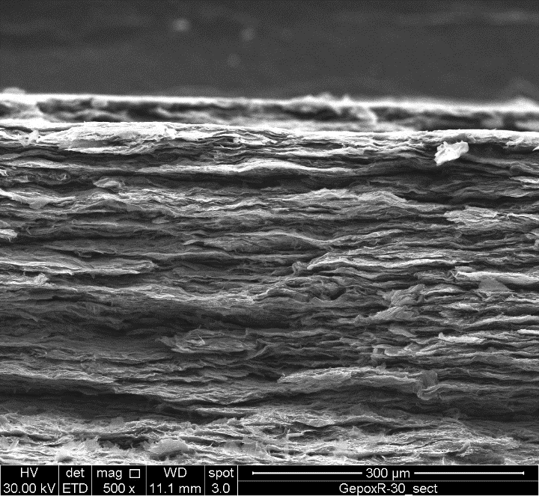 | 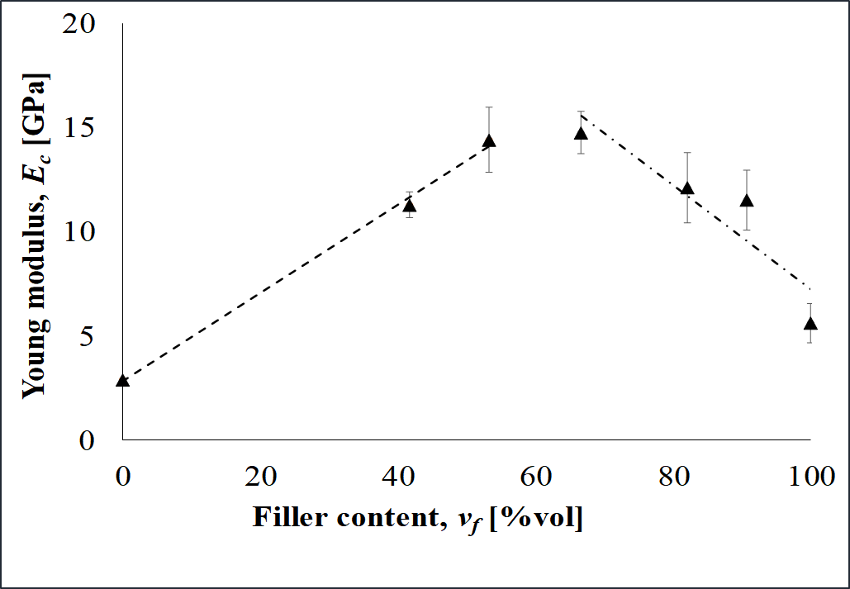
- b)
Figure 1. SEM Fracture surface (70/30 %w/w) (a); Young Modulus vs filler content (b)

Acknowledgement: Activities were carried out in the framework of an Italian grant “AMICO”. PhD grant of Fabrizia Cilento is supported by the programme “PON Ricerca e Innovazione 2014-2020”

References
[1] Y. Yao, J. Ping, Recent advances in graphene-based freestanding paper-like materials for sensing applications, TrAC - Trends Anal. Chem. 105 (2018) 75–88. doi:10.1016/j.trac.2018.04.014.
[2] D.F. Schmidt, Nanolaminates - Bioinspired and beyond, Mater. Lett. 108 (2013) 328–335. doi:10.1016/j.matlet.2013.07.004.
[3] M.R. Ricciardi, F. Cristiano, F. Bertocchi, A. Martone, M. Giordano, Manufacturing and properties of biomimetic graphite nanoplatelets foils, Polym. Eng. Sci. (2019) pen.25200. doi:10.1002/pen.25200.
[4] A. Martone, M.R. Ricciardi, M. Giordano, Mechanical Properties of Nanolaminates Based on Graphene Nanoplatelets, Exp. Charact. Predict. Mech. Therm. Model. Nanostructures Their Polym. Compos. (2018) 233–251. doi:10.1016/B978-0-323-48061-1.00006-3.
[5] Y. Zhang, S. Gong, Q. Zhang, P. Ming, S. Wan, J. Peng, et al., Graphene-based artificial nacre nanocomposites, Chem. Soc. Rev. 45 (2016) 2378–2395. doi:10.1039/C5CS00258C.
[6] Y. Liu, B. Xie, Z. Zhang, Q. Zheng, Z. Xu, Mechanical properties of graphene papers, J. Mech. Phys. Solids. 60 (2012) 591–605. doi:10.1016/j.jmps.2012.01.002.
[7] Z.U. Khan, A. Kausar, H. Ullah, A. Badshah, W.U. Khan, A review of graphene oxide, graphene buckypaper, and polymer/graphene composites: Properties and fabrication techniques, J. Plast. Film Sheeting. 32 (2016) 336–379. doi:10.1177/8756087915614612.

