High internal phase emulsion-templated biomaterials for drug delivery
Presenting Author Giuseppe Tripodo¹, Marco Corti¹, Enrica Calleri¹, Gloria Brusotti¹, Gabriella Massolini¹
¹Department of Drug Sciences, University of Pavia, Viale Taramelli 12, 27100, Pavia.

Abstract
Polymer-based drug delivery systems have been widely explored in medicine in the last years. Three-dimensional porous scaffolds (3D) represent the first class of biomaterials applied in biotechnological fields such as controlled delivery of drugs in long-term therapies and cell growth supports. 3D porous scaffolds are considered as polymer-based materials with an internal interconnected structure.
The present work focuses on the preparation of polyacrylate based biomaterials designed as patches for dermal/transdermal drug delivery using materials obtained by the high internal phase emulsion (HIPE) technique. In particular, butyl acrylate and glycidyl methacrylate were selected, respectively, as backbone and functional monomer while two different crosslinkers, bifunctional or trifunctional, were used to form the covalent network. The influence of PEG on the main properties of the materials was also investigated, Figure 1.[1-3]
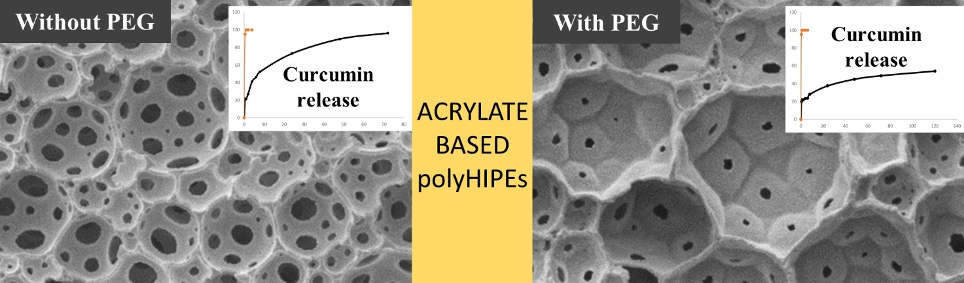
Figure 1. Characteristic internal structure of polyHIPEs and main drug release profile.

We selected curcumin as a model active molecule with numerous applications, i.e., in wound healing, cancer treatment and anti-inflammatory activity.[4] Curcumin is a highly hydrophobic drug as several molecules of pharmaceutical interest are, such as steroidal drugs and different antibiotics. Curcumin would benefit from its loading into a partially hydrophobic matrix because it should spread inside the material and would be released when in sink conditions.
Figure 2. Drug release profiles of curcumin from polyHIPEs at different compositions.

The release rate, Figure 2, shows a moderate burst effect at the beginning of the experiment (mostly due to the drug adsorbed on the matrix surface) and an almost constant release rate up to the complete release. The release curves are dived in two main groups and the prepared samples eventually showed tailorable features in terms of drug release depending on the internal structure.

References:
[1] M. Corti, E. Calleri, S. Perteghella, A. Ferrara, R. Tamma, C. Milanese, D. Mandracchia, G. Brusotti, M. L. Torre, D. Ribatti, F. Auricchio, G. Massolini, and G. Tripodo, “Polyacrylate/polyacrylate-PEG biomaterials obtained by high internal phase emulsions (HIPEs) with tailorable drug release and effective mechanical and biological properties,” Materials science & engineering. C, Materials for biological applications, vol. 105, pp. 110060-110060, 2019-Dec, 2019.
[2] G. Tripodo, G. Marrubini, M. Corti, G. Brusotti, C. Milanese, M. Sorrenti, L. Catenacci, G. Massolini, and E. Calleri, “Acrylate-based poly-high internal phase emulsions for effective enzyme immobilization and activity retention: from computationally-assisted synthesis to pharmaceutical applications,” Polymer Chemistry, vol. 9, no. 1, pp. 87-97, Jan, 2018.
[3] G. Brusotti, E. Calleri, C. Milanese, L. Catenacci, G. Marrubini, M. Sorrenti, A. Girella, G. Massolini, and G. Tripodo, “Rational design of functionalized polyacrylate-based high internal phase emulsion materials for analytical and biomedical uses,” Polymer Chemistry, vol. 7, no. 48, pp. 7436-7445, 2016.
[4] M. Pulido-Moran, J. Moreno-Fernandez, C. Ramirez-Tortosa, and M. C. Ramirez-Tortosa, “Curcumin and health,” Molecules, vol. 21, no. 3, 2016.

