Multipurpose sensors and lab-on-chip for medical diagnostics
E. Primiceri, M.S. Chiriacò, A. G. Monteduro, S. Rizzato, F. Sirsi, G. Marzano, G. Maruccio

Department of Mathematics and Physics, University of Salento, Via per Arnesano, 73100, Lecce, Italy.
CNR NANOTEC - Istituto di Nanotecnologia, Via per Arnesano, 73100 Lecce, Italy.

The development of sensors and lab-on-chip devices attracted large interest for detection of specific analytes/markers, cellular studies, drug screening as well as food and environmental monitoring. In this keynote talk, an introduction to progress, opportunities and new directions in the field will be provided with focus on sensors and microfluidics technologies/components as well as their applications.

Then, the development of a multipurpose electrochemical biochip in Lecce will be described. Such biochips were first demonstrated to be suitable for viability assays, cytotoxicity tests and migration assays on cell populations [1]. Then other applications were reported concerning the ultrasensitive (pM) detection of biorecognition events in flow immunoassays, such as in the case of cholera toxin in solution or cancer biomarkers in siera [2].

Our publications demonstrate that these biochips are very suitable for clinical analysis, being faster and more reproducible than traditional techniques. In particular, our attention was so far focused mainly on cancer diseases. For example, by means of appositely developed biochips, we assessed the presence of autoantibodies against Ser-419-phosphorylated ENOA in sera originating from patients with pancreatic ductal adenocarcinoma (PDAC) [3]. Biochip results are in agreement with those from traditional techniques, such as ELISA and Western Blot, but measurements are much more sensitive and specific increasing the possibility of PDAC diagnosis. Similar chips also allowed to evaluate the free-to-total PSA ratio useful for screening of prostate cancer risk [4] and retinol binding protein 4 for early management of type II diabetes [5]. On a different approach, these biochips were modified to enable automatic tests to quantify the invasive potential of cell lines by detecting the migratory activity of hepatocellular carcinoma (HCC) cells as a function of microenvironment [6]. Moreover, they were also employed for the simultaneous detection of multiple lower genital tract pathogens[7]. Similar biochips were also applied for food and environmental monitoring [8-10].

Presently, we are integrating more advanced microfluidic components and monolithic valves for fluid handling using thermo-responsive hydrogels, as well as other read-out approaches for increasing sensitivity in the case of small molecules thanks to magnetoresistive, plasmonic or SAW transducers [11, 12]. For example, in a recent EU project, we target early detection of neurodegenerative diseases from blood samples.

References:
[1] E. Primiceri, M. S. Chiriacò, E. D'Amone, E. Urso, R. E. Ionescu, A. Rizzello, et al., "Real-time monitoring of copper ions-induced cytotoxicity by EIS cell chips," Biosensors and Bioelectronics, vol. 25, pp. 2711-2716, 2010.
[2] M. S. Chiriacò, E. Primiceri, E. D'Amone, R. E. Ionescu, R. Rinaldi, and G. Maruccio, "EIS microfluidic chips for flow immunoassay and ultrasensitive cholera toxin detection," Lab on a Chip, vol. 11, pp. 658-663, 2011 2011.
[3] M. S. Chiriacò, E. Primiceri, A. G. Monteduro, A. Bove, S. Leporatti, M. Capello, et al., "Towards pancreatic cancer diagnosis using EIS biochips," Lab on a Chip, vol. 13, pp. 730-734, 2013 2013.
[4] M. S. Chiriacò, E. Primiceri, A. Montanaro, F. De Feo, L. Leone, R. Rinaldi, et al., "On-chip screening for prostate cancer: An EIS microfluidic platform for contemporary detection of free and total PSA," Analyst, vol. 138, pp. 5404-5410, 2013.
[5] A. Paul, M. S. Chiriacò, E. Primiceri, D. N. Srivastava, and G. Maruccio, "Picomolar detection of retinol binding protein 4 for early management of type II diabetes," Biosensors and Bioelectronics, vol. 128, pp. 122-128, 2019/03/01/ 2019.
[6] E. Primiceri, M. S. Chiriacò, F. Dioguardi, A. G. Monteduro, E. D'Amone, R. Rinaldi, et al., "Automatic transwell assay by an EIS cell chip to monitor cell migration," Lab on a Chip, vol. 11, pp. 4081-4086, 2011 2011.
[7] M. S. Chiriacò, E. Primiceri, F. De Feo, A. Montanaro, A. G. Monteduro, A. Tinelli, et al., "Simultaneous detection of multiple lower genital tract pathogens by an impedimetric immunochip," Biosensors and Bioelectronics, vol. 79, pp. 9-14, 5/15/ 2016.
[8] M. S. Chiriacò, F. de Feo, E. Primiceri, A. G. Monteduro, G. E. de Benedetto, A. Pennetta, et al., "Portable gliadin-immunochip for contamination control on the food production chain," Talanta, vol. 142, pp. 57-63, Sep 2015.
[9] E. Primiceri, M. S. Chiriacò, F. de Feo, E. Santovito, V. Fusco, and G. Maruccio, "A multipurpose biochip for food pathogen detection," Analytical Methods, vol. 8, pp. 3055-3060, 2016 2016.
[10] M. S. Chiriacò, A. Luvisi, E. Primiceri, E. Sabella, L. De Bellis, and G. Maruccio, "Development of a lab-on-a-chip method for rapid assay of Xylella fastidiosa subsp pauca strain CoDiRO," Scientific Reports, vol. 8, May 2018.
[11] S. Rizzato, E. Primiceri, A. G. Monteduro, A. Colombelli, A. Leo, M. G. Manera, et al., "Interaction-tailored organization of large-area colloidal assemblies," Beilstein Journal of Nanotechnology, vol. 9, pp. 1582-1593, May 2018.
[12] M. S. Chiriacò, S. Rizzato, E. Primiceri, S. Spagnolo, A. G. Monteduro, F. Ferrara, et al., "Optimization of SAW and EIS sensors suitable for environmental particulate monitoring," Microelectronic Engineering, vol. 202, pp. 31-36, Dec 15 2018.
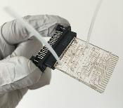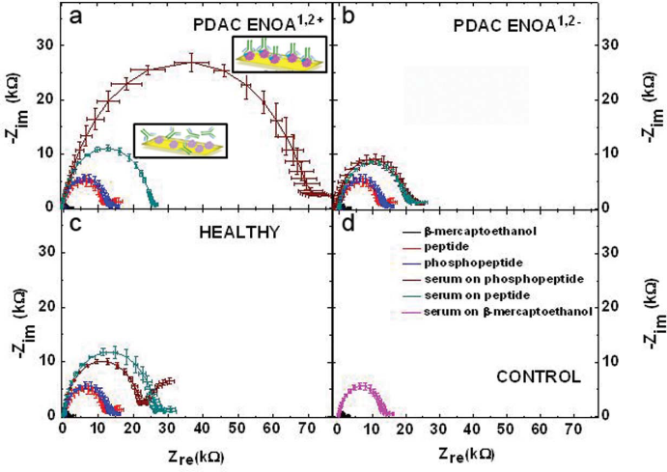
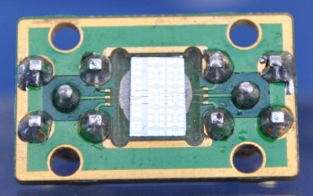
Fig. 1: (top, left) Multipurpose biochip with microfluidic and electrochemical components. (top, right) Impedance Nyquist spectra from PDAC ENOA1,2+ sera, ENOA1,2- sera, healthy sera and control samples. (bottom, left) SAW device interconnected to PCB. (bottom, right) Plasmonic array fabricated by colloidal lithography.

