Slide 1: Table with Samples
Q0: Is it possible to add the fluences of samples #2-12 and also the temperature at which the resistivity was measured?
I believe Antonio Serra said that all these samples should have been measured at 295K (22*C).
See attached file

I would like to make a graph of Resistivity vs Fluence such that we have more or less a calibration graph if in the future we would like to make, let's say 10MOhm/sq or 50MOhm/sq. Error on the fluences: 10-15%.

#9,#11 --> Same fluence, but substrate was not moved and received most energetic part of the plasma plume. #9,#11
#12,#13 --> Same fluence as #9, #11 but this time the substrate was moved and did not receive all the time the most energetic part of the plasma plume
Anna Paola will make a figure to explain better the positioning of the substrate w.r.t. the plasma plume

Slide 2: Van Der Pauw Method
Original Article: LJ Van Der Pauw, Philips Res. Rept., 13 (1958), p. 1
Maybe good article (?) A.RamadanR.D.GouldA.Ashour, On the Van der Pauw method of resistivity measurements. Thin Solid Films 239 2 (1994), p272-275 https://doi.org/10.1016/0040-6090(94)90863-X
Q1: How do you measure I,V?
A1: not with multimeter / electrometer / ... but with an integrated device BIORAD (?)
We used a Biorad HL5500PC Hall effect measurements system. It consists of a AC/DC constant voltage/current source Biorad, an input amplifier Biorad with an impedance of 10 G Ohm and a high input resistance buffer amplifier HL5580PC is available for specimens with higher resistance.
Q2: What are the errors on the resistivity measurements?
A2: Errors on the method: 0.01 (1%). Errors on the measurement: 50 measurements were made, and standard deviation is calculated. this leads to a standard deviation of typically 10%.

Slide 3: Resistivity as function of Temperature
Q3: Can you make Raman measurement both before and after heating up? It would be interesting to see whether the heating of the DLC film lead to change of the DLC film characteristics
Yes it is possible to perform Raman measurements

slide 4: Raman spectrum:
D = Disorder --> high disorder means dominions of crystaline graphite are small
G = Graphite Band
Left plot was made on pyrolytic graphite and is used as reference measurement

slide 5: Analysis of Raman spectroscopy data:
L and sigma are obtained from a model that is based on the shift of the D and G position as well as intensity ratio ID/IG. Model made by Ferrari, can you please provide details Antonio?
I found this article, but reading diagonally i did not find formulas that give me sigma:
Andrea Carlo Ferrari, Determination of bonding in diamond-like carbon by Raman spectroscopy
Diamond and Related Materials, 11, 3–6, (2002), p1053-1061
https://doi.org/10.1016/S0925-9635(01)00730-0
The film stress was determined by using the following relation
[R.J. Narayan, Laser processing of diamond-like carbon-metal composites, Appl. Surf. Sci. 245 (2005) 420–430.
M. Lubwama, B. Corcoran, K.V.Rajani, C.S. Wong, J.B. Kirabira, A. Sebbit, K.A. McDonnell, D. Dowling, K. Sayers, Raman analysis of DLC and Si-DLC films deposited on nitrile rubber, Surf. Coat. Technol. 232 (2013) 521–527.
Y. Miki, A. Nishimoto, T.Sone, Y. Araki, Residual stress measurement in DLC films deposited by PBIID method using Raman micro probe spectroscopy, Surf. Coat. Technol. 283 (2015) 274–280.
K.Nakamatsu, M. Nagase, J. Igaki, H. Namatsu, S. Matsui, Mechanical characteristics and its annealing effect of diamond-like carbon nano springs fabricated by focused-ion-beam chemical vapor deposition, J. Vac. Sci. Technol. B 23 (2005) 2801–2805]
$$σ=2G\left[\frac{1+v}{1-v}\right]\left[\frac{∆w}{w_{0}}\right]$$
where G is the shear modulus (G=70GPa), v is the Poison’s ratio (about 0.3) [Y. Lifshitz, S.R. Kasi, J.W. Rabalais, Subplantation model for film growth from hyperthermal species: application to diamond, Phys. Rev. Lett. 62 (1989) 1290–1293], Δw is the shift in the Raman wavenumber of the G band and w₀ is the Raman wavenumber of reference (HOPG)

Q4: Is it possible to make a plot of rho_sheet vs ID/IG (Actually I would like more to have something like rho_sheet vs sp3/sp2, but I understood it is still difficult to obtain sp3/sp2 ratio).
Q5: How can we get a plot of sp3/sp2? (apologies if you answered it already, I failed to write down the procedure)
A possibility is to perform X-ray Photoelectron Spectroscopy (XPS) analysis. There are also empirical formula to deduce the sp3/sp2 ratio starting from Raman spectra but it is necessary to have several information about the film composition…..However, we have to study more about this aspect

Eg = Band gap. Bandgap #10 = 3.5. For comparison: bandgap graphite = 1eV, bandgap diamond is 5.5 eV. If I remember well bandgap Si is 3.2 eV. So this is a clear indication the material is a mix of sp2 and sp3, however I was told this could not be used to obtain sp3/sp2 ratio :-(. Measurements were made by Emittanza / Trasmittanza
It is correct
Q6: Is this measurement made with the same Raman spectroscopy setup?
The energy gap values were determined from transmittance and reflectance measurements performed by a Varian Cary5 spectrophotometer, on the contrary, Raman spectra were obtained by a RenishawInvia spectrometer. The optical analysis is based on model of Heavens as reported in D. Manno, et al

slide 6: Transmission Electron Microscopy:
Diffraction of sp3 should give rise to three rings, we can clearly see 2 rings and based on the position of the rings, the fraction of sp3 is not trascurable says Antonio Serra. D measured here is the same L extracted from Ferrari's model based on Raman spectroscopy and gives an indication of the dimensions of the crystalline graphite dominions. Epsilon gives the strain. (I do not remember whether this is strain w.r.t. reference sample)
Q7: Is it possible to measure the stress (sigma)? - Not possible (but I do not remember why)
Q7: Daniela, can you please give some reference to the models and measurements?

The three rings can come only from graphite nanocrystals as in figure 1 (from R. Matassaet al.)

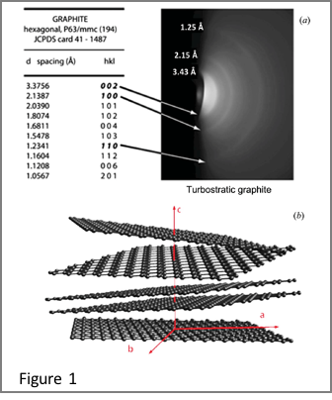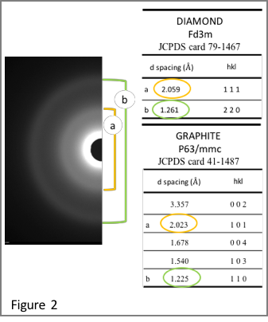

We can clearly see 2 rings (figure 2). The two rings are compatible with both the diffraction maxima 111 and 220 of the diamond, and with the diffraction maxima 101 and 110 of the graphite.
This can be interpreted as an overlapping of nano-graphene (missing the ring corresponding to the planes 002 of the graphite) and nanodiamond.
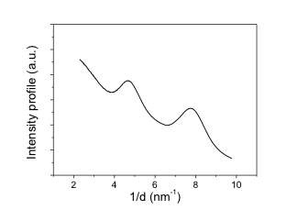
At the moment I interpret the experimental diffraction pattern using the software ‘Digital Micrograph’, a Gatan software with PASAD-tool,.
I can obtain

- the diffraction profile in the reciprocal spacing
- the position and the enlargement of the peaks

Figure 3
Peaks position and enlargement can be processed as in Serra et al to obtain grain size and strain. The method is well known for x-diffraction,.
As regard a fine electron diffraction interpretation a simulation needs (as in Czigany et al). This is not trivial, but I'm working on the algorithm.

Discussion & Next steps
It would be good to do AFM-Raman measurements together
Next steps: make other three samples with the same settings & characterize. This would be a good start to write an article on PLD of DLC on Kapton. Later on we can have more material for a second article if we again perform the characterization methods on chemically wet-etched samples.

greets
Piet

D. Manno, A. Serra, M. D Giulio, G. Micocci and A. Tepore Physical and Structural characterization of tungsten oxide thin films for NO gas detection. Thin Solid Films 324 (1998) 44-51
R. Matassa,S. Orlanducci,E. Tamburri,V. Guglielmotti,D. Sordi,M. L. Terranova,D. Passeriand M. Rossi Characterization of carbon structures produced by graphene self-assembly, J. Appl. Cryst. (2014). 47, 222–227)
Gammer C, Mangler C, Rentenberger C and Karnthaler H P “Quantitative local profile analysis of nanomaterials by electron diffraction “ ScriptaMaterialia 63 (2010) 312-315
Gammer C, Mangler C, Karnthaler H P and Rentenberger C “Three-dimensional analysis by electron diffraction methods of nanocrystalline materials” Materials Microsc.Microanal. 17 (2011) 866-871
A. Serra, D. Manno, A. Buccolieri, G G Carbone and L CalcagnilePhotochromic properties in silver-doped titania nanoparticlesMater. Res. Express 6 (2019) 036206
G.K.Williamson and W.H. Hall. X-ray line broadening from filed aluminium and wolfram ActaMetall 1 (1953) 22
T. Ungar and A. Borbely. The effect of dislocation contrast on x‐ray line broadening: A new approach to line profile analysis.Appl. Phys. Lett. 69 (1996) 3173
Z.Czigany, L. Hultman, Interpretation of electron diffraction patterns from amorphous and fullerene-like carbon allotropes Ultramicroscopy 110 (2010) 815–819

