*ITEP, May 2016*

1. Permanent magnet multipoles (PMМ) development and manufacturing for ion accelerator magnetic optics.

Experience in permanent magnet multipoles development and application-oriented engineering, which have been investigated and successfully implemented in ITEP for more than three decades, as well as high-quality rare-earth (in particular radiation resistant) permanent magnets of Russian and Chinese manufacturers are supposed [1].

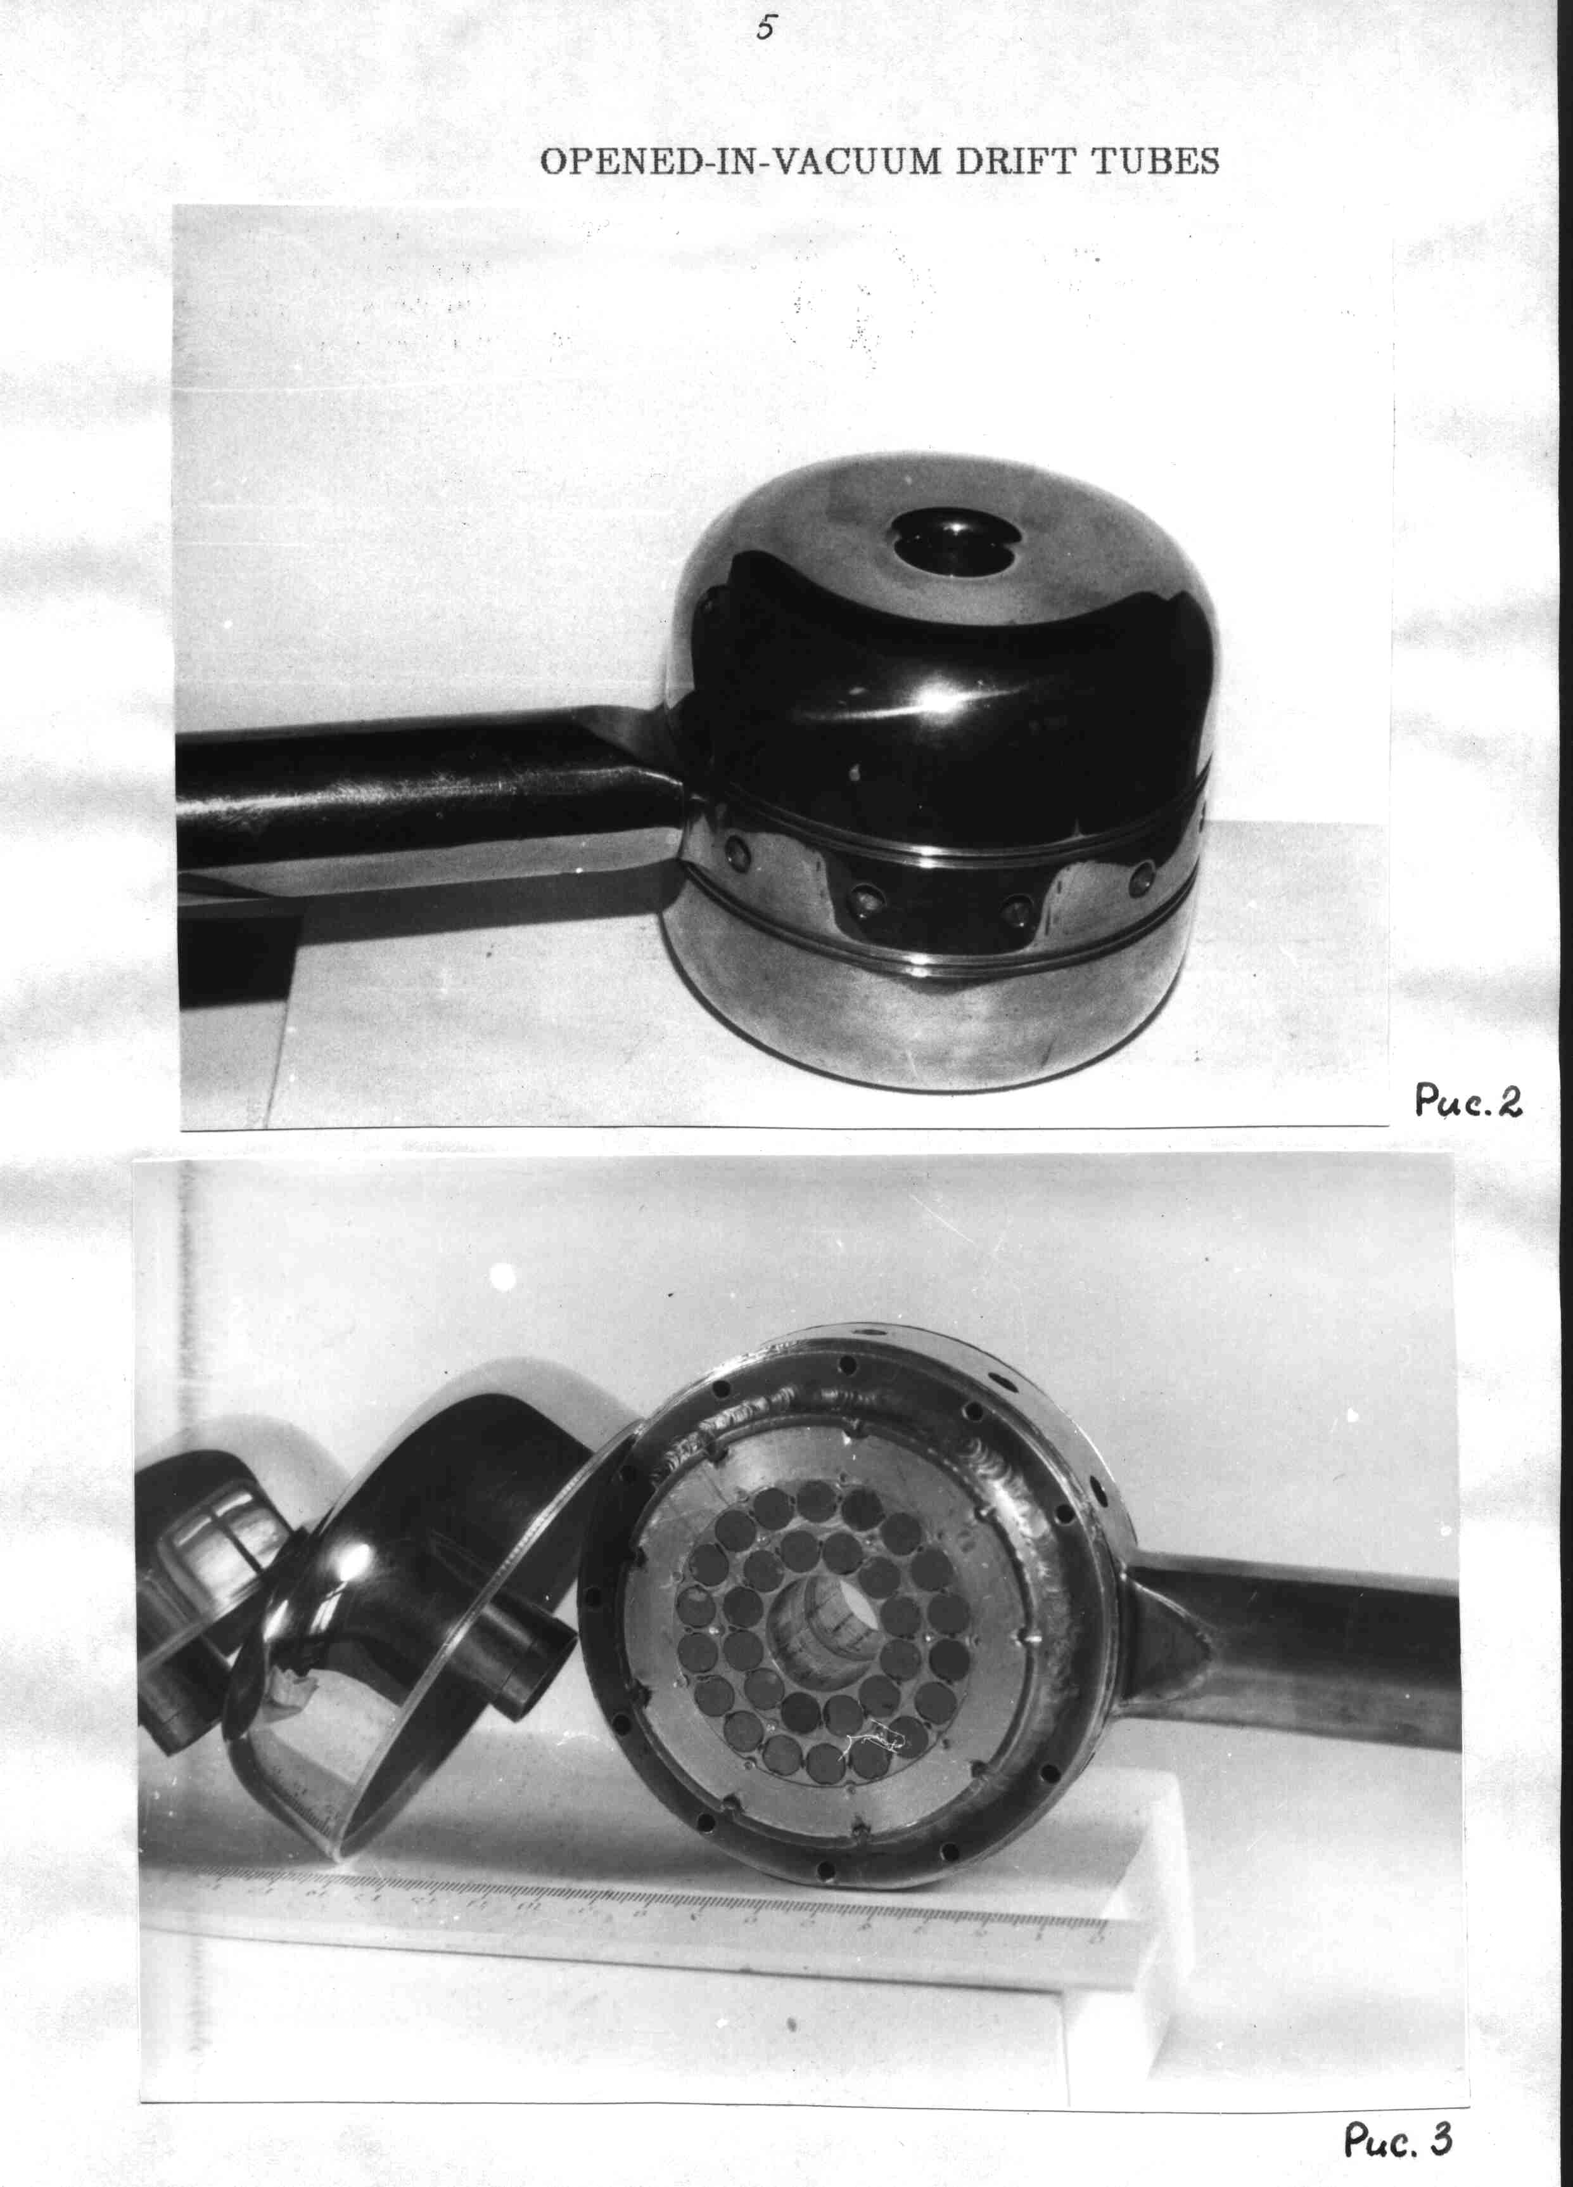 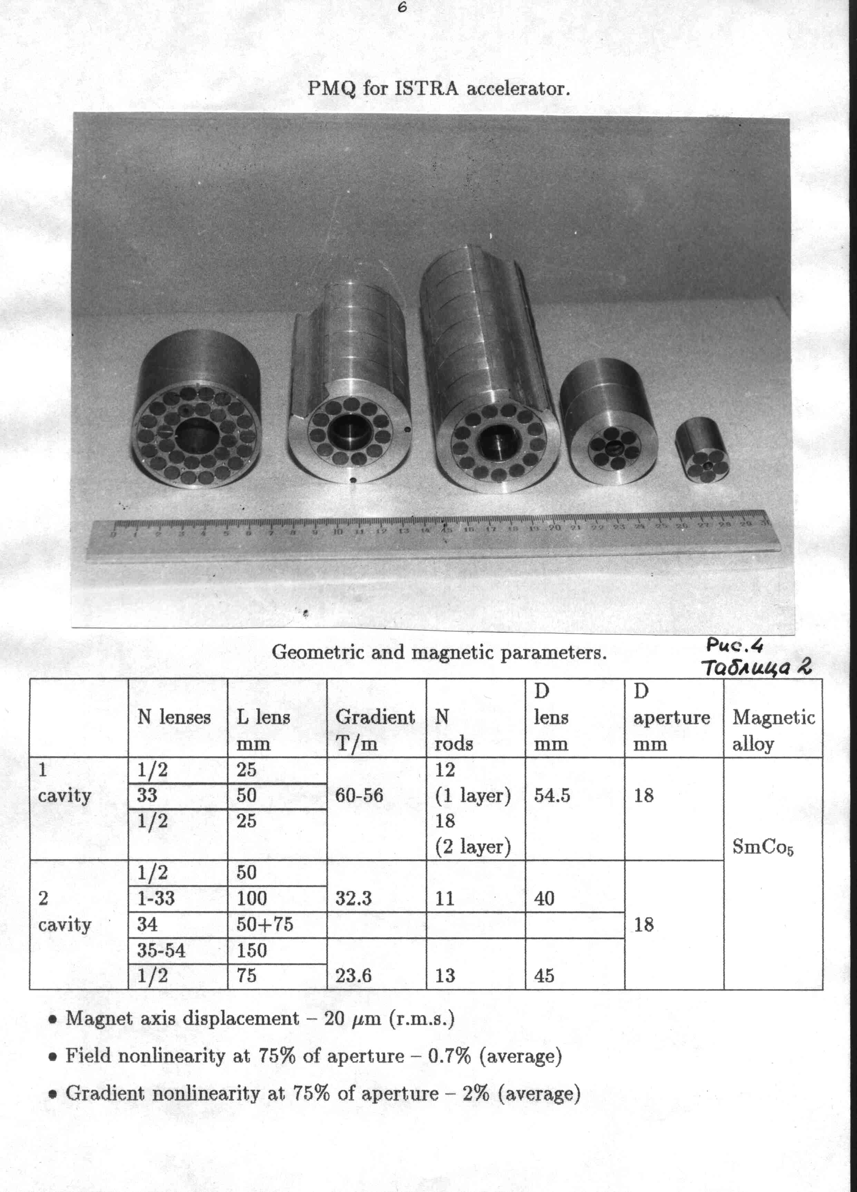

ITEP’s rod type quadrupole (PMQ) lenses from SmCo5 alloy.

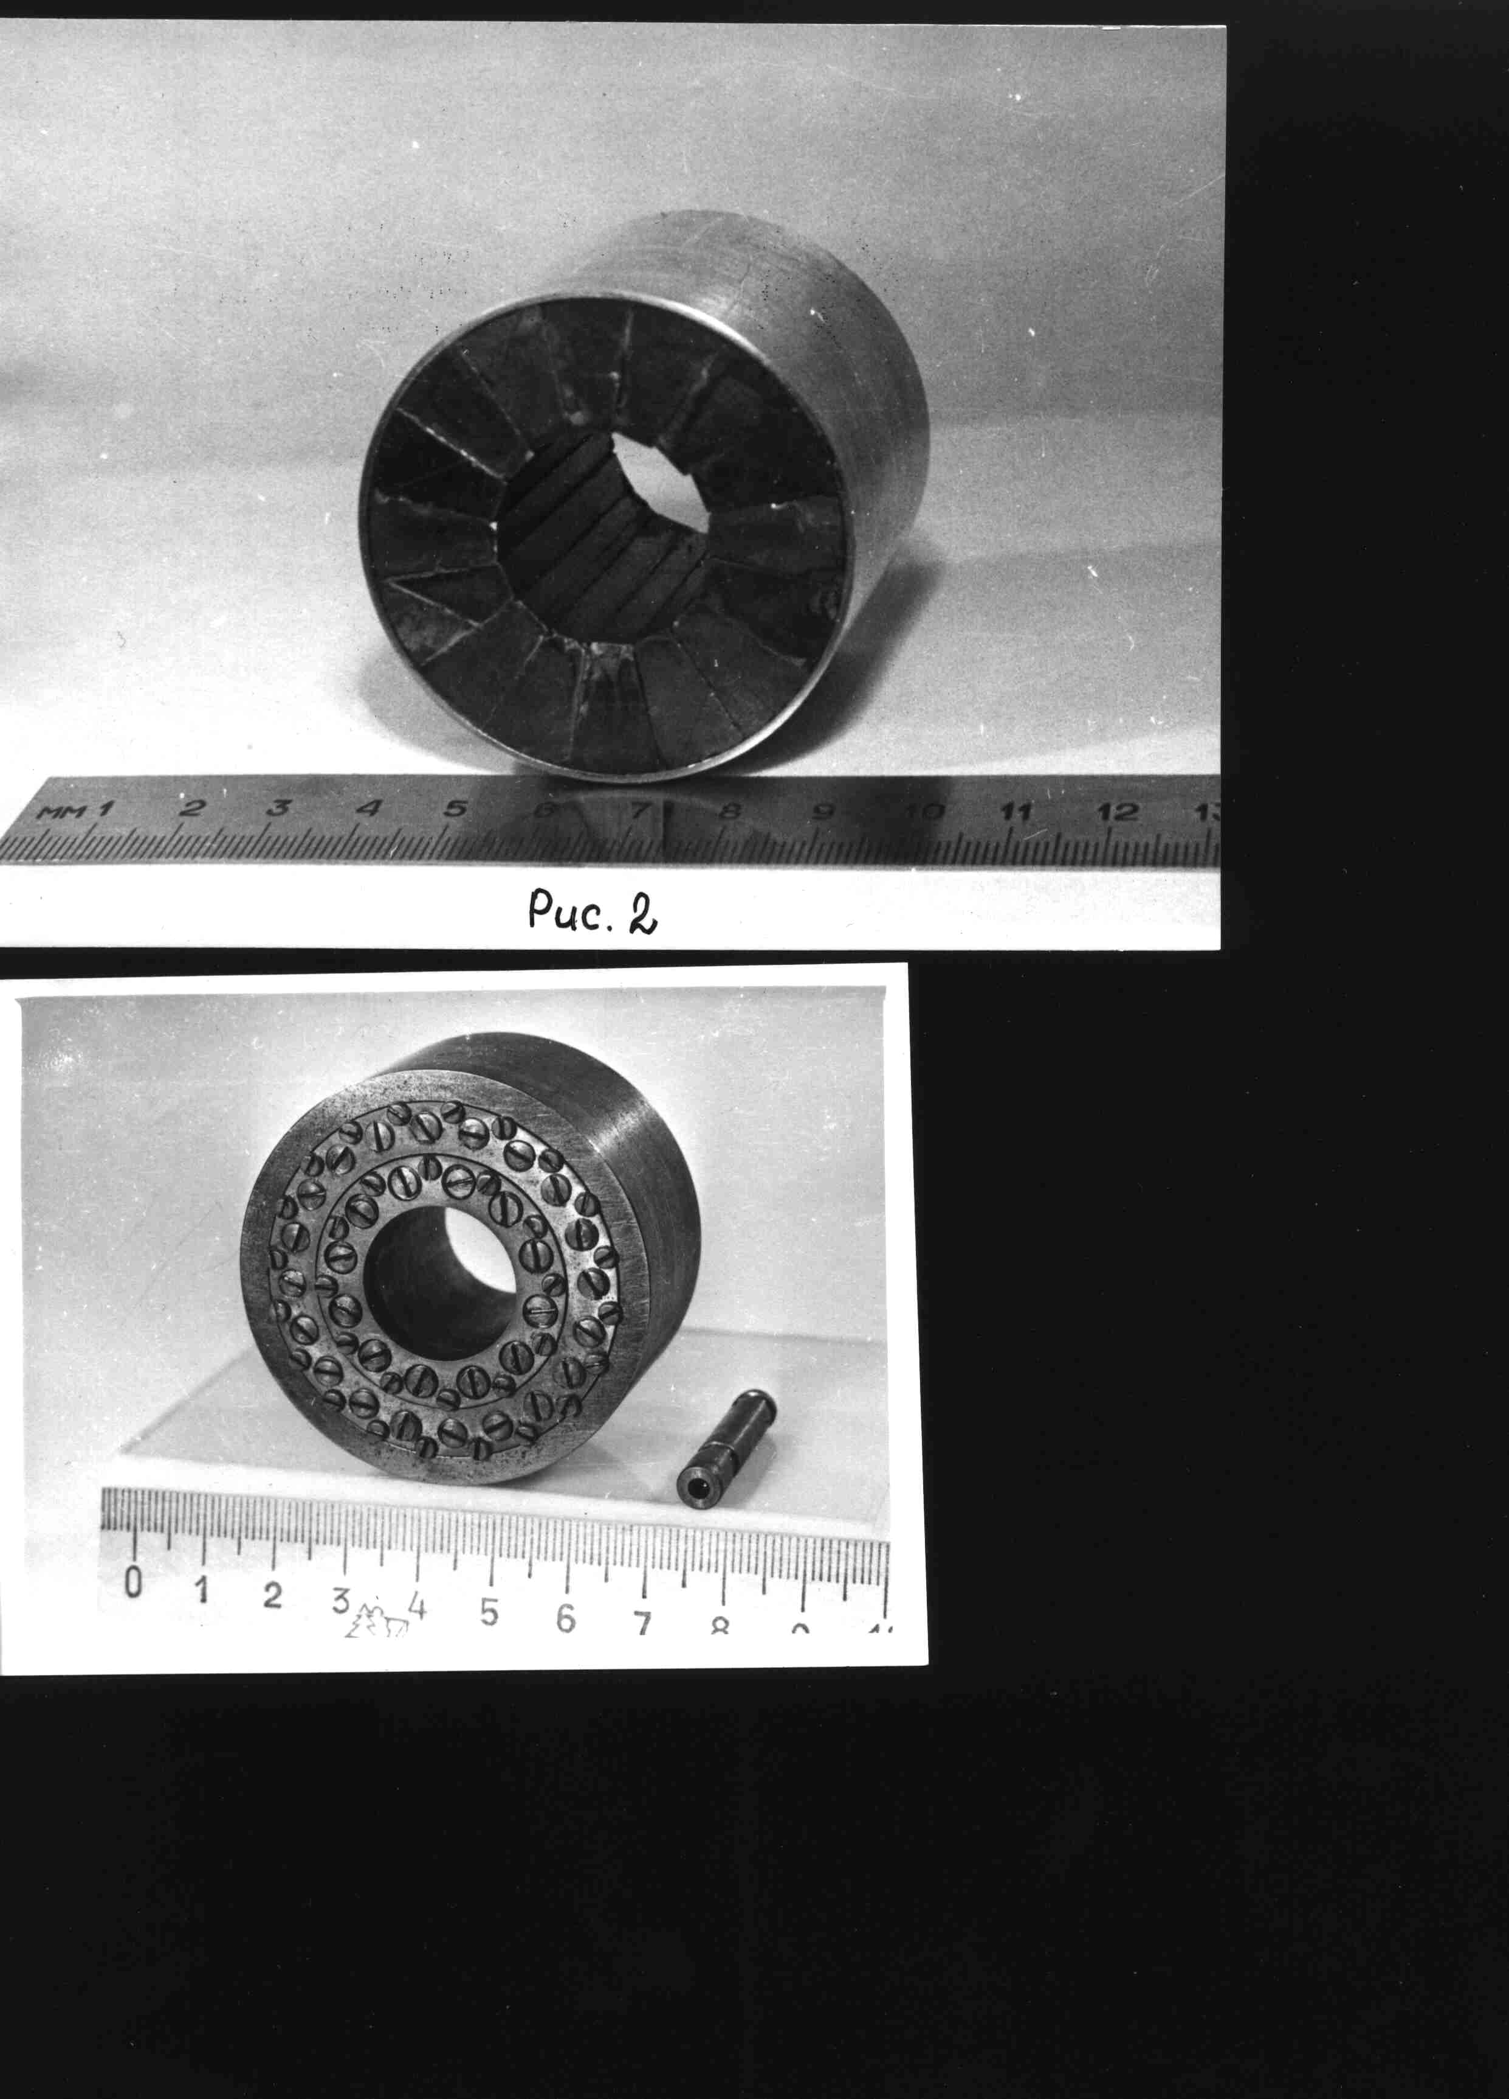 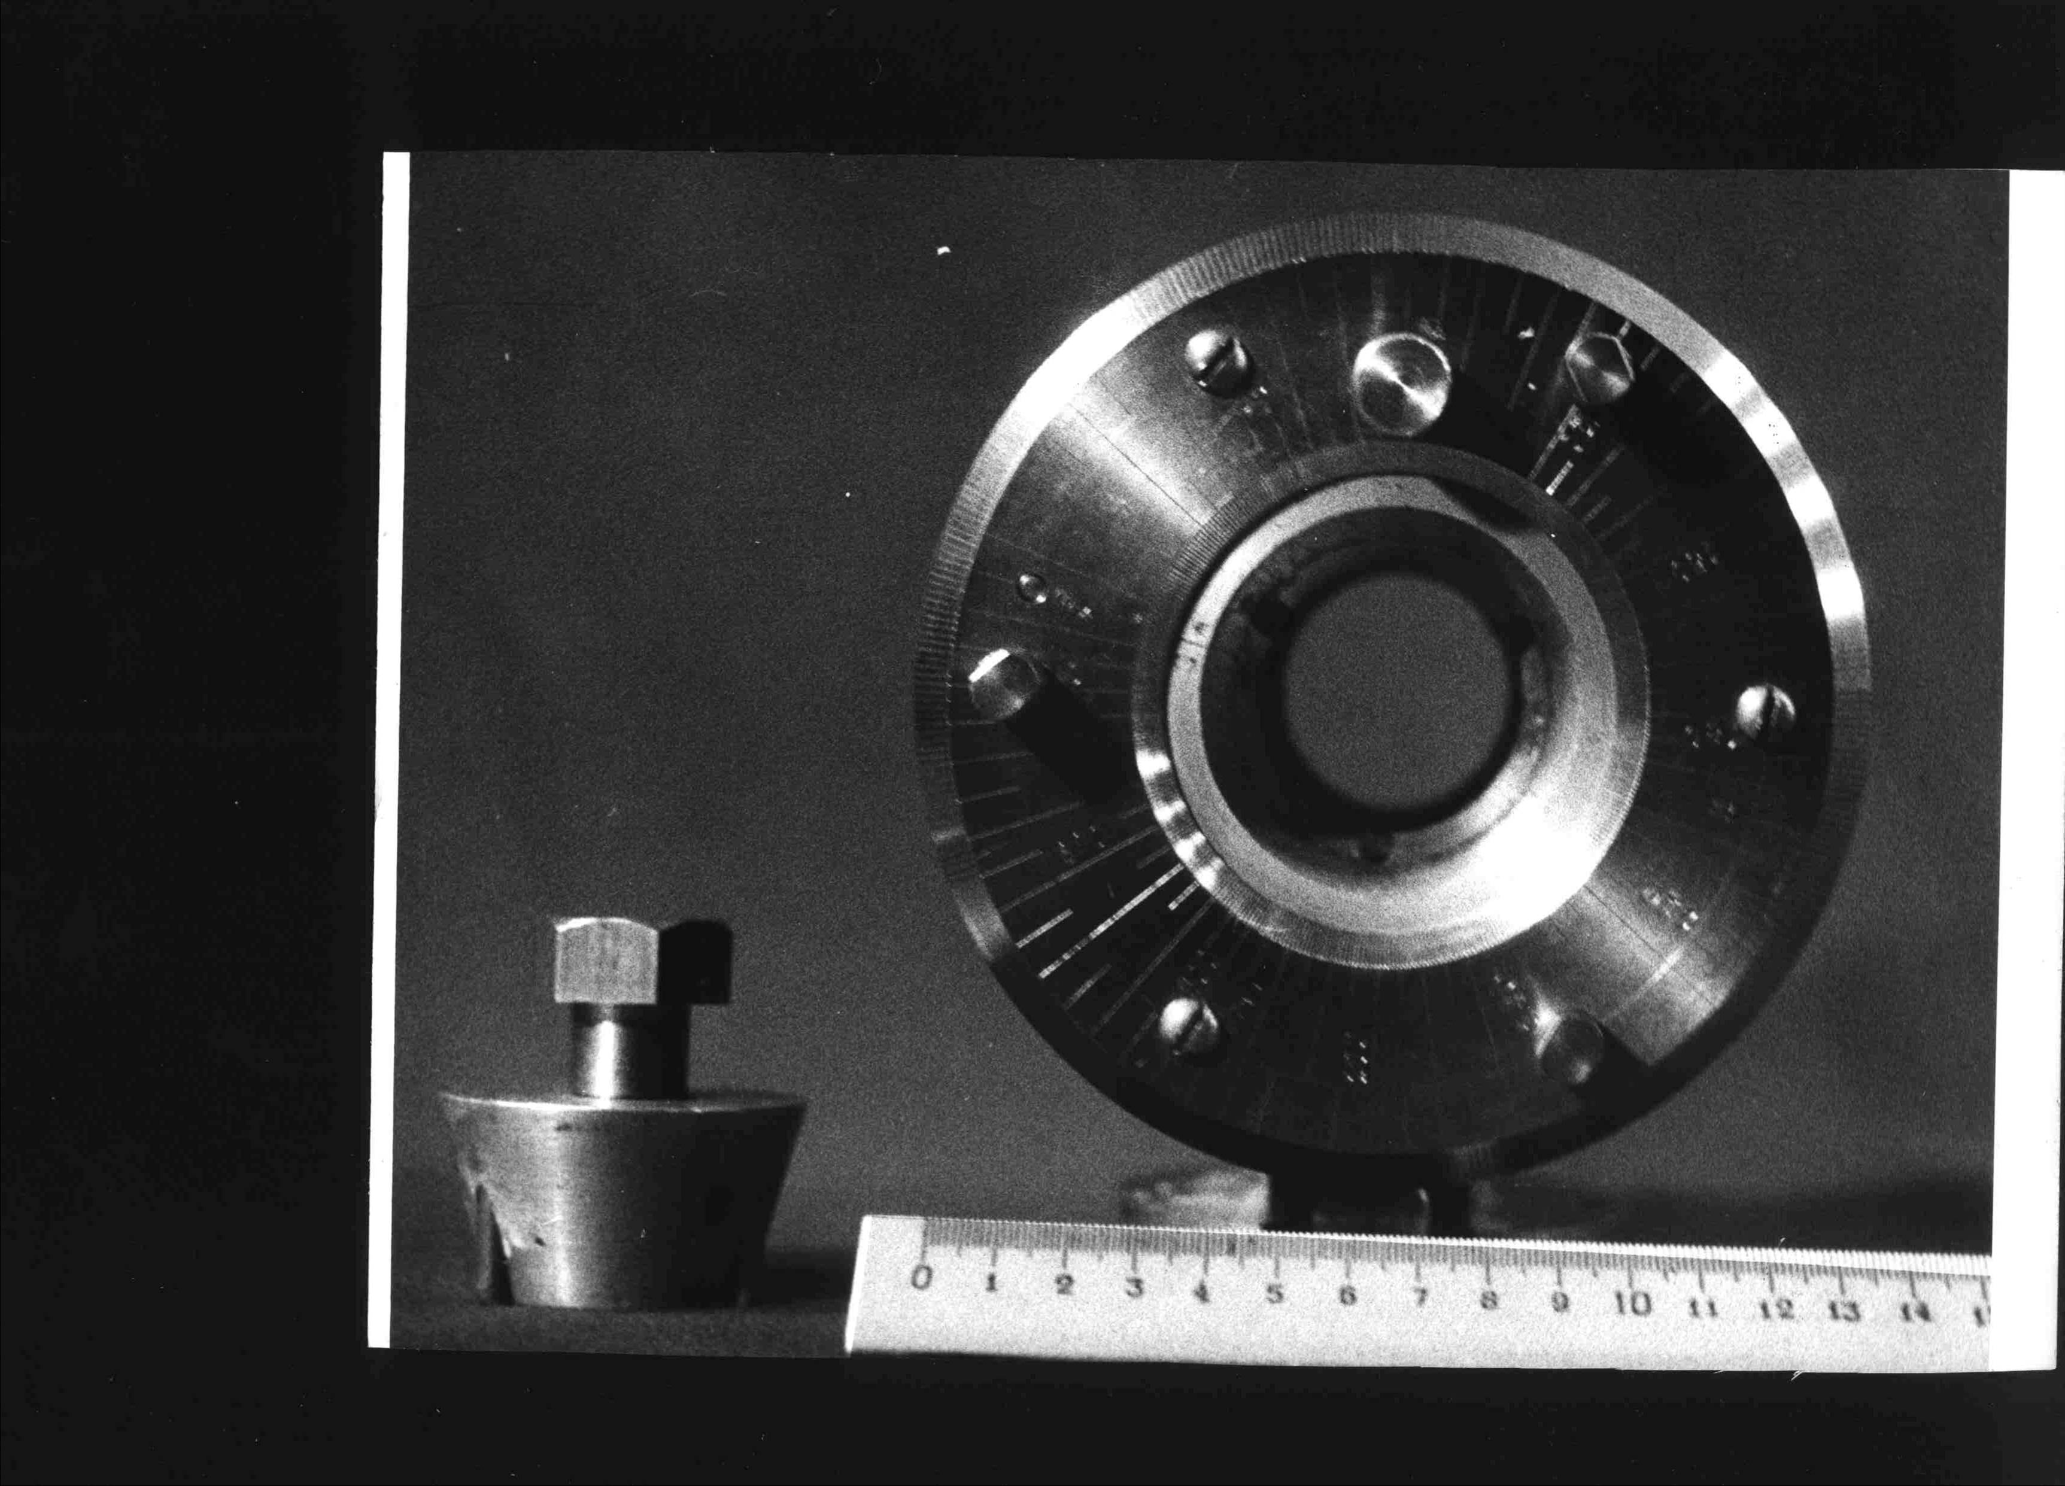 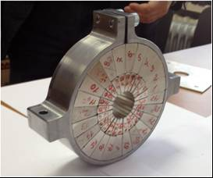

SmCo5 and NdFeB dipole and quadrupole lenses of segmented type. Left figure – first full-scale quad developed in 1977 within collaboration ITEP-CBSM, Russia. Central figure – two layer dipole with variable field in up to 90 % range. Right figure – PMQ module for PRIOR experiments [2,3] with extremely high parameters: the magnetic field gradient – *G*=123 Т/m at aperture of Ø30 mm, nonlinearity of less than 0.7 %; has been developed for proton microscope optics line.

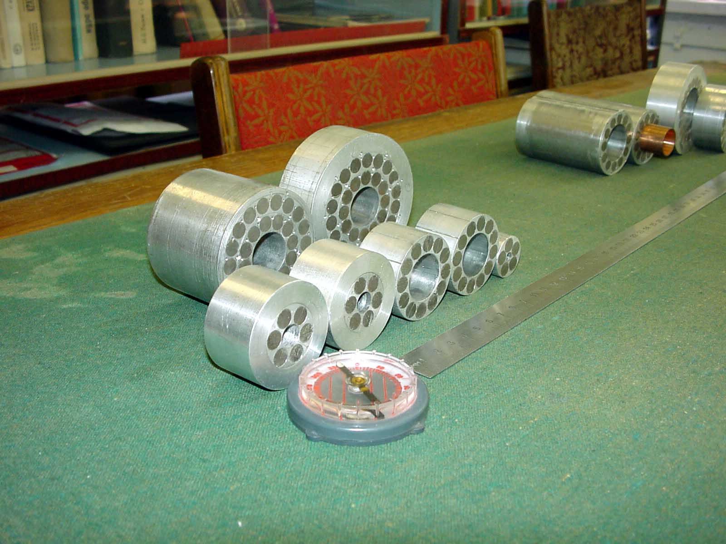

Precise SmCo5 and NdFeB PMМs family of rod type, in particular, of small-aperture, and high gradient.

 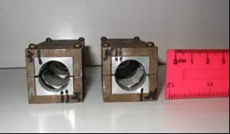

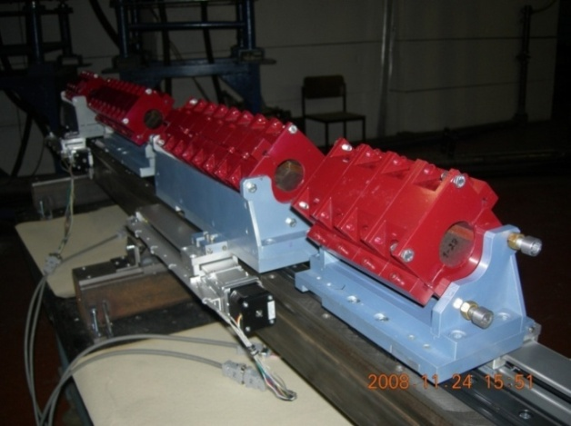 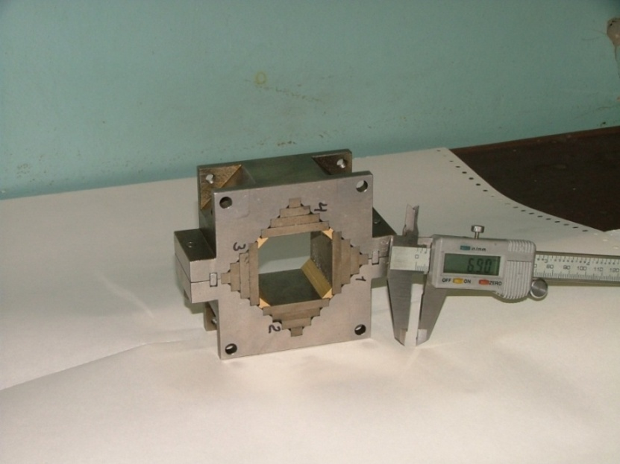

NdFeB dipole and quadrupole permanent magnet assemblies of Quasi-Sheet Multipole (QSM) design: for race-track microtrons – upper, as well as PMQ modular quadruplet (field gradient – *G*=28 Т/m at aperture of Ø40 mm, nonlinearity of less than 0.75 %) and alone quadrupole section of 40×40 mm rectangle aperture for ITEP’s 800 MeV PUMA proton microscopy facility [4,5] – lower.

1. Development of precise magnetometers for 2D/3D magnetic field reconstruction by harmonic mathematical models of spatial magnetostatic field distribution have been undertaken in ITEP since mid 80s for magnetic optics elements of accelerator channels and transport lines. These models can be implemented for on-line remote optimization and/or continuous visualization of accelerating machine regime as well as for periodic verification/retuning of magnetic elements and in time technical attendance of magnetic, in particular, rare-earth permanent magnet devices.

Magnetic measurement scanners are presumed/offered for LNL-INFN accelerating complex on base of techniques evaluated and implemented in ITEP since 80s for magnetostatic field reconstruction in rare-earth PMМ elements of optic focusing.

In case of measurement of characteristic of PMQ lenses, scanning of the magnetic field is performed on cylindrical surface near the inner surface of a PMQ lens in automatic mode with the use of developed software. Only the radial component of the magnetic field is measured. Based on such scanning results calculations of the mathematical model developed in ITEP are carried out. The model describes the distribution of the magnetic field at any point within the aperture of the lens. Such technique avoids the measuring in numerous nodes of three-dimensional greed and also does not require measurements of all perhaps up to three components of the magnetic field.

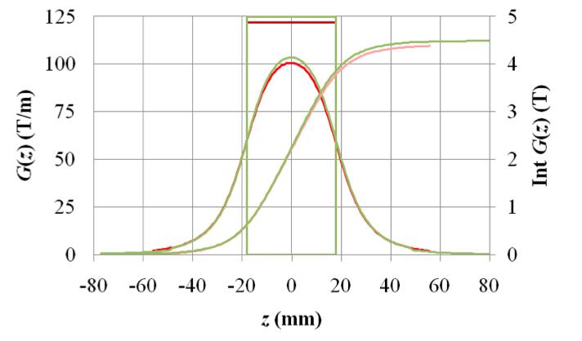

Example of the longitudinal magnetic field gradient distribution in a two-layer quad module got with mathematical model.

Two types of Hall probes are used to get high accuracy of magnetic field measurements:

* Group_3_MPT-141 thermo corrected Hall probe with measurement unit DTM-141. Accuracy of magnetic field measurement is 0.01%. The probe size – 14×5×2 mm.
* PCE_606118А small-size probe with measurement unit Agilent 34972A and two Standa 8MT175 type linear actuators with accuracy 2.5 microns. Accuracy of magnetic field measurement is 0.1%. The probe size – of 2×1.5×0.6 mm.

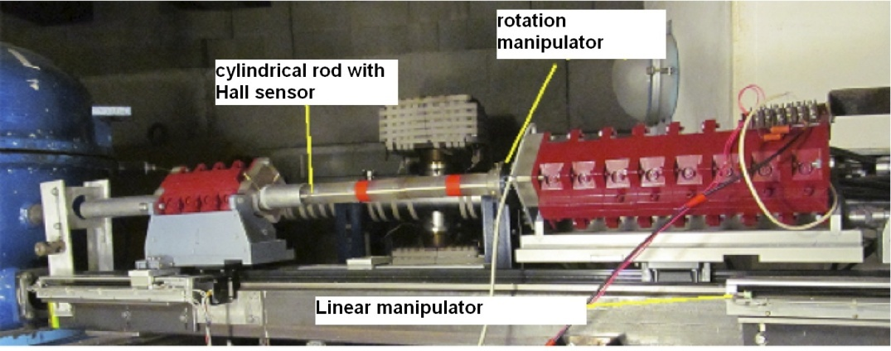 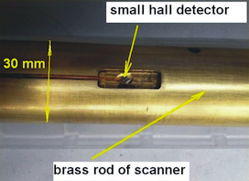

The scanner operation at the PMQ magnetic field measurements just on the PUMA facility beam line – left and slot in the movement rod for Hall probe housing and automated handling – right.

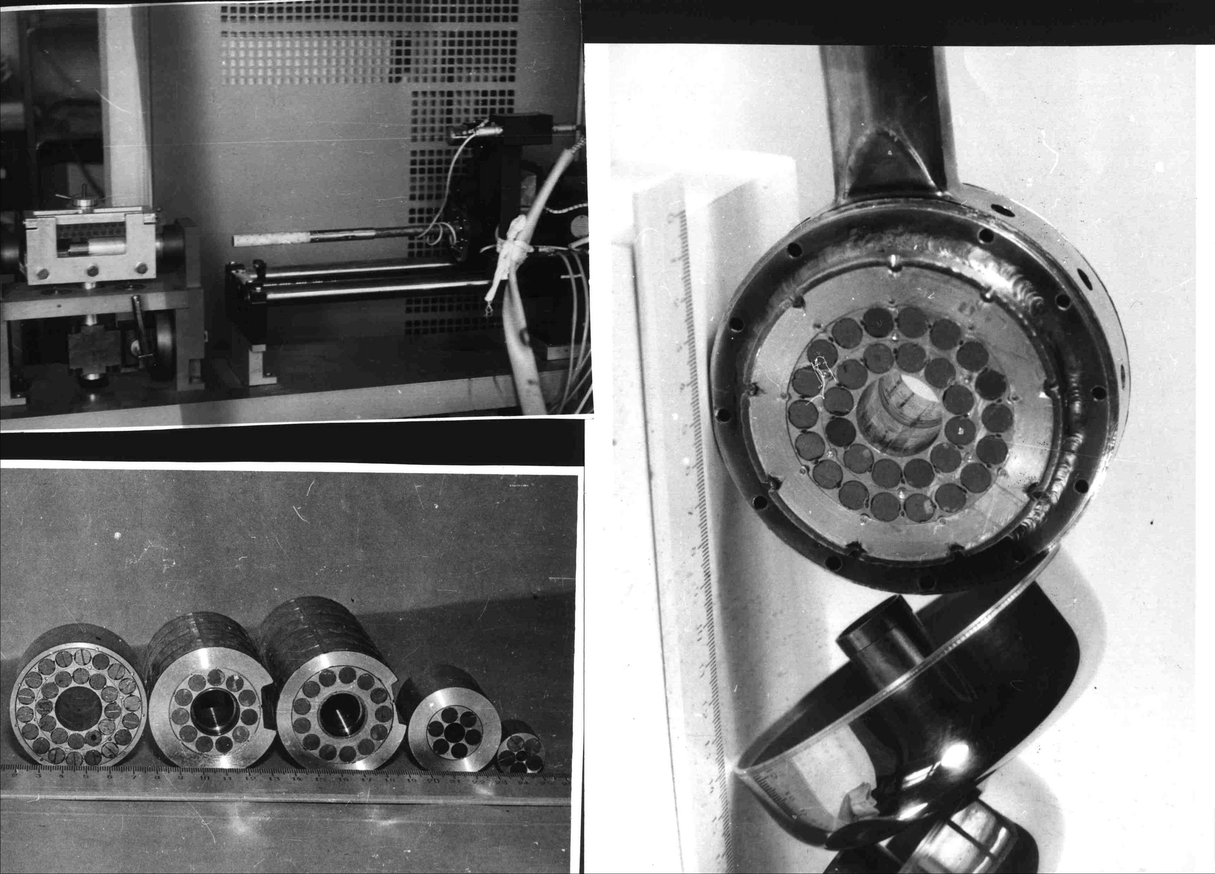 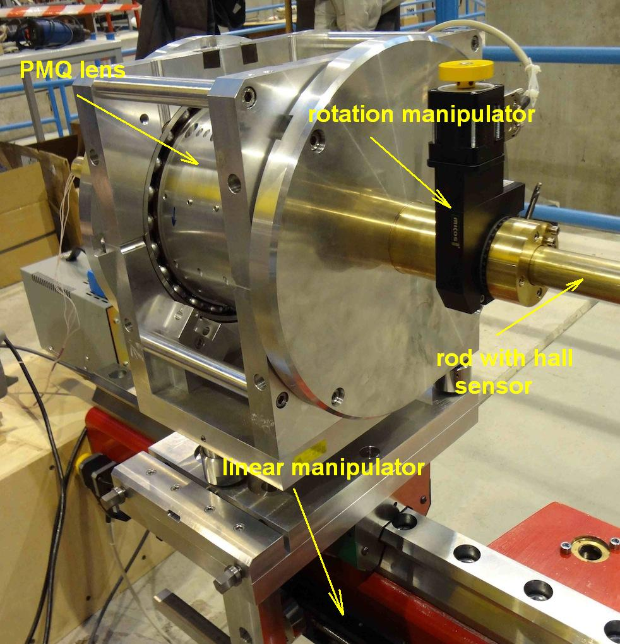

ITEP’s automatically-driven Hall probe magnetometers for 3-D detail description of the field distribution: in focusing PMQs for ITEP high current proton linear prototype – left and in PMQ lens of focusing quadruplet for the PRIOR 4.5 GeV proton microscope installation – right.

According to ITEP’s techniques the spatial distribution of static magnetic fields is described by universal mathematical models based on scalar potential, for example, of the following simplest form

$$U\left(r,φ,z\right)=\sum_{k=1}^{∞}{\sum_{n=0}^{∞}{\frac{I_{n}\left(\frac{πkr}{l}\right)}{I_{n}\left(\frac{πkr_{0}}{l}\right)}}}\left({\overline{A}}_{kn}\cos{nφ}+{\overset{̿}{A}}_{kn}\sin{nφ}\right)\sin{\frac{πk\left(z-z_{0}\right)}{l}}$$

and proper supplied with efficient computer codes. Computing routine for field evaluation, which use experimentally determined Fourier-Bessel series coefficients, can be adapted accurately for on-line tuning of accelerator and suitable built into computer control visualization system.

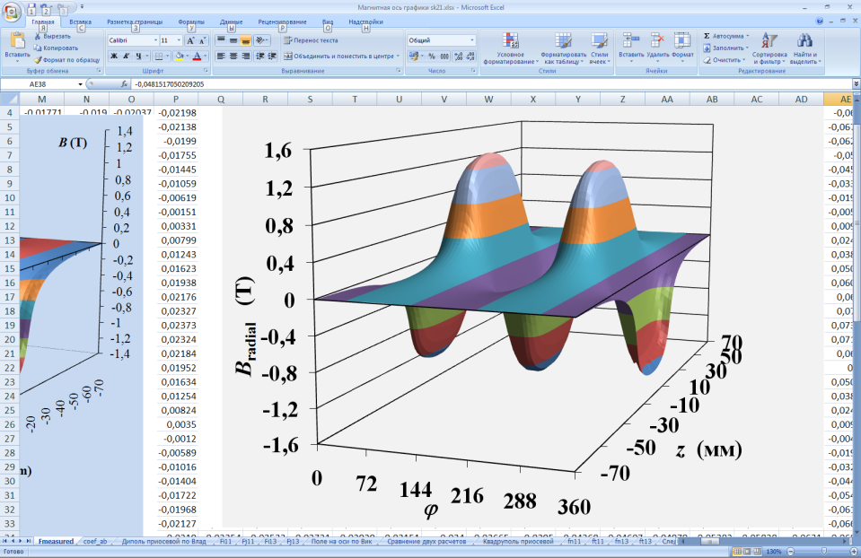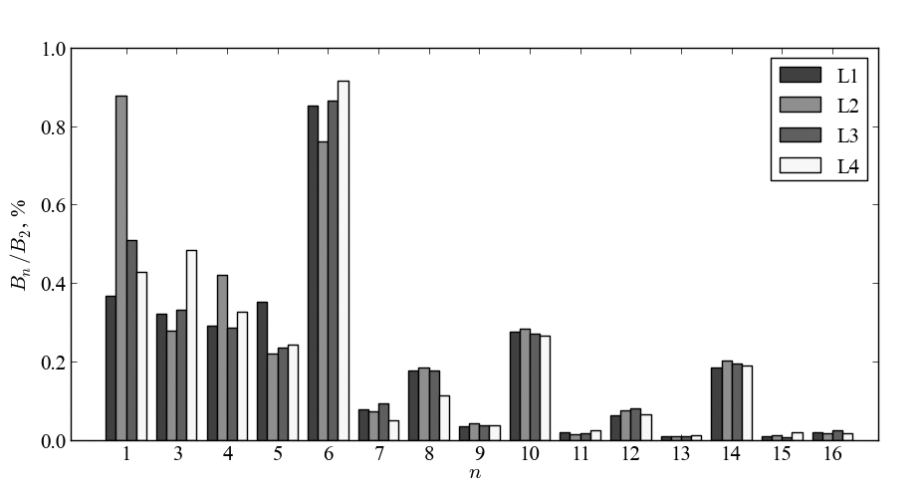

ITEP’s measurement technique; numerical treatment: normal magnetic field component distribution measured on the boundary of a PMQ module aperture surface and reconstructed one with 3D model – left, and spatial nonlinear harmonic spectra in PRIOR permanent magnet quadruplet on pole tip field of 1.83 T – right. Dominated 6-th nonlinear harmonic is experimental evidence that to achieve extremely high field in PRIOR quads the permanent magnet should withstand high-level demagnetization factor.

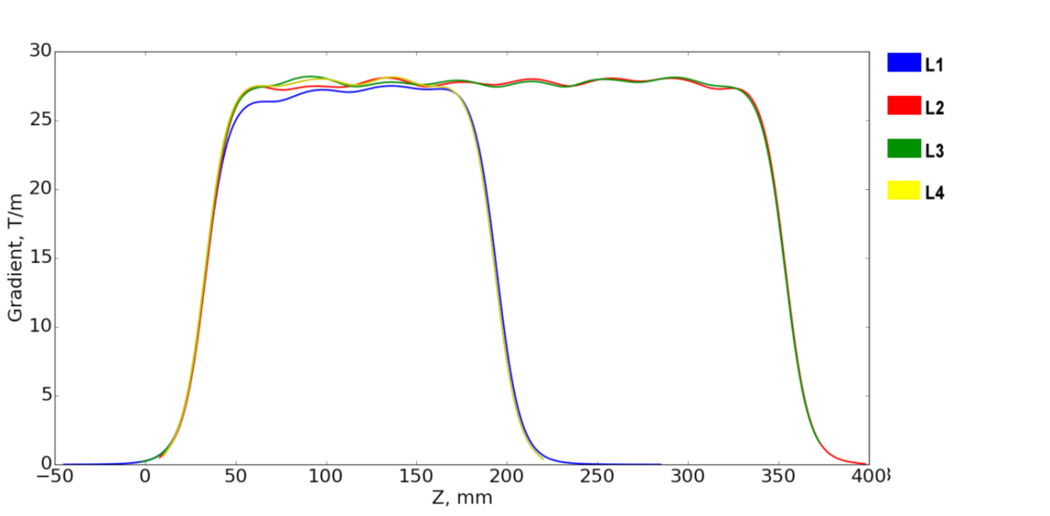

The magnetic field gradient distribution in PUMA setup PMQ lenses.

References:

1. Vl. Skachkov et al., 2d Workshop on High Energy Proton Microscopy, Chernogolovka, Russia, June 2–4, 2010, <http://www.ficp.ac.ru/hepm2010/presentations/HEPM2010-Skachkov.pdf>;
2. Kantsyrev A.V.,.., Skachkov Vl.S. et al., Development of PMQ lenses for PRIOR, 4th International Workshop on High Energy Proton Microscopy (HEPM-2013), Darmstadt, Germany, July 2013; <http://www-aix-new.gsi.de/conferences/HEPM2013/> talks/Jul16-1215_Kantsyrev.pdf;
3. D. Varentsov et al.; Commissioning of the PRIOR proton microscope, Review of Scientific Instruments, 2016, 87, issue 2, p. 023303/1–023303/8;
4. A.V. Kantsyrev, A.A. Golubev, V.I Turtikov et al., ITEP proton microscopy facility, Proceedings of PPPS2013, p.1-5, San-Francisco, USA;
5. A.V. Kantsyrev, A. A. Golubev, .. , V. S. Skachkov, et al. , TWAC-ITEP Proton Microscopy Facility, Instruments and Experimental Techniques, 2014, Vol. 57, No. 1, pp. 1–10;