Summary EuroNNAc 2012 Meeting
The 2012 meeting of the European Network for Novel Accelerators (EuroNNAc) took place at CERN from May 2 to 5. The agenda and the presentations are available on the INDICO web site:
http://indico.cern.ch/conferenceDisplay.py?confId=187383
The meeting invitation went to the member board with representatives from presently 52 institutes.
The results and decisions of the EuroNNAc 2012 meeting are summarized below. After approval the summary will be distributed to the full distribution list of EuroNNAc.

I) Distributed Test Facility on Novel Acceleration
The coherent description of various test areas and the fostering of enhanced collaboration and technical exchange is one of the main objectives for EuroNNAc. The meeting therefore had a focus on discussing the ongoing research and facilities. The goal was to get a view on a possible distributed test facility formed out of the various individual activities.
As a first step the 14 most important technical goals were discussed and summarized. They are listed and shortly described here, as they will be used in the summary tables that are discussed later:
- External optical injection
  - Create a particle beam with laser-driven plasma source
  - Inject into a laser-driven plasma accelerator
  - Characterize final beam energy, quality, …
- External RF injection
  - Create a particle beam with an RF injector
  - Inject into a laser-driven plasma accelerator
  - Characterize final beam energy, quality, …
- Laser wakefield acceleration (LWFA) with self injection
  - Create a particle beam with laser-driven plasma source
  - Maximize energy and/or charge
- Multi-stage LWFA
  - Similar to external optical injection
  - A generic stage of laser-driven wakefield acceleration
- Synchrotron radiation with advanced beams
  - Transport beam from plasma injector
  - Use to generate synchrotron radiation in classical undulators
- Electron beam driven PWFA
  - Use an electron beam to drive plasma wakefields
  - Test with external injection of beam
- Proton beam driven PWFA
  - Use a proton beam to drive plasma wakefields
  - Test with external injection of beam
- Betatron radiation in plasma
  - Off-axis oscillations of electrons within plasma wakefields
  - Use and manipulate this process to generate synchrotron radiation
  - Possibility for ultra-compact radiation sources (injector + transport + undulator within plasma cell)
- Plasma undulator
  - External off-axis injection into a plasma wakefield stage
  - Any driver technology is possible
- Stability and beam quality
  - Measure, characterize, optimize advanced beams
  - Any driver technology is possible
- Polarized beams in plasmas
  - Inject polarized beams into a plasma accelerator with any driver technology
  - Measure depolarization
- Positron acceleration
  - Inject positrons into a plasma accelerator with any driver technology
  - Measure acceleration and beam quality preservation
- Femto-second synchronization
  - Set up of femto-second timing and synchronization systems
  - Cross synchronization between multiple particle and laser beams
- Power and efficiency
  - Technology improvement efforts to increase efficiency.
  - Measurement of energy transfer from wall plug through laser and plasma to beam particle.
  - Optimizing efficiency and minimizing power consumption.
Every facility represented at the meeting was discussed in terms of these technical goals. The involvement of each facility in each of the technical goals was judged with four possible states:
- Not involved (0 stars).
- Possible but additional resources would be required (1 star).
- Advanced project, not funded at the moment (2 star).
- Funded (3 star).
In addition, the possible user access was discussed for every facility. Three access conditions were defined:
- “User, Comm”: User facility with defined access conditions. Selection by a committee at the facility.
- “Collaboration”: Access by joining an existing collaboration at the facility.
- “Laser Lab”: Access through the Laser Lab Program.
Based on these agreed classifications 8 European facilities were then reviewed. The summary table is shown Table 1 (also available as EXCEL file).

Table 1 First attempt to classify various test facilities for their interests and capabilities. The representatives from the facilities provided the information.
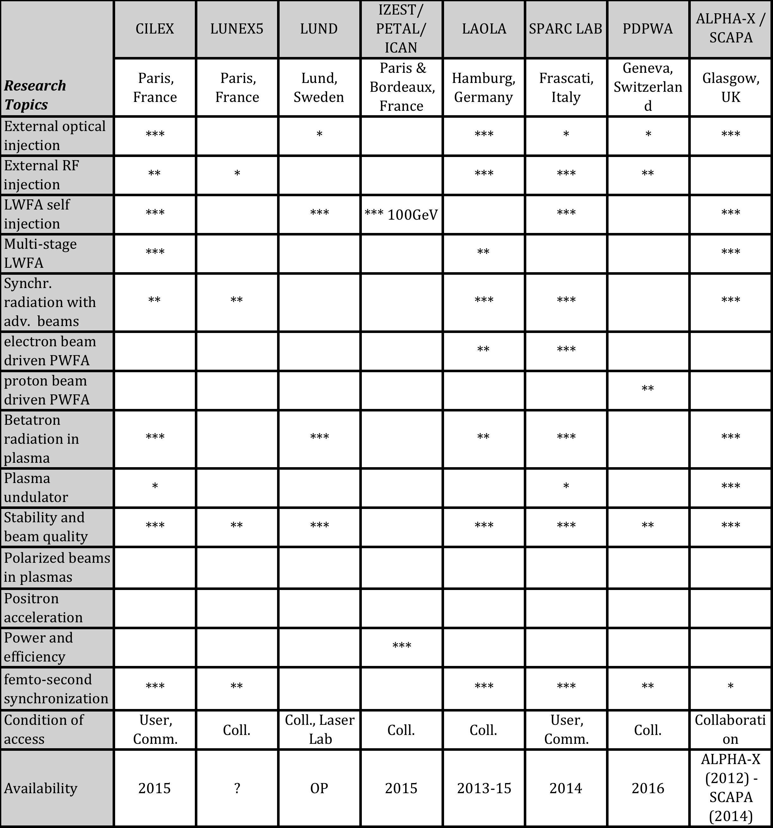

The draft table was discussed. It was agreed that this approach is very useful. The missing facilities should be added to complete this table. For example, ELI presents a major investment and should therefore be part of this table. R. Assmann agreed to follow up. The draft table allows already a nice overview on well and not so well covered research topics. This is illustrated in Figure 1 where the graphical visualization of research topics is shown.
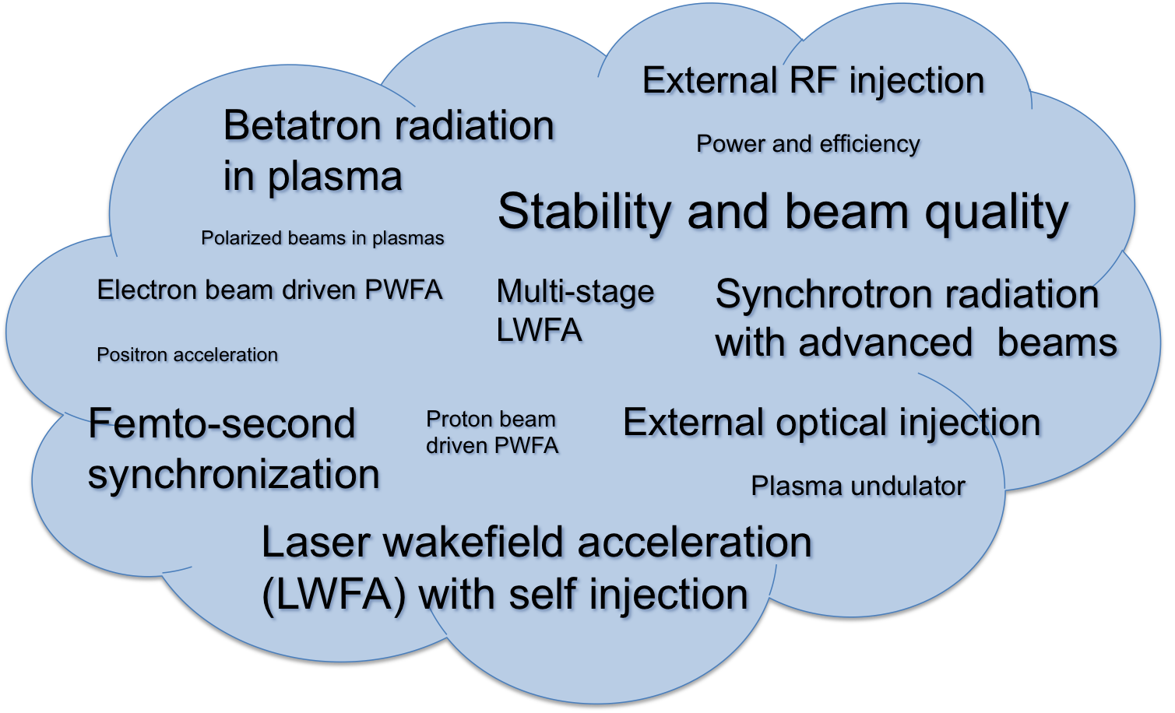
Figure 1 Graphical visualization of research topics in advanced acceleration R&D that are pursued in various facilities, as derived from Table 1. The font size reflects the number of stars the activity received within the agreed EuroNNAc classification scheme.
It was agreed that a description of the facilities should include one paragraph of text per facility. In this text, the facilities, acronyms, main mission, … should be explained. It was decided that the text should be provided by a responsible of each facility.
It was decided that a similar table should be prepared for technical parameters and performance. This has been done and the table is included in the EXCEL file of EuroNNAc tables (distributed separately). The table should be filled by a responsible of each facility.

II) Role of Smaller Groups at Universities
The role of smaller university teams in the work was discussed. Two important roles were identified:
- Follow-up on special technology R&D that requires a small and focused team, that then contributes the technology to one or various test facilities. One could think about plasma cells, detector technology, and specialized simulations. Universities should have the role of technology and knowledge drivers. The role of universities detector R&D for particle physics was mentioned as a possible example.
- Link to students. The universities teach the students about challenges in advanced acceleration and can bring the help of these students to the research done at the test facilities. The imbalance between student applicants and positions was discussed. In some places there is a strong surplus of applicants, in others a shortage.
It was decided that EuroNNAc will set up an European Job Market for Advanced Acceleration Topics, that list all offers, such that universities can get an easy overview. R. Jones will follow up.
It was decided that budget support from EU should be asked for special technology R&D and students. See also section III) of this summary.

III) FP8 Funding Plans
The discussion showed that multiple research facilities are under preparation in various countries. The completion dates are from 2014 to 2016 (see Table 1). It was therefore decided that it is too early to prepare a EU funding request for a European pilot facility. EuroNNAc should instead focus initially on supporting the concept of a distributed test facility and aim at strengthening coherence of goals, collaboration, synergy and technical exchange. The following ideas for funding support were discussed:
- A training network for education and exchange of students and experts.
- Travel funds for collaboration, transport costs, setup costs for use of non-local facilities.
- Funding for common development of special diagnostics, which can be used at several research facilities.
- Funding for distributed R&D and strategic workshops on this distributed R&D (for example plasma sources, novel source technologies for plasma accelerators.
- Funding for specialized CPU time, codes, …, as long as not covered by other programs.
It was agreed to find out about adequate European programs for such funding.

IV) WG Leaders and Deputy Leaders
Several colleagues volunteered to help in driving ahead the program. More volunteers are needed. Alternatively the coordinators will start one-on-one discussions with several institutes and colleagues. Once a proposal is ready it will be submitted to the member’s board for approval.

V) 1st European Advanced Accelerator Conference (EAAC)
It was decided that a 1st European Advanced Accelerator Conference (EAAC13) should be organized for 2013. The EuroNNAc member’s board will act as advisory and program committee. It was stressed that EAAC should be set up in close coordination with AAC in the US and any Asian efforts.
D. Perret-Gallix proposed the ASEPS 2013 “ASia-Europe Physics Summit” (http://aseps-blog.blogspot.fr/) to act as a forum that can help to build strong links with the Asian physics community. It was also proposed to invite Asian coorganization. It could also be considered to organize a EuroNNAc meeting in Asia for a meeting with Asian counterparts.
Concerning close collaboration with US it was proposed that J. Osterhoff will discuss with US colleagues during the AAC in June 2012.
Concerning the scope, it was decided that the broad scope of AAC should be taken as a good example. Therefore one should include also dielectric structures, laser development, high gradient conventional linac R&D and linear collider concepts.
It was decided that EAAC should have a length of 5 working days, including 1 day reserved for a student session. The EuroNNAc 2013 meeting will be combined with EAAC13.
It was decided to ask for support from ICFA. It was also decided to ask for sponsoring from institutes and industry. An amount of 10 k€ per sponsor was proposed. The support would be used for student travel support and for financing somes prizes. It was decided to aim at establishing prizes for the best PhD and the best poster.
It was discussed to plan for about 200 participants. Two institutes volunteered to host EAAC13. Once confirmed, the location and date will be announced. B. Cros agreed to propose some feasible dates.

VI) EuroNNAc Statement to European Strategy Group
It was decided that a statement from EuroNNAc would be submitted to the European Strategy Group on future particle physics.
Volunteers for drafting this statement: R. Assmann, A. Caldwell, T. Tajima, J. Osterhoff, H. Videau. The draft will be distributed to the member’s board for comments and approval. Deadline for final submission is 31.7.2012.
It was decided that the statement should provide first a state-of-the-art description of advanced acceleration techniques: just facts without judgment. An optimistic outlook of the possible achievements ahead should follow this, including the outlook to more compact accelerator facilities for HEP and photon science.
It should be argued that a stronger HEP support is required. Support should not just be of financial nature but should also include technical collaboration on novel detectors, instrumentation, evaluation of test beams, support for beam/laser time, …

VII) Review Paper for Annalen der Physik
An invitation has been received to write a review of the status of the field for Annalen der Physik. It was decided to accept this invitation. The report will be based on the overview tables and the information that EuroNNAc is collecting. There should be short paragraphs per facility, which are written by the experts in charge. Goal is to have the review completed in September 2012.

VIII) Training
Not much thinking went so far into this. It was agreed that the UK would propose a concept and a plan. The following persons were proposed for follow-up: R. Jones, R.Bartolini, P.Karataev and S.Mangles.

IX) Connection to Other Activities
The required close connection to other activities was stressed, for example the interaction from EuroNNAc to other regions (US, Asia) and to other organizations (LaserLab, ICFA, ESGARD, TIARA). The close coordination with the ICFA/ICUIL task force was also emphasized. It was agreed that we would rely on the support and initiative from the members that represent other areas and organizations in EuroNNAc.

X) AOB
It was agreed that strategic meetings on special technical topics would be very useful. As a first example a special meeting on plasma sources was proposed to maximize synergy. It was decided to ask Patric Muggli and Simon Hooker if they would be willing to organize a special EuroNNAc meeting on plasma sources.
During the meeting S. Chattopadhyay proposed via e-mail a EuroNNAc focus on "novel source technologies for plasma accelerators". This might also make an excellent topic for a strategic EuroNNAc workshop.

Reported by R. Assmann, 18.5.2012

